UNITED STATES

SECURITIES AND EXCHANGE COMMISSION
WASHINGTON, D.C. 20549

FORM 8-K

CURRENT REPORT

Pursuant to Section 13 or 15(d)
of the Securities Exchange Act of 1934

Date of report (Date of earliest event reported): November 14, 2024

Invivyd, Inc.

(Exact Name of Registrant as Specified in its Charter)

Delaware | 001-40703 | 85-1403134
(State or Other Jurisdiction | (Commission | (IRS Employer
of Incorporation) | File Number) | Identification No.)

1601 Trapelo Road, Suite 178
Waltham, MA | 02451
(Address of Principal Executive Offices) | (Zip Code)

Registrant’s telephone number, including area code: (781) 819-0080

Not applicable

(Former Name or Former Address, if Changed Since Last Report)

Check the appropriate box below if the Form 8-K filing is intended to simultaneously satisfy the filing obligation of the registrant under any of the following provisions:

- Written communications pursuant to Rule 425 under the Securities Act (17 CFR 230.425)

- Soliciting material pursuant to Rule 14a-12 under the Exchange Act (17 CFR 240.14a-12)

- Pre-commencement communications pursuant to Rule 14d-2(b) under the Exchange Act (17 CFR 240.14d-2(b))

- Pre-commencement communications pursuant to Rule 13e-4(c) under the Exchange Act (17 CFR 240.13e-4(c))

Securities registered pursuant to Section 12(b) of the Act:

Title of each class |  | Trading |  | Name of each exchange
 |  | Symbol(s) |  | on which registered
Common stock, par value $0.0001 per share |  | IVVD |  | The Nasdaq Stock Market LLC

Indicate by check mark whether the registrant is an emerging growth company as defined in Rule 405 of the Securities Act of 1933 (§230.405 of this chapter) or Rule 12b-2 of the Securities Exchange Act of 1934 (§240.12b-2 of this chapter).

Emerging growth company ☒

If an emerging growth company, indicate by check mark if the registrant has elected not to use the extended transition period for complying with any new or revised financial accounting standards provided pursuant to Section 13(a) of the Exchange Act. ☐

Item 2.02. Results of Operations and Financial Condition.

On November 14, 2024, Invivyd, Inc. (the “Company”) issued a press release announcing its financial results for the quarter ended September 30, 2024, and recent business highlights. A copy of the press release is furnished as Exhibit 99.1 to this Current Report on Form 8-K and is incorporated by reference into this Item 2.02.

The information furnished pursuant to this Item 2.02, including Exhibit 99.1, shall not be deemed to be “filed” for purposes of Section 18 of the Securities Exchange Act of 1934, as amended (the “Exchange Act”), or otherwise subject to the liabilities of that Section, nor shall it be deemed to be incorporated by reference into any of the Company’s filings with the Securities and Exchange Commission under the Exchange Act or the Securities Act of 1933, as amended, whether made before or after the date hereof, regardless of any general incorporation language in such a filing, except as expressly set forth by specific reference in such a filing.

Item 8.01. Other Events.

On November 14, 2024, the Company posted an updated corporate presentation on its website at www.invivyd.com. A copy of the presentation is filed as Exhibit 99.2 to this Current Report on Form 8-K and is incorporated by reference into this Item 8.01.

On November 14, 2024, the Company issued a press release entitled “Invivyd Announces New England Journal of Medicine Publishes Letter to the Editor Highlighting Immunobridging Pathway Leading to PEMGARDA™ (pemivibart) Emergency Use Authorization; Comments on Adjacent Third-Party Letter to the Editor.” A copy of the press release is filed as Exhibit 99.3 to this Current Report on Form 8-K and is incorporated by reference into this Item 8.01.

Item 9.01. |  | Financial Statements and Exhibits.
(d) Exhibits
Exhibit |  |  |  | Description
No. |  |  |  | Description
99.1 |  | Press Release, dated November 14, 2024
99.2 |  | Corporate Presentation, dated November 14, 2024
99.3 |  | Press Release, dated November 14, 2024
104 |  | Cover Page Interactive Data File (embedded within the Inline XBRL document)

SIGNATURES

Pursuant to the requirements of the Securities Exchange Act of 1934, as amended, the registrant has duly caused this report to be signed on its behalf by the undersigned hereunto duly authorized.

INVIVYD, INC.

Date: November 14, 2024 By: /s/ Jill Andersen

Jill Andersen

Chief Legal Officer and Corporate Secretary

Exhibit 99.1

Invivyd Reports Third Quarter 2024 Financial Results and Recent Business Highlights

- Q3 2024 PEMGARDA™ (pemivibart) net product revenue of $9.3 million; Invivyd ended Q3 2024 with $106.9 million in cash and cash equivalents

- Targets near-term (1H 2025) profitability with existing cash and cash equivalents, anticipated growth of net product revenue, and various operational efficiency improvements

- PEMGARDA Fact Sheet updated to properly reflect neutralization activity of PEMGARDA against current circulating variants tested; on track for continued growth now reflective of ongoing commercial optimization

- Next generation molecule VYD2311 first-in-human clinical trial dosing began in August 2024 with anticipated preliminary data readout late Q4 2024

- Management to host conference call today at 8:30AM ET

WALTHAM, Mass., Nov. 14, 2024 – Invivyd, Inc. (Nasdaq: IVVD), a biopharmaceutical company devoted to delivering protection from serious viral infectious diseases, today announced financial results for the quarter ended September 30, 2024, and recent business highlights.

With the September 26, 2024 update, the PEMGARDA™ (pemivibart) Fact Sheet for Healthcare Providers (Fact Sheet) now includes validated data for pemivibart’s neutralization activity against the latest circulating COVID-19 variants tested, including KP.3, KP.3.1.1 and LB.1. This Fact Sheet update aligns with exploratory clinical efficacy data from the CANOPY Phase 3 clinical trial that demonstrated substantial protection from symptomatic COVID-19 versus placebo in immunocompetent participants across a broad spectrum of viral strains including KP.3 and KP.3.1.1. By ensuring that healthcare providers and other stakeholders have access to accurate information, Invivyd aims to reinforce confidence in the therapeutic potential of PEMGARDA for immunocompromised people needing pre-exposure prophylaxis of COVID-19, as authorized. Invivyd reported $9.3 million in PEMGARDA™ (pemivibart) net product revenue in Q3 2024, an increase from $2.3 million in Q2 2024. Though not at previously anticipated rates, PEMGARDA net product revenue grew through the third quarter and continues to grow.

“With the current Fact Sheet that accurately reflects the neutralization activity of PEMGARDA against KP.3.1.1, the exploratory clinical efficacy data reconfirming a substantial level of relative risk reduction of developing symptomatic COVID-19 versus placebo during the KP.3 and KP.3.1.1 wave, and with our predicted continued neutralization activity of pemivibart against the XEC variant, we are confident in the growth potential for PEMGARDA,” said Marc Elia, Chairman of the Invivyd Board of Directors.

“We are excited about the potential of PEMGARDA to address the significant unmet need of COVID-19 pre-exposure prophylaxis for certain immunocompromised people and expect that ongoing commercial execution will drive substantial revenue growth and market expansion,” said Tim Lee, Chief Commercial Officer of Invivyd. “We have expanded our outreach efforts—driving awareness of PEMGARDA in the healthcare providers community, increasing our ability to reach to additional points of care, and adding new programs to support patients.”

Recent Business Highlights

- Submitted Emergency Use Authorization (EUA) amendment request to U.S. Food & Drug Administration (FDA) for PEMGARDA for the treatment of mild-to-moderate COVID-19 in certain immunocompromised patients

- Announced 180-day exploratory clinical efficacy data from the company’s ongoing CANOPY Phase 3 clinical trial showing PEMGARDA™ (pemivibart) demonstrated 84% relative risk reduction from symptomatic COVID-19 versus placebo through month 6 in Cohort B, a placebo-controlled cohort of all-comer immunocompetent individuals, with safety profile reported as remaining consistent with previously disclosed CANOPY clinical trial data

- Reported CANOPY Phase 3 long-term exploratory clinical efficacy data showing PEMGARDA™ (pemivibart) provided 64% relative risk reduction from symptomatic COVID-19 versus placebo in Cohort B over six-month off-drug follow-up period (months 7-12), with no new safety observations occurring during months 7-12

- U.S. FDA has updated the PEMGARDA™ EUA Fact Sheet with accurate SARS-CoV-2 variant susceptibility information and PEMGARDA in vitro neutralization activity data

- Announced preprint conveying CANOPY Phase 3 clinical trial data including long-term protection versus recent JN.1 sublineages at low residual titers uploaded in MedRxiv; manuscript conveying pivotal safety, immunobridging, and exploratory clinical efficacy results from the CANOPY clinical trial will be submitted to a major scientific journal shortly

- Announced preprint describing Invivyd scientists’ novel method for predicting the activity of a monoclonal antibody in the face of variant evolution uploaded in BioRxiv; method predicts continued neutralization activity for pemivibart against SARS-CoV-2 variant XEC, with formal assay assessment pending

Recent Pipeline Highlights

- Initiated dosing of first participants in Phase 1 clinical trial of VYD2311, a next generation monoclonal antibody candidate for COVID-19, building on the success of PEMGARDA

Third Quarter 2024 Financial Results

- Revenue: Reported $9.3 million of net product revenue of PEMGARDA in Q3 2024 as compared to $2.3 million in Q2 2024.

- Cash Position: Cash and cash equivalents were $106.9 million as of September 30, 2024.

- Projected 2024 Year-End Cash Position: Based on current operating plans, Invivyd expects to end 2024 with at least $65 million in cash and cash equivalents, based on anticipated growth of net product revenue and various operational efficiency improvements.

- Research & Development (R&D) Expenses (including In-Process R&D): R&D expenses were $57.9 million for the quarter ended September 30, 2024, compared to $30.2 million for the comparable period of 2023. This increase is primarily attributable to an increase in VYD2311 manufacturing as compared to lower manufacturing costs of PEMGARDA during the same period in 2023.

- Selling, General & Administrative (SG&A) Expenses: SG&A expenses remained relatively consistent at $13.0 million for the quarter ended September 30, 2024 and $12.9 million for the comparable period of 2023.

- Net Loss and Net Loss per Share: Net loss was $60.7 million for the quarter ended September 30, 2024, compared to $39.4 million for the comparable period in 2023. Basic and diluted net loss per share was $0.51 for the quarter ended September 30, 2024, compared to $0.36 for the comparable period in 2023.

Conference Call & Webcast

Listeners can register for the webcast via this link. Analysts wishing to participate in the question and answer session should use this link. A replay of the webcast will be available via the company’s investor website approximately two hours after the call’s conclusion. Those who plan on participating are advised to join 15 minutes prior to the start time.

About PEMGARDA

PEMGARDA™ (pemivibart) is a half-life extended investigational monoclonal antibody (mAb). PEMGARDA was engineered from adintrevimab, Invivyd’s investigational mAb that has a robust safety data package and provided evidence of clinical efficacy in a global Phase 2/3 clinical trial for the prevention and treatment of COVID-19. PEMGARDA has demonstrated in vitro neutralizing activity against major SARS-CoV-2 variants, including JN.1, KP.3, KP.3.1.1, and LB.1. PEMGARDA targets the SARS-CoV-2 spike protein receptor binding domain (RBD), thereby inhibiting virus attachment to the human ACE2 receptor on host cells.

PEMGARDA (pemivibart) injection (4500 mg), for intravenous use is an investigational mAb that has not been approved, but has been authorized for emergency use by the U.S. FDA under an EUA for the pre-exposure prophylaxis (prevention) of COVID-19 in adults and adolescents (12 years of age and older weighing at least 40 kg) who have moderate-to-severe immune compromise due to certain medical conditions or receipt of certain immunosuppressive medications or treatments and are unlikely to mount an adequate immune response to COVID-19 vaccination. Recipients should not be currently infected with or have had a known recent exposure to an individual infected with SARS-CoV-2.

PEMGARDA is not authorized for use for treatment of COVID-19 or post-exposure prophylaxis of COVID-19. Pre-exposure prophylaxis with PEMGARDA is not a substitute for vaccination in individuals for whom COVID-19 vaccination is recommended. Individuals for whom COVID-19 vaccination is recommended, including individuals with moderate-to-severe immune compromise who may derive benefit from COVID-19 vaccinations, should receive COVID-19 vaccination. In individuals who have recently received a COVID-19 vaccine, PEMGARDA should be administered at least 2 weeks after vaccination.

Anaphylaxis has been observed with PEMGARDA and the PEMGARDA Fact Sheet for Healthcare Providers includes a boxed warning for anaphylaxis. The most common adverse events (all grades, incidence ≥2%) observed in participants who have moderate-to-severe immune compromise treated with PEMGARDA included systemic and local infusion-related or hypersensitivity reactions, upper respiratory tract infection, viral infection, influenza-like illness, fatigue, headache, and nausea. For additional information, please see the PEMGARDA full product Fact Sheet for Healthcare Providers, including important safety information and boxed warning.

To support the EUA for PEMGARDA, an immunobridging approach was used to determine if PEMGARDA may be effective for pre-exposure prophylaxis of COVID-19. Immunobridging is based on the serum virus neutralizing titer-efficacy relationships identified with other neutralizing human mAbs against SARS-CoV-2. This includes adintrevimab, the parent mAb of pemivibart, and other mAbs that were previously authorized for EUA. There are limitations of the data supporting the benefits of PEMGARDA. Evidence of clinical efficacy for other neutralizing human mAbs against SARS-CoV-2 was based on different populations and SARS-CoV-2 variants that are no longer circulating. Further, the variability associated with cell-based EC50 value determinations, along with limitations related to pharmacokinetic data and efficacy estimates for the mAbs in prior clinical trials, impact the ability to precisely estimate protective titer ranges. Additionally, certain SARS-CoV-2 viral variants may emerge that have substantially reduced susceptibility to PEMGARDA, and PEMGARDA may not be effective at preventing COVID-19 caused by these SARS-CoV-2 viral variants.

The emergency use of PEMGARDA is only authorized for the duration of the declaration that circumstances exist justifying the authorization of the emergency use of drugs and biological products during the COVID-19 pandemic under Section 564(b)(1) of the Federal Food, Drug, and Cosmetic Act, 21 U.S.C. § 360bbb-3(b)(1), unless the declaration is terminated or authorization revoked sooner. PEMGARDA is authorized for use only when the combined national frequency of variants with substantially reduced susceptibility to PEMGARDA is less than or equal to 90%, based on available information including variant susceptibility to PEMGARDA and national variant frequencies.

About CANOPY

The ongoing CANOPY Phase 3 clinical trial is designed to evaluate the safety and tolerability of pemivibart and to assess immunobridging from pemivibart to certain historical data from the company’s previous Phase 2/3 clinical trial of adintrevimab (ADG20) for the prevention of symptomatic COVID-19 (EVADE). Additionally, there are pre-specified exploratory endpoints through three, six and twelve months to evaluate clinical efficacy of pemivibart compared to placebo in the prevention of RT-PCR-confirmed symptomatic COVID-19. The latest analysis from the Phase 3 CANOPY clinical trial includes 365-day data. The CANOPY clinical trial enrolled participants in two cohorts: Cohort A is a single-arm, open-label trial in adults who have moderate-to-severe immune compromise including complex underlying medical conditions. Cohort B is a randomized, placebo-controlled cohort that enrolled adults without moderate-to-severe immune compromise who are at risk of acquiring COVID-19 due to regular unmasked face-to-face interactions in indoor settings.

About VYD2311

VYD2311 is a novel monoclonal antibody (mAb) candidate being developed for COVID-19 to continue to address the urgent need for new therapeutic options for vulnerable populations, including immunocompromised people. Globally, there are millions of immunocompromised people, with an estimated 8 million in the U.S. alone, who may not adequately respond to COVID-19 vaccination, increasing their risk for severe outcomes from COVID-19.

VYD2311 was engineered from adintrevimab, Invivyd’s investigational mAb that has a robust safety data package and demonstrated clinically meaningful results in global Phase 3 clinical trials for both the prevention and treatment of COVID-19. The pharmacokinetic profile of VYD2311 may offer the ability to deliver clinically meaningful titer levels through more patient-friendly means such as an intramuscular route of administration.

About Invivyd

Invivyd, Inc. (Nasdaq: IVVD) is a biopharmaceutical company devoted to delivering protection from serious viral infectious diseases, beginning with SARS-CoV-2. The company’s proprietary INVYMAB™ platform approach combines state-of-the-art viral surveillance and predictive modeling with advanced antibody engineering. INVYMAB is designed to facilitate the rapid, serial generation of new monoclonal antibodies (mAbs) to address evolving viral threats. In March 2024, Invivyd received emergency use authorization (EUA) from the U.S. FDA for its first mAb in a planned series of innovative antibody candidates. Visit https://invivyd.com/ to learn more.

Cautionary Note Regarding Forward Looking Statements

This press release contains forward-looking statements within the meaning of the Private Securities Litigation Reform Act of 1995. Words such as “anticipates,” “believes,” “could,” “expects,” “intends,” “potential,” “predict,” “projects,” and “future” or similar expressions (as well as other words or expressions referencing future events, conditions or circumstances) are intended to identify forward-looking statements. Forward-looking statements include statements concerning, among other things, the company’s expectation regarding its cash and cash equivalents balance at the end of 2024; the company’s aim for near-term profitability; the company’s belief that its existing cash and cash equivalents, anticipated growth of net product revenue and various operational efficiency improvements will be sufficient to fund operations through profitability; the company’s expectations regarding the commercialization of PEMGARDA; the company’s ongoing research and clinical development activities, as well as future potential research and clinical development efforts; anticipated timing of a preliminary data readout from the company’s VYD2311 first-in-human clinical trial; the company’s EUA amendment request to the FDA for PEMGARDA for the treatment of mild-to-moderate COVID-19 in certain immunocompromised patients; the company’s expectations regarding the neutralization activity of pemivibart against SARS-CoV-2 variants, including XEC; the company’s expectation that the preprint conveying CANOPY clinical trial data will be submitted to a major scientific journal shortly; the company’s expectation that PEMGARDA is the first mAb in a planned series of innovative antibody candidates; the potential of PEMGARDA as a mAb for pre-exposure prophylaxis (prevention) of COVID-19 in certain adults and adolescents who have moderate-to-severe immune compromise; the company’s devotion to delivering protection from serious viral infectious diseases, beginning with SARS-CoV-2; the design of the company’s INVYMAB platform approach to facilitate the rapid, serial generation of new mAbs to address evolving viral threats; the company’s business strategies and objectives; and other statements that are not historical fact. The company may not actually achieve the plans, intentions or expectations disclosed in the company’s forward-looking statements and you should not place undue reliance on the company’s forward-looking statements. These forward-looking statements involve risks and uncertainties that could cause the company’s actual results to differ materially from the results described in or implied by the forward-looking statements, including, without limitation: uncertainties regarding the company’s expectations, projections and estimates regarding future costs and expenses, future revenue, capital requirements, and the availability of and the need for additional financing; whether the company’s cash and cash equivalents are sufficient to support its operating plan for as long as anticipated; uncertainties regarding market acceptance, payor coverage or future sales and revenue generated by PEMGARDA; uncertainties regarding the potential advantages from the company’s planned operational efficiency improvements; how long the EUA granted by the FDA for PEMGARDA for COVID-19 PrEP in certain immunocompromised patients will remain in effect and whether such EUA is revised or revoked by the FDA; the potential negative impacts on Invivyd’s business of any virologic activity data in the public domain that creates doubt regarding the neutralization activity of pemivibart or any other of Invivyd’s product candidates that is generated by academic or other third-party labs and not as part of Invivyd’s ongoing industrial-grade virology efforts; the company’s ability to maintain and expand sales, marketing and distribution capabilities to successfully commercialize PEMGARDA; changes in expected or existing competition; the outcome of the company’s EUA amendment request for PEMGARDA for treatment of mild-to-moderate COVID-19 in certain immunocompromised patients, and the timing thereof; uncertainties related to the regulatory authorization or approval process; changes in the regulatory environment; the timing, progress and results of the company’s discovery, preclinical and clinical development activities; unexpected safety or efficacy data observed during preclinical studies or clinical trials; the ability to maintain a continued acceptable safety, tolerability and efficacy profile of any product candidate following regulatory authorization or approval; the predictability of clinical success of the company’s product candidates based on neutralizing activity in nonclinical studies; the risk that results of nonclinical studies or clinical trials may not be predictive of future results, and interim data are subject to further analysis; the company’s reliance on third parties with respect to virus assay creation and product candidate testing and with respect to its clinical trials; potential variability in neutralizing activity of product candidates tested in different assays, such as pseudovirus assays and authentic assays; variability of results in models and methods used to predict activity against SARS-CoV-2 variants; formal assay assessment results in comparison to predictions made using Invivyd’s molecular panel approach with respect to neutralization activity of pemivibart; whether PEMGARDA, VYD2311, or any other product candidate is able to demonstrate and sustain neutralizing activity against major SARS-CoV-2 variants, particularly in the face of viral evolution; the complexities of manufacturing mAb therapies; the company’s dependence on third parties to manufacture, label, package, store and distribute clinical and commercial supplies of its product candidates; the company’s ability to leverage its INVYMAB platform approach to facilitate the rapid, serial generation of new mAbs to address evolving viral threats; any legal proceedings or investigations relating to the company; the company’s ability to continue as a going concern; and whether the company has adequate funding to meet future operating expenses and capital expenditure requirements. Other factors that may cause the company’s actual results to differ materially from those expressed or implied in the forward-looking statements in this press release are described under the heading “Risk Factors” in the company’s Annual Report on Form 10-K for the year ended December 31, 2023 and the company’s Quarterly Report on Form 10-Q for the quarter ended June 30, 2024, each filed with the Securities and Exchange Commission (SEC), and in the company’s other filings with the SEC, and in its future reports to be filed with the SEC and available at www.sec.gov. Forward-looking statements contained in this press release are made as of this date, and Invivyd undertakes no duty to update such information whether as a result of new information, future events or otherwise, except as required under applicable law.

This press release contains hyperlinks to information that is not deemed to be incorporated by reference in this press release.

Contacts:

Media Relations

- 208-1747 media@invivyd.com

Investor Relations

- 208-1747 investors@invivyd.com

INVIVYD, INC.

CONDENSED CONSOLIDATED BALANCE SHEETS

(UNAUDITED)

(In thousands, except share and per share amounts)

 | September 30, |  |  |  | December 31,
 |  | 2024 |  |  |  | 2023
Assets
Current assets:
Cash and cash equivalents | $ | 106,869 |  |  | $ | 200,641
Accounts receivable, net |  | 8,154 |  |  |  | —
Inventory, net |  | 27,067 |  |  |  | —
Prepaid expenses and other current assets |  | 9,011 |  |  |  | 24,240
Total current assets |  | 151,101 |  |  |  | 224,881
Property and equipment, net |  | 1,640 |  |  |  | 1,896
Operating lease right-of-use assets |  | 1,729 |  |  |  | 2,229
Other non-current assets |  | 7,452 |  |  |  | 175
Total assets | $ | 161,922 |  |  | $ | 229,181
Liabilities, Preferred Stock and Stockholders’ Equity
Current liabilities:
Accounts payable | $ | 17,707 |  |  | $ | 7,953
Accrued expenses⁽¹⁾ |  | 59,401 |  |  |  | 40,860
Operating lease liabilities, current |  | 1,414 |  |  |  | 1,443
Other current liability |  | 20 |  |  |  | 35
Total current liabilities |  | 78,542 |  |  |  | 50,291
Operating lease liabilities, non-current |  | 219 |  |  |  | 722
Other non-current liability |  | — |  |  |  | 700
Total liabilities |  | 78,761 |  |  |  | 51,713
Commitments and contingencies
Stockholders’ equity (deficit):
Preferred stock (undesignated), $0.0001 par value; 10,000,000 shares authorized and no shares issued and
outstanding at September 30, 2024 and December 31, 2023 |  | — |  |  |  | —
Common stock, $0.0001 par value; 1,000,000,000 shares authorized, 119,604,035 shares issued and outstanding at
September 30, 2024; 110,160,684 shares issued and outstanding at December 31, 2023 |  | 12 |  |  |  | 11
Additional paid-in capital |  | 966,718 |  |  |  | 909,539
Accumulated other comprehensive loss |  | (18) |  |  |  | (13)
Accumulated deficit |  | (883,551) |  |  |  | (732,069)
Total stockholders’ equity |  | 83,161 |  |  |  | 177,468
Total liabilities, preferred stock and stockholders’ equity | $ | 161,922 |  |  | $ | 229,181

- Includes related-party amounts of $1,349 and $700 as of September 30, 2024 and December 31, 2023, respectively.

INVIVYD, INC.

CONDENSED CONSOLIDATED STATEMENTS OF OPERATIONS AND COMPREHENSIVE LOSS

(UNAUDITED)

(In thousands, except share and per share amounts)

 | Three Months |  |  |  | Three Months |  |  |  | Nine Months |  |  | Nine Months
 |  | Ended |  |  |  | Ended |  |  | Ended |  |  | Ended
 | September 30, |  |  |  | September 30, |  |  | September 30, |  |  |  | September 30,
 |  | 2024 |  |  |  | 2023 |  |  | 2024 |  |  | 2023
Revenue:
Product revenue, net | $ | 9,300 |  |  | $ | — |  | $ | 11,564 |  | $ | —
Total revenue |  | 9,300 |  |  |  | — |  |  | 11,564 |  |  | —
Operating costs and expenses:
Cost of product revenue⁽¹⁾ |  | 806 |  |  |  | — |  |  | 894 |  |  | —
Research and development ⁽²⁾ |  | 57,850 |  |  |  | 25,574 |  |  | 119,344 |  |  | 96,393
Acquired in-process research and development ⁽³⁾ |  | — |  |  |  | 4,600 |  |  | — |  |  | 5,575
Selling, general and administrative |  | 12,955 |  |  |  | 12,886 |  |  | 48,973 |  |  | 34,038
Total operating costs and expenses |  | 71,611 |  |  |  | 43,060 |  |  | 169,211 |  |  | 136,006
Loss from operations |  | (62,311) |  |  |  | (43,060) |  |  | (157,647) |  |  | (136,006)
Other income:
Other income, net |  | 1,572 |  |  |  | 3,620 |  |  | 6,165 |  |  | 11,017
Total other income, net |  | 1,572 |  |  |  | 3,620 |  |  | 6,165 |  |  | 11,017
Net loss |  | (60,739) |  |  |  | (39,440) |  |  | (151,482) |  |  | (124,989)
Other comprehensive income (loss)
Unrealized (loss) gain, net of tax |  | (6) |  |  |  | 20 |  |  | (5) |  |  | 270
Comprehensive loss | $ | (60,745) |  | $ |  | (39,420) |  | $ | (151,487) |  | $ | (124,719)
Net loss per share attributable to common stockholders, basic and
diluted | $ | (0.51) |  | $ |  | (0.36) |  | $ | (1.28) |  | $ | (1.14)
Weighted-average common shares outstanding, basic and diluted |  | 119,495,284 |  |  |  | 109,754,812 |  |  | 118,163,599 |  |  | 109,333,684

- Includes related-party amounts of $463 for both the three and nine months ended September 30, 2024, and no related-party amounts for both the three and nine months ended September 30, 2023.

- Includes related-party amounts of $1,133 and $3,399 for the three and nine months ended September 30, 2024, respectively, and related-party amounts of $1,448 and $6,666 for the three and nine months ended September 30, 2023, respectively.
- Includes no related-party amounts for both the three and nine months ended September 30, 2024, and related party amounts of $4,600 and $4,975 for the three and nine months ended September 30, 2023, respectively.



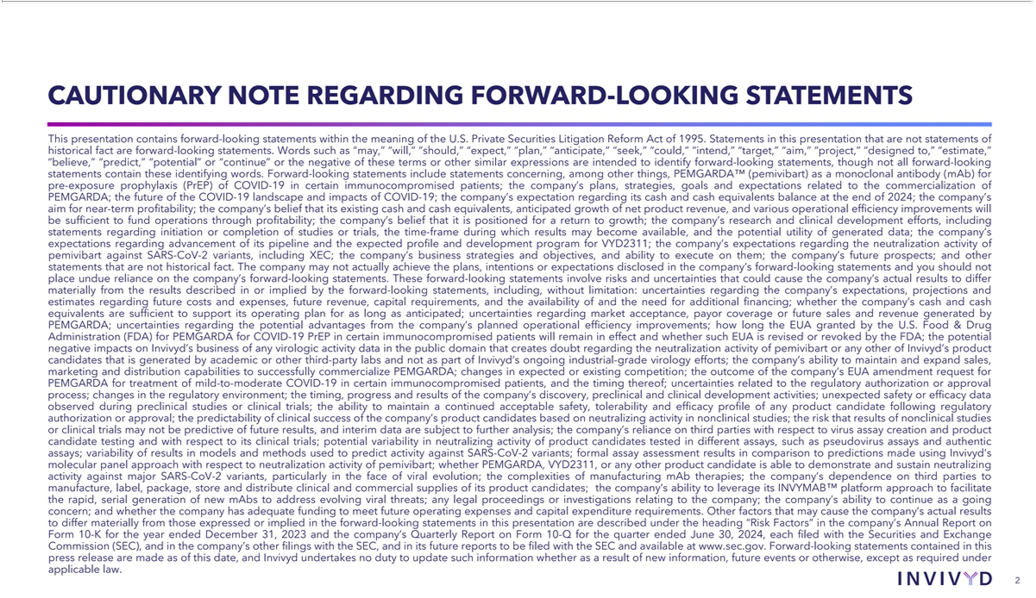

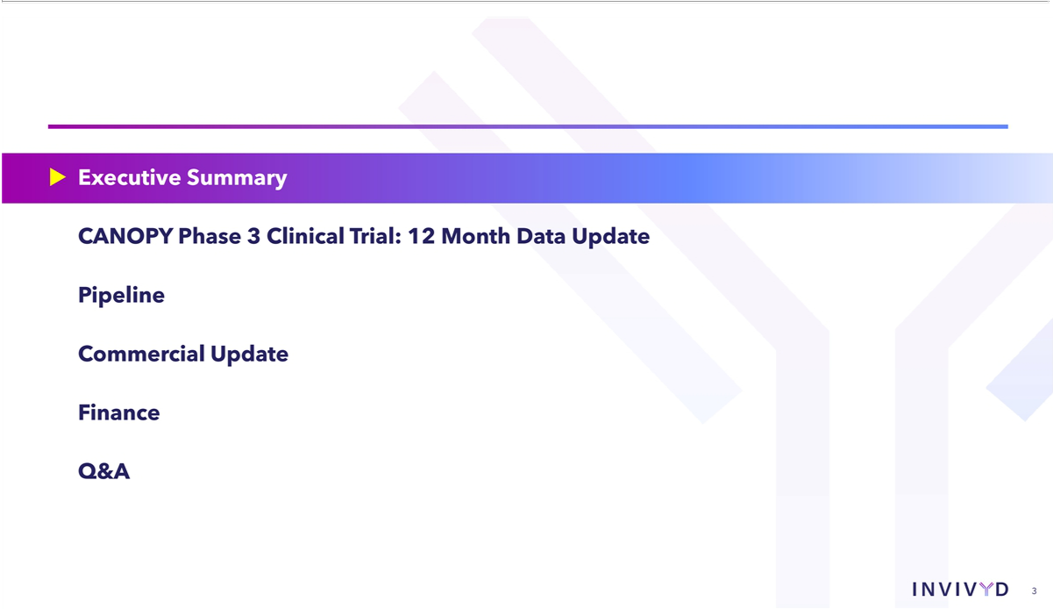

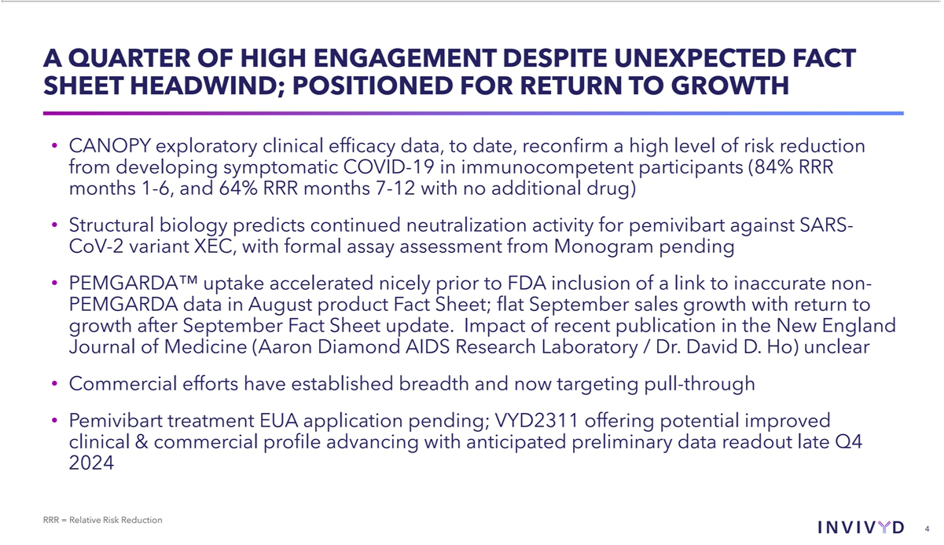

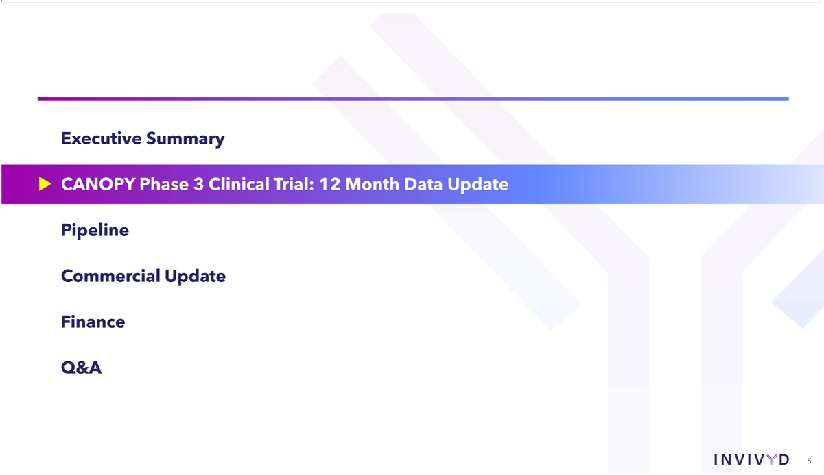

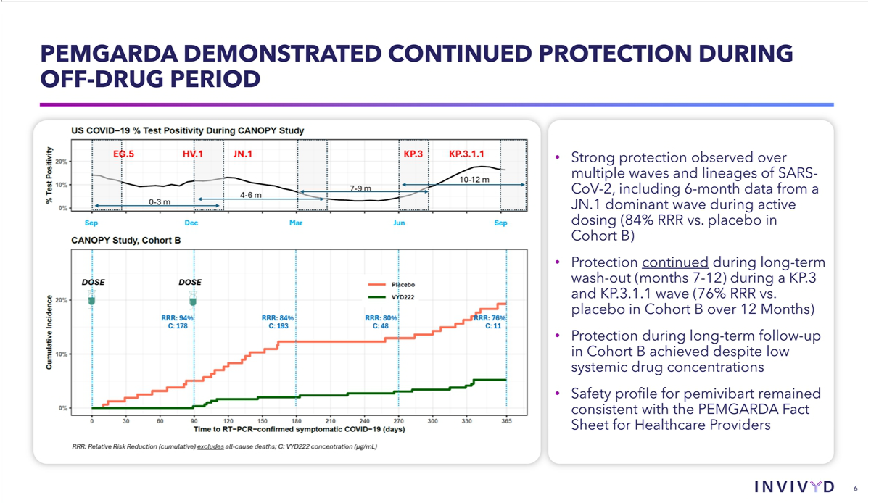

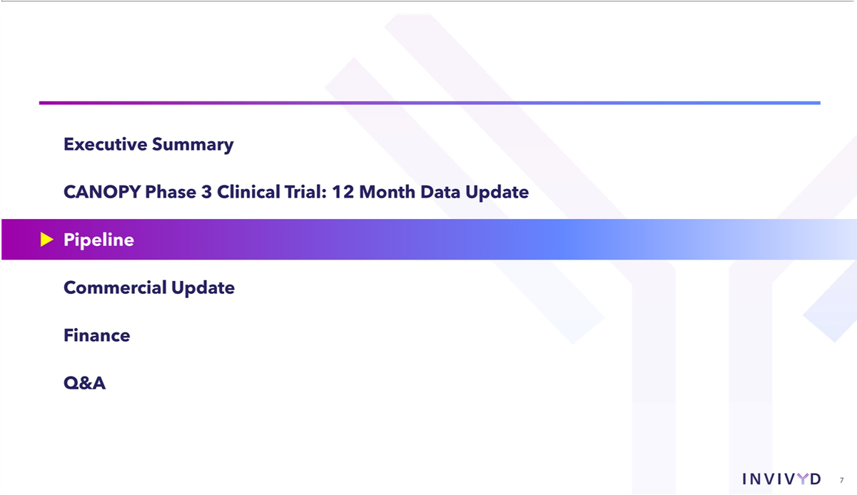

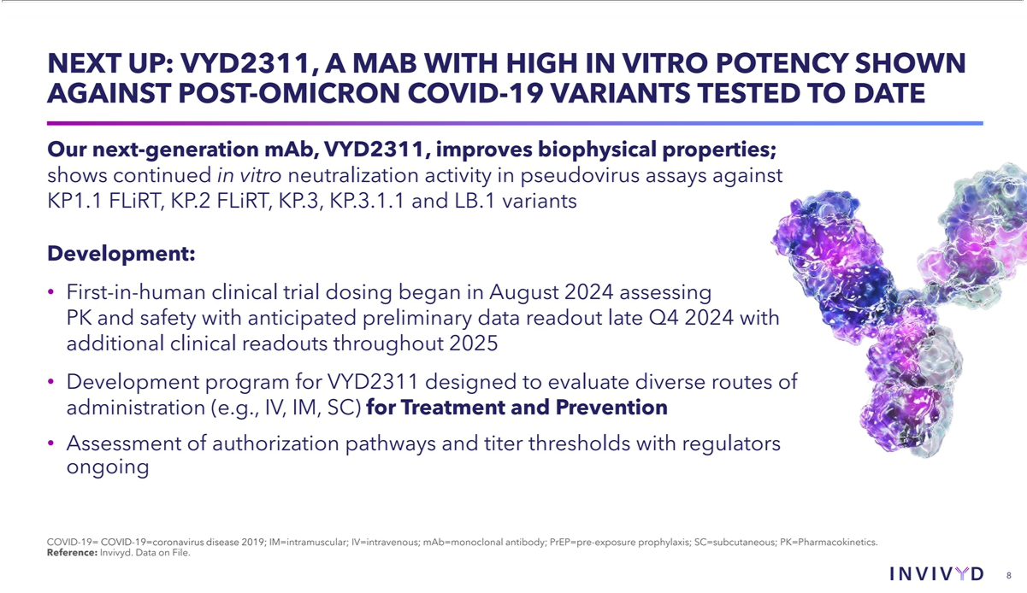

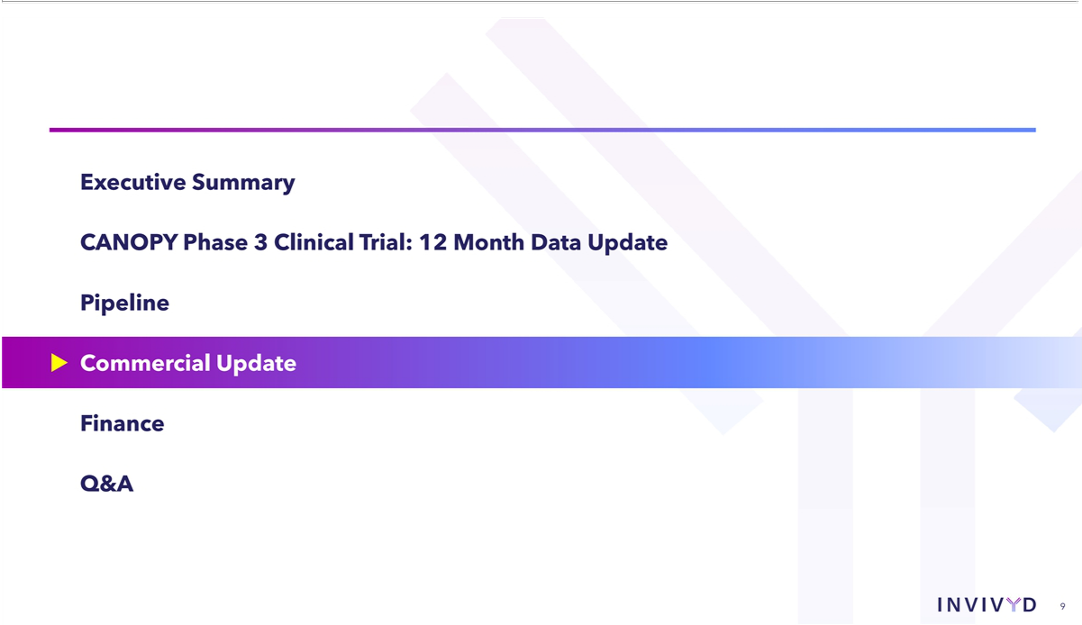

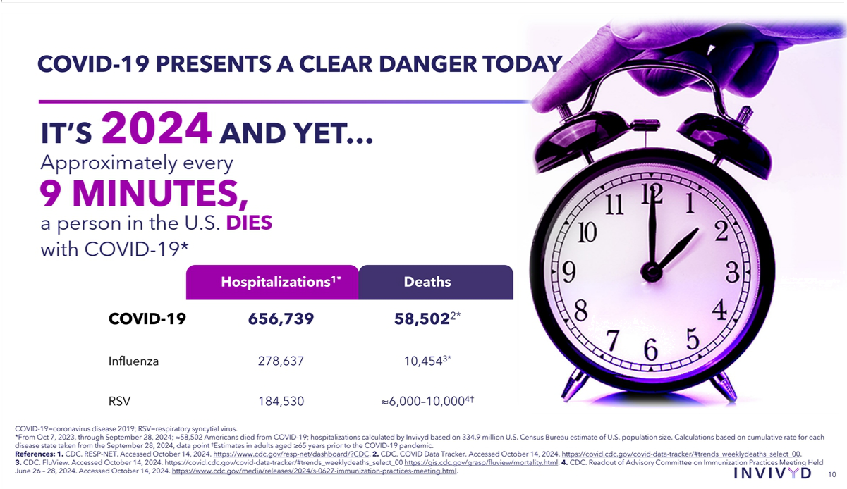

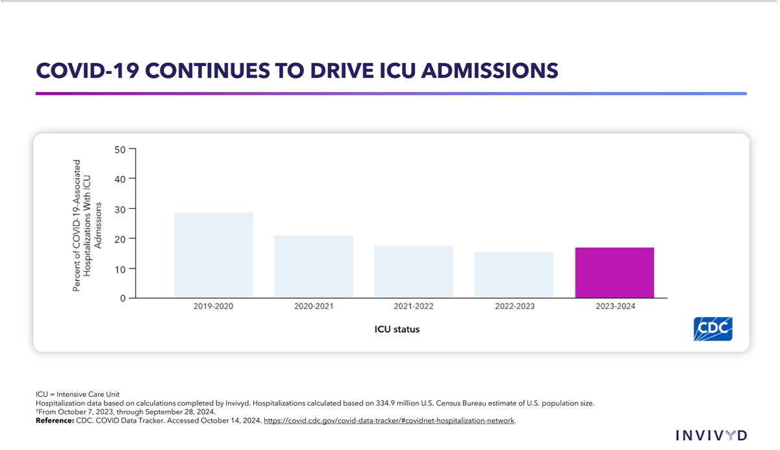

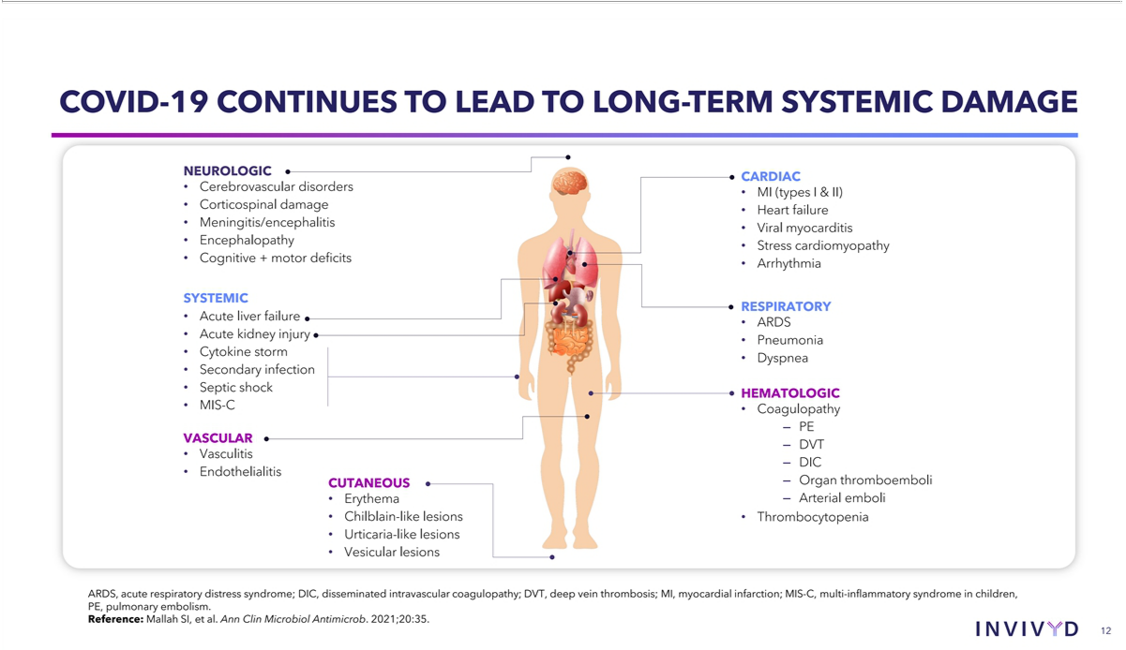

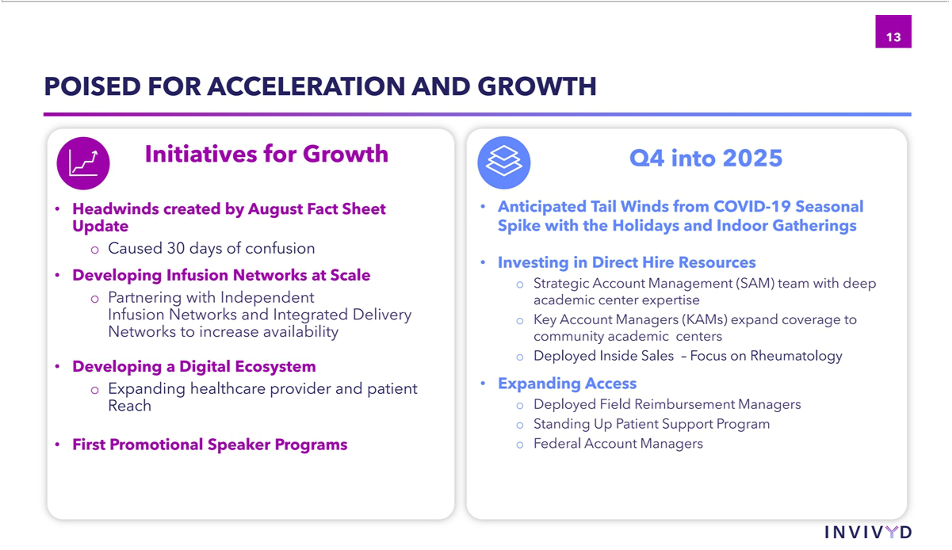

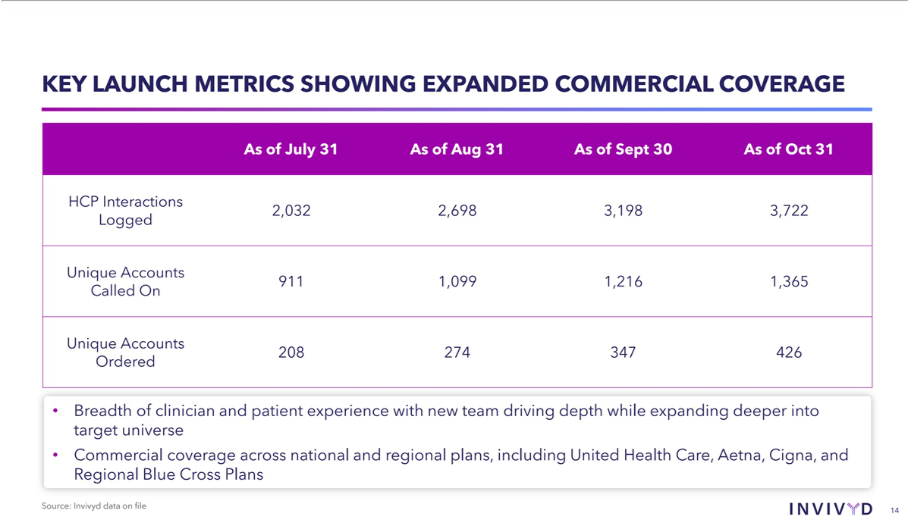

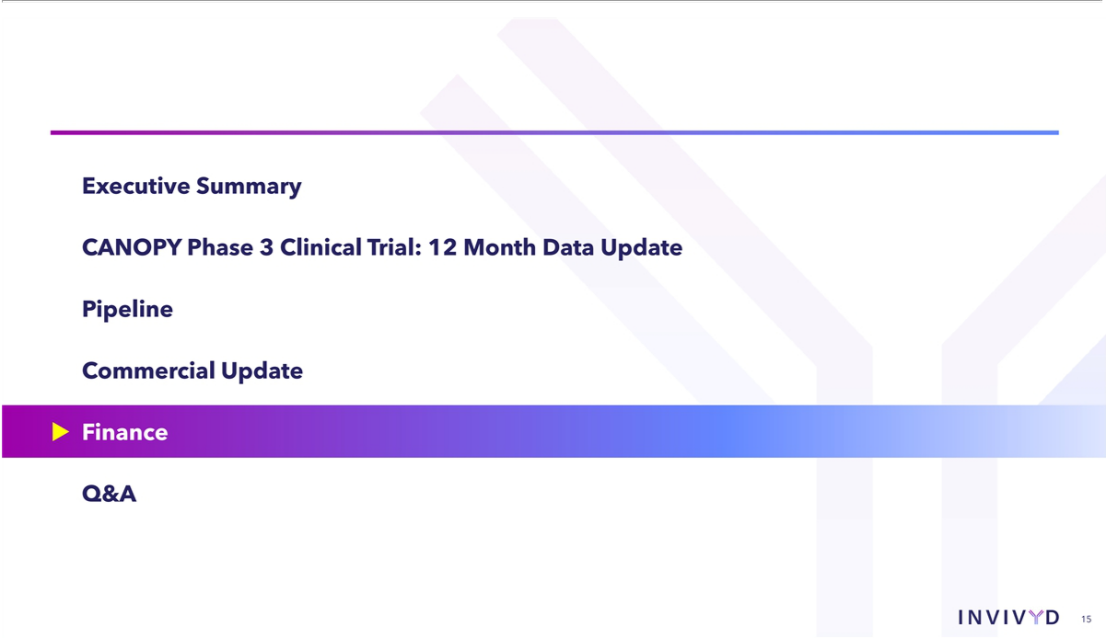

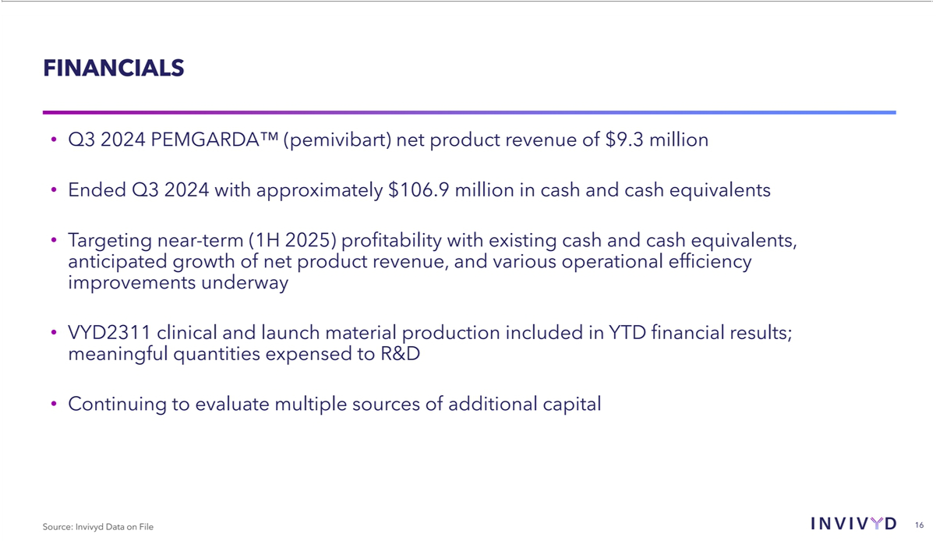

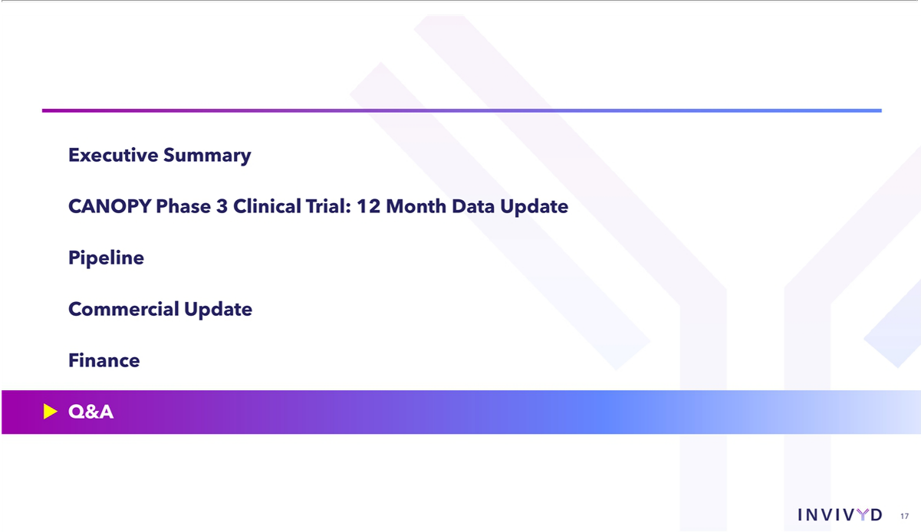

Exhibit 99.3

Invivyd Announces New England Journal of Medicine Publishes Letter to the Editor Highlighting Immunobridging Pathway Leading to PEMGARDA™ (pemivibart) Emergency Use Authorization; Comments on Adjacent Third-Party Letter to the Editor

- The New England Journal of Medicine (NEJM) Letter to the Editor outlines the novel, rapid immunobridging authorization pathway for PEMGARDA and provides an updated correlate of protection curve for monoclonal antibody protection from symptomatic COVID-19

- The updated correlate of protection analysis published in the Letter to the Editor indicates the potential for strong protection from symptomatic COVID-19 at titer levels well below doses explored clinically with pemivibart, consistent with recently disclosed CANOPY exploratory efficacy data, and useful for future drug development

- Company expresses disappointment in NEJM’s publication of a separate Letter to the Editor from a third-party, academic laboratory reflecting outdated, inaccurate virology data produced with “research-grade” “pemivibart”

- PEMGARDA™ (pemivibart) Fact Sheet continues to include accurate data reflecting neutralization activity against KP.3.1.1

WALTHAM, Mass., Nov. 14, 2024 (GLOBE NEWSWIRE) — Invivyd, Inc. (Nasdaq: IVVD), a biopharmaceutical company devoted to delivering protection from serious viral infectious diseases, today announces that The New England Journal of Medicine (NEJM) has published a peer-reviewed Letter to the Editor describing the PEMGARDA™ (pemivibart) immunobridging emergency use authorization (EUA) pathway, as well as an updated correlate of protection (CoP) curve for prevention of symptomatic COVID-19 via recombinant monoclonal antibodies (mAbs) such as pemivibart.

The immunobridging approach highlighted in NEJM draws on pharmacokinetic bioequivalence principles and was designed by the U.S. Food and Drug Administration (FDA) to allow rapid development and authorization of serial, novel mAbs that can protect vulnerable populations from symptomatic COVID-19 amid a rapidly evolving variant landscape. The immunobridging approach established by the FDA for pemivibart development relied on a comparison between the serum virus neutralizing antibody (sVNA) titers of a novel antibody, pemivibart, and the sVNA titer associated with previous clinical protection at a single point in time from a single prototype mAb, in this case, Invivyd’s prior investigational mAb, adintrevimab.

The updated CoP data curve for mAbs also published in the NEJM letter as Figure 1B builds on prior published work¹ and provides a meta-analytic continuous curve describing the quantitative relationship between sVNA titers and clinical protection from symptomatic COVID-19 across multiple mAbs. Such a continuous curve depicts human immunobiology better than binary point estimate immunobridging analysis and resembles the analyses deployed to understand the clinical protection possible from COVID-19 vaccination. This curve in Figure 1B has not been updated to reflect, but generally comports well with, the positive exploratory clinical efficacy data from Invivyd’s CANOPY Phase 3 registrational clinical trial. Inclusive of the emerging CANOPY exploratory clinical efficacy data, the CoP relationship for mAbs against symptomatic COVID-19 now spans years of virus evolution, dozens of variants of concern, and vast quantities of viral variation, unlocking the potential of such an analysis to rapidly develop mAbs that can protect against symptomatic COVID-19 without requiring excess dose to address the clinical uncertainty of viral variation. Invivyd intends to leverage these data in development of next-generation molecule VYD2311, targeting a low dose, intramuscular or subcutaneous scalable, system- and patient-friendly profile that can confer strong protection with attractive safety.

- Stadler E, et al. Monoclonal antibody levels and protection from COVID-19. Nat Commun 2023; 14:4545. Follmann, et al. Examining protective effects of SARS-CoV-2 neutralizing antibodies after vaccination or monoclonal antibody administration. Nat Commun 2023; 14: 3605. Schmidt, et al. Antibody-mediated protection against symptomatic COVID-19 can be achieved at low serum neutralizing titers. Sci Transl Med 2023; 15(688): eadg2783.

“We are pleased that the immunobridging pathway leading to PEMGARDA authorization has been published in one of the highest impact medical journals in clinical medicine, the New England Journal of Medicine,” said Mark Wingertzahn, Ph.D., Senior Vice President of Clinical Development and Medical Affairs. “This approach, borrowed from vaccine development, can provide clinicians and regulators alike with a useful framework for mAbs as we innovate toward rational, scalable, high efficacy medicines that can protect vulnerable populations against COVID-19.”

Dr. Wingertzahn continued, “While we are gratified by the publication of Invivyd’s Letter to the Editor, we are disappointed by today’s publication by NEJM of a separate Letter to the Editor from the Columbia University Aaron Diamond AIDS Research Laboratory / Dr. David D. Ho (Ho Lab) that describes neutralization data of “research-grade” “pemivibart” synthesized at Columbia against KP.3.1.1 (Ho Letter). The data contained in the Ho Letter are highly discordant from the information contained in the FDA-authored PEMGARDA Fact Sheet and can cause confusion for healthcare professionals and their patients who may benefit from PEMGARDA.” The Ho Letter rebroadcasted outdated and inaccurate “research grade” “pemivibart” data that first appeared in the public domain in August 2024 via a preprint posted to BioRxiv (Ho Preprint). These data contend that JN.1 sublineages, notably KP.3.1.1, display substantially reduced susceptibility in vitro to an antibody made in the Ho Lab referred to as “pemivibart.”

A series of events that occurred in the summer of 2024 spark questions about data reflected in the Ho Preprint and Letter. On July 30, 2024, Dr. Ho communicated to Invivyd that he had “an optimized mAb that neutralizes all SARS-CoV-2 with great potency,” bringing to light a conflict of interest. Moreover, on August 13, 2024, an author of the Ho Preprint emailed Invivyd requesting authentic pemivibart so they could perform a side-by-side comparison of the neutralization activities of authentic pemivibart against their version of “pemivibart.” To date, Invivyd has declined requests to share authentic pemivibart with the Ho Lab.

Under protest from Invivyd, reference to the Ho Preprint was added to the PEMGARDA™ Fact Sheet for Healthcare Providers (Fact Sheet) in August 2024. Importantly, upon receipt of the validated pemivibart KP.3.1.1 neutralization data from Labcorp-Monogram Biosciences (Monogram) in September 2024, the FDA removed such references from the PEMGARDA Fact Sheet, added the Monogram data supporting the ongoing potential benefit of PEMGARDA (pemivibart) in the authorized population, and stated that PEMGARDA likely retains adequate neutralization activity against circulating SARS-CoV-2 variants in the U.S. including KP.3.1.1, LB.1, KP.3, and KP.2, which comprise more than 75% of currently circulating variants. The PEMGARDA Fact Sheet continues to accurately reflect the neutralization activity of PEMGARDA (pemivibart) against KP.3.1.1.

The totality of the data, including Invivyd-generated assay data, data generated at a third-party, independent, industrial-grade laboratory, and the previously reported CANOPY trial exploratory clinical efficacy data showing robust reduction of risk of symptomatic COVID-19 compared to placebo observed during a U.S. COVID-19 wave dominated by KP.3 and KP.3.1.1 variants, all favor the validity of the ongoing virology work Invivyd has routinely provided to regulators that underlines the potential clinical benefits of PEMGARDA, as authorized. Importantly, with all this data in hand, the FDA continues to assert in the current PEMGARDA Fact Sheet that based upon the totality of scientific evidence available it is reasonable to believe that PEMGARDA may be effective for pre-exposure prophylaxis of COVID-19 caused by susceptible SARS-CoV-2 variants in the authorized population. As a reminder, Invivyd recently disclosed a proprietary method for interrogating the structural biology of pemivibart activity against emerging virus variants that predicts continued activity against XEC, with formal assay testing at Monogram pending.

About Invivyd

Invivyd, Inc. (Nasdaq: IVVD) is a biopharmaceutical company devoted to delivering protection from serious viral infectious diseases, beginning with SARS-CoV-2. The company’s proprietary INVYMAB™ platform approach combines state-of-the-art viral surveillance and predictive modeling with advanced antibody engineering. INVYMAB is designed to facilitate the rapid, serial generation of new monoclonal antibodies (mAbs) to address evolving viral threats. In March 2024, Invivyd received emergency use authorization (EUA) from the U.S. FDA for its first mAb in a planned series of innovative antibody candidates. Visit https://invivyd.com/ to learn more.

About PEMGARDA

PEMGARDA™ (pemivibart) is a half-life extended investigational monoclonal antibody (mAb). PEMGARDA was engineered from adintrevimab, Invivyd’s investigational mAb that has a robust safety data package and provided evidence of clinical efficacy in a global Phase 2/3 clinical trial for the prevention and treatment of COVID-19. PEMGARDA has demonstrated in vitro neutralizing activity against major SARS-CoV-2 variants, including JN.1, KP.3, KP.3.1.1 and LB.1. PEMGARDA targets the SARS-CoV-2 spike protein receptor binding domain (RBD), thereby inhibiting virus attachment to the human ACE2 receptor on host cells.

PEMGARDA (pemivibart) injection (4500 mg), for intravenous use is an investigational mAb that has not been approved, but has been authorized for emergency use by the U.S. FDA under an EUA for the pre-exposure prophylaxis (prevention) of COVID-19 in adults and adolescents (12 years of age and older weighing at least 40 kg) who have moderate-to-severe immune compromise due to certain medical conditions or receipt of certain immunosuppressive medications or treatments and are unlikely to mount an adequate immune response to COVID-19 vaccination. Recipients should not be currently infected with or have had a known recent exposure to an individual infected with SARS-CoV-2.

PEMGARDA is not authorized for use for treatment of COVID-19 or post-exposure prophylaxis of COVID-19. Pre-exposure prophylaxis with PEMGARDA is not a substitute for vaccination in individuals for whom COVID-19 vaccination is recommended. Individuals for whom COVID-19 vaccination is recommended, including individuals with moderate-to-severe immune compromise who may derive benefit from COVID-19 vaccinations, should receive COVID-19 vaccination. In individuals who have recently received a COVID-19 vaccine, PEMGARDA should be administered at least 2 weeks after vaccination.

Anaphylaxis has been observed with PEMGARDA and the PEMGARDA Fact Sheet for Healthcare Providers includes a boxed warning for anaphylaxis. The most common adverse events (all grades, incidence ≥2%) observed in participants who have moderate-to-severe immune compromise treated with PEMGARDA included systemic and local infusion-related or hypersensitivity reactions, upper respiratory tract infection, viral infection, influenza-like illness, fatigue, headache, and nausea. For additional information, please see the PEMGARDA full product Fact Sheet for Healthcare Providers, including important safety information and boxed warning.

To support the EUA for PEMGARDA, an immunobridging approach was used to determine if PEMGARDA may be effective for pre-exposure prophylaxis of COVID-19. Immunobridging is based on the serum virus neutralizing titer-efficacy relationships identified with other neutralizing human mAbs against SARS-CoV-2. This includes adintrevimab, the parent mAb of pemivibart, and other mAbs that were previously authorized for EUA. There are limitations of the data supporting the benefits of PEMGARDA. Evidence of clinical efficacy for other neutralizing human mAbs against SARS-CoV-2 was based on different populations and SARS-CoV-2 variants that are no longer circulating. Further, the variability associated with cell-based EC50 value determinations, along with limitations related to pharmacokinetic data and efficacy estimates for the mAbs in prior clinical trials, impact the ability to precisely estimate protective titer ranges. Additionally, certain SARS-CoV-2 viral variants may emerge that have substantially reduced susceptibility to PEMGARDA, and PEMGARDA may not be effective at preventing COVID-19 caused by these SARS-CoV-2 viral variants.

The emergency use of PEMGARDA is only authorized for the duration of the declaration that circumstances exist justifying the authorization of the emergency use of drugs and biological products during the COVID-19 pandemic under Section 564(b)(1) of the Federal Food, Drug, and Cosmetic Act, 21 U.S.C. § 360bbb-3(b)(1), unless the declaration is terminated or authorization revoked sooner. PEMGARDA is authorized for use only when the combined national frequency of variants with substantially reduced susceptibility to PEMGARDA is less than or equal to 90%, based on available information including variant susceptibility to PEMGARDA and national variant frequencies.

About CANOPY

The ongoing CANOPY Phase 3 clinical trial is designed to evaluate the safety and tolerability of pemivibart and to assess immunobridging from pemivibart to certain historical data from the company’s previous Phase 2/3 clinical trial of adintrevimab (ADG20) for the prevention of symptomatic COVID-19 (EVADE). Additionally, there are pre-specified exploratory endpoints through three, six and twelve months to evaluate clinical efficacy of pemivibart compared to placebo in the prevention of RT-PCR-confirmed symptomatic COVID-19. The latest analysis from the Phase 3 CANOPY clinical trial includes 365-day data. The CANOPY clinical trial enrolled participants in two cohorts: Cohort A is a single-arm, open-label trial in adults who have moderate-to-severe immune compromise including complex underlying medical conditions. Cohort B is a randomized, placebo-controlled cohort that enrolled adults without moderate-to-severe immune compromise who are at risk of acquiring COVID-19 due to regular unmasked face-to-face interactions in indoor settings.

Cautionary Note Regarding Forward Looking Statements

This press release contains forward-looking statements within the meaning of the Private Securities Litigation Reform Act of 1995. Words such as “anticipates,” “believes,” “could,” “expects,” “estimates,” “intends,” “potential,” “predicts,” “projects,” and “future” or similar expressions (as well as other words or expressions referencing future events, conditions or circumstances) are intended to identify forward-looking statements. Forward-looking statements include statements concerning, among other things, the company’s ongoing research and clinical development activities, as well as future potential research and clinical development efforts; the potential implications of a correlate of protection curve for COVID-19 mAb development, and the company’s intention to leverage these data in the development of VYD2311, targeting a low dose, intramuscular or subcutaneous scalable, system-and patient-friendly profile that can confer strong protection with attractive safety; the potential of an immunobridging approach to provide clinicians and regulators a useful framework as the company innovates toward rational, scalable, high efficacy medicines that can protect vulnerable populations against COVID-19; the potential for strong protection from symptomatic COVID-19 at titer levels well below doses explored clinically with pemivibart; expectations regarding the neutralization activity of pemivibart against SARS-CoV-2 variants, including XEC; the potential of PEMGARDA as a mAb for pre-exposure prophylaxis (prevention) of COVID-19 in certain adults and adolescents who have moderate-to-severe immune compromise; the company’s devotion to delivering protection from serious viral infectious diseases, beginning with SARS-CoV-2; the design of the company’s INVYMAB platform approach to facilitate the rapid, serial generation of new mAbs to address evolving viral threats; the company’s plans for a series of innovative antibody candidates; and other statements that are not historical fact. The company may not actually achieve the plans, intentions or expectations disclosed in the company’s forward-looking statements and you should not place undue reliance on the company’s forward-looking statements. These forward-looking statements involve risks and uncertainties that could cause the company’s actual results to differ materially from the results described in or implied by the forward-looking statements, including, without limitation: the timing, progress and results of the company’s discovery, preclinical and clinical development activities; the risk that results of nonclinical studies or clinical trials may not be predictive of future results, and interim data are subject to further analysis; unexpected safety or efficacy data observed during preclinical studies or clinical trials; the predictability of clinical success of the company’s product candidates based on neutralizing activity in nonclinical studies; potential variability in neutralizing activity of product candidates tested in different assays, such as pseudovirus assays and authentic assays; the company’s reliance on third parties with respect to virus assay creation and product candidate testing and with respect to its clinical trials; variability of results in models and methods used to predict activity against SARS-CoV-2 variants; formal assay assessment results in comparison to predictions made using Invivyd’s molecular panel approach with respect to neutralization activity of pemivibart; whether pemivibart, VYD2311 or any other product candidate is able to demonstrate and sustain neutralizing activity against major SARS-CoV-2 variants, particularly in the face of viral evolution; how long the EUA granted by the FDA for PEMGARDA will remain in effect and whether the EUA is revised or revoked by the FDA; the potential negative impacts on Invivyd’s business of any virologic activity data in the public domain that creates doubt regarding the neutralization activity of pemivibart or any other of Invivyd’s product candidates that is generated by academic or other third-party labs and not as part of Invivyd’s ongoing industrial-grade virology efforts; uncertainties related to the regulatory authorization or approval process, and available development and regulatory pathways for authorization or approval of the company’s product candidates; the ability to maintain a continued acceptable safety, tolerability and efficacy profile of any product candidate following regulatory authorization or approval; changes in the regulatory environment; changes in expected or existing competition; the complexities of manufacturing mAb therapies; the company’s ability to leverage its INVYMAB platform approach to facilitate the rapid, serial generation of new mAbs to address evolving viral threats; any legal proceedings or investigations relating to the company; the company’s ability to continue as a going concern; and whether the company has adequate funding to meet future operating expenses and capital expenditure requirements. Other factors that may cause the company’s actual results to differ materially from those expressed or implied in the forward-looking statements in this press release are described under the heading “Risk Factors” in the company’s Annual Report on Form 10-K for the year ended December 31, 2023 and the company’s Quarterly Report on Form 10-Q for the quarter ended June 30, 2024, each filed with the Securities and Exchange Commission (SEC), and in the company’s other filings with the SEC, and in its future reports to be filed with the SEC and available at www.sec.gov. Forward-looking statements contained in this press release are made as of this date, and Invivyd undertakes no duty to update such information whether as a result of new information, future events or otherwise, except as required under applicable law.

This press release contains hyperlinks to information that is not deemed to be incorporated by reference in this press release.

Contacts:

Media Relations

- 208-1747 media@invivyd.com

Investor Relations

- 208-1747 investors@invivyd.com

