UNITED STATES
SECURITIES AND EXCHANGE COMMISSION
Washington, D.C. 20549
SCHEDULE 14A
Proxy Statement Pursuant to Section 14(a) of
the Securities Exchange Act of 1934
Filed by the Registrant ☒
Filed by a Party other than the Registrant ☐
Check the appropriate box:
☐ Preliminary Proxy Statement
☐ Confidential, for Use of the Commission Only (as permitted by Rule 14a-6(e)(2))
☐ Definitive Proxy Statement
☒ Definitive Additional Materials
☐ Soliciting Material Pursuant to §240.14a-12
Invivyd, Inc.
(Name of Registrant as Specified In Its Charter)

(Name of Person(s) Filing Proxy Statement, if other than the Registrant)
Payment of Filing Fee (Check all boxes that apply):
☒ No fee required
☐ Fee paid previously with preliminary materials
☐ Fee computed on table in exhibit required by Item 25(b) per Exchange Act Rules 14a-6(i)(1) and 0-11

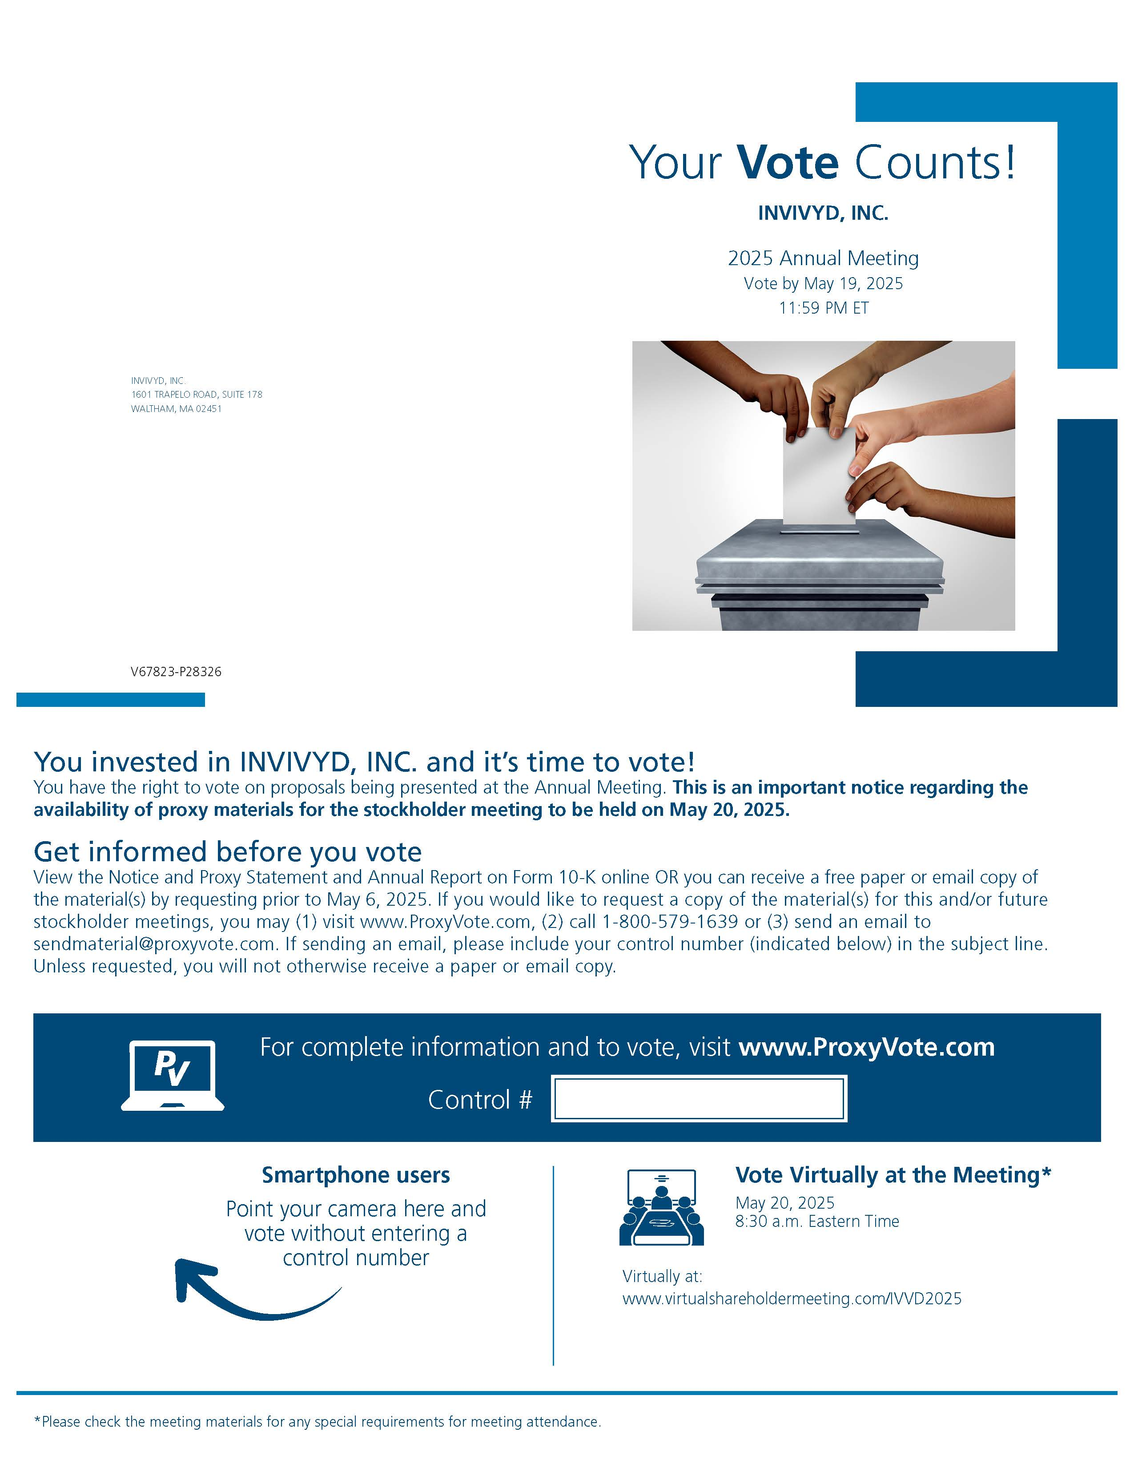
INVIVYD, INC. 1601 TRAPELO ROAD, SUITE 178 WALTHAM, MA 02451 Your Vote Counts! INVIVYD, INC. 2025 Annual Meeting Vote by May 19, 2025 11:59 PM ET V67823-P28326 You invested in INVIVYD, INC. and it’s time to vote! You have the right to vote on proposals being presented at the Annual Meeting. This is an important notice regarding the availability of proxy materials for the stockholder meeting to be held on May 20, 2025. Get informed before you vote View the Notice and Proxy Statement and Annual Report on Form 10-K online OR you can receive a free paper or email copy of the material(s) by requesting prior to May 6, 2025. If you would like to request a copy of the material(s) for this and/or future stockholder meetings, you may (1) visit www.ProxyVote.com, (2) call 1-800-579-1639 or (3) send an email to sendmaterial@proxyvote.com. If sending an email, please include your control number (indicated below) in the subject line. Unless requested, you will not otherwise receive a paper or email copy. For complete information and to vote, visit www.ProxyVote.com Control # Smartphone users Point your camera here and vote without entering a control number Vote Virtually at the Meeting* May 20, 2025 8:30 a.m. Eastern Time Virtually at: www.virtualshareholdermeeting.com/IVVD2025 *Please check the meeting materials for any special requirements for meeting attendance.

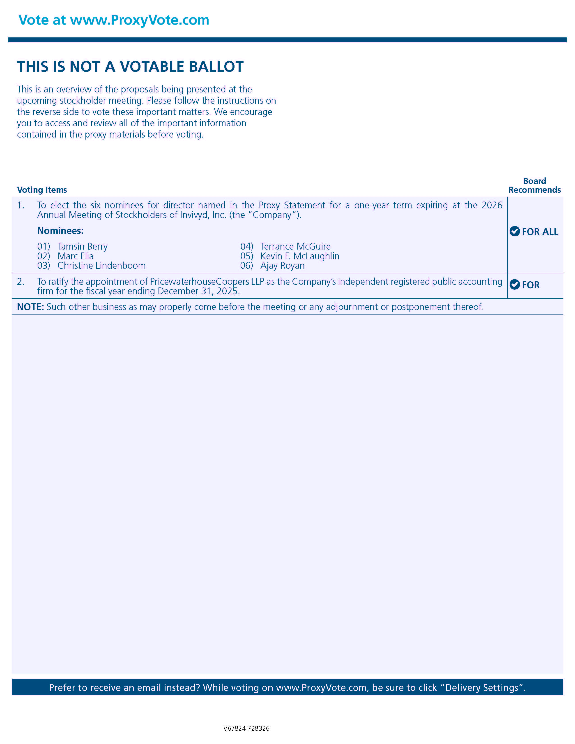
Vote at www.ProxyVote.com THIS IS NOT A VOTABLE BALLOT This is an overview of the proposals being presented at the upcoming stockholder meeting. Please follow the instructions on the reverse side to vote these important matters. We encourage you to access and review all of the important information contained in the proxy materials before voting. Voting Items Board Recommends 1. To elect the six nominees for director named in the Proxy Statement for a one-year term expiring at the 2026 Annual Meeting of Stockholders of Invivyd, Inc. (the “Company”). Nominees: 01) Tamsin Berry 02) Marc Elia 03) Christine Lindenboom 04) Terrance McGuire 05) Kevin F. McLaughlin 06) Ajay Royan FOR ALL 2. To ratify the appointment of PricewaterhouseCoopers LLP as the Company’s independent registered public accounting firm for the fiscal year ending December 31, 2025. FOR NOTE: Such other business as may properly come before the meeting or any adjournment or postponement thereof. Prefer to receive an email instead? While voting on www.ProxyVote.com, be sure to click “Delivery Settings” V67824-P28326

