UNITED STATES

SECURITIES AND EXCHANGE COMMISSION
Washington, D.C. 20549

SCHEDULE 14A

Proxy Statement Pursuant to Section 14(a) of the
Securities Exchange Act of 1934

Filed by the Registrant ☒

Filed by a Party other than the Registrant ☐

Check the appropriate box:

- Preliminary Proxy Statement

- Confidential, for Use of the Commission Only (as permitted by Rule 14a-6(e)(2))

- Definitive Proxy Statement

- Definitive Additional Materials

- Soliciting Material under §240.14a-12

INVIVYD, INC.

(Name of Registrant as Specified in its Charter)

(Name of Person(s) Filing Proxy Statement, if Other Than the Registrant)

Payment of Filing Fee (Check all boxes that apply):

- No fee required

- Fee paid previously with preliminary materials

- Fee computed on table in exhibit required by Item 25(b) per Exchange Act Rules 14a-6(i)(1) and 0-11


Your Vote Counts!

INVIVYD, INC.

2023 Annual Meeting

Vote by May 22, 2023
11:59 PM ET



INVIVYD, INC.
1601 TRAPELO ROAD, SUITE 178
WALTHAM, MA 02451


V07272-P87524


You invested in INVIVYD, INC. and it’s time to vote!

You have the right to vote on proposals being presented at the Annual Meeting. This is an important notice regarding the availability of proxy materials for the stockholder meeting to be held on May 23, 2023.

Get informed before you vote

View the Notice and Proxy Statement and Annual Report on Form 10-K online OR you can receive a free paper or email copy of the material(s) by requesting prior to May 9, 2023. If you would like to request a copy of the material(s) for this and/or future stockholder meetings, you may (1) visit www.ProxyVote.com, (2) call 1-800-579-1639 or (3) send an email to sendmaterial@proxyvote.com. If sending an email, please include your control number (indicated below) in the subject line. Unless requested, you will not otherwise receive a paper or email copy.
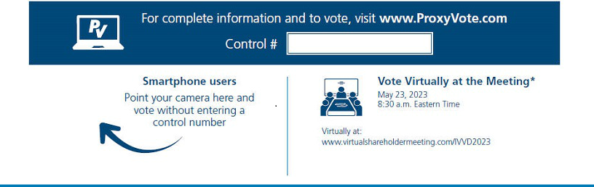

* Please check the meeting materials for any special requirements for meeting attendance.

V1.1

Vote at www.ProxyVote.com

THIS IS NOT A VOTABLE BALLOT

This is an overview of the proposals being presented at the

upcoming stockholder meeting. Please follow the instructions on the

reverse side to vote these important matters. We encourage you to

access and review all of the important information contained in the

proxy materials before voting.

Voting Items |  |  | Board
 |  |  | Recommends
1. | To approve an amendment to the Amended and Restated Certificate of Incorporation of Invivyd, Inc. (the “Company”) to
 | (i) declassify the Company’s Board of Directors and provide for the annual election of all directors and (ii) provide that
 | directors of the Company may be removed with or without cause by the affirmative vote of the holders of at least a majority |  | FOR
 | of the voting power of all then-outstanding shares of capital stock of the Company entitled to vote generally at an election of
 | directors (the “Declassification Amendment”).
2. | To elect the two nominees for director named in the Proxy Statement for a three-year term expiring at the 2026 Annual
 | Meeting of Stockholders (provided, that if the Declassification Amendment is approved and implemented, the terms of such
 | directors will expire at the 2024 Annual Meeting of Stockholders). |  | FOR ALL
 | Nominees: |  | FOR ALL
 | 01) | Christine Lindenboom
 | 02) | Terrance McGuire
3. | To ratify the appointment of PricewaterhouseCoopers LLP as the Company’s independent registered public accounting firm |  | FOR
 | for the fiscal year ending December 31, 2023. |  | FOR
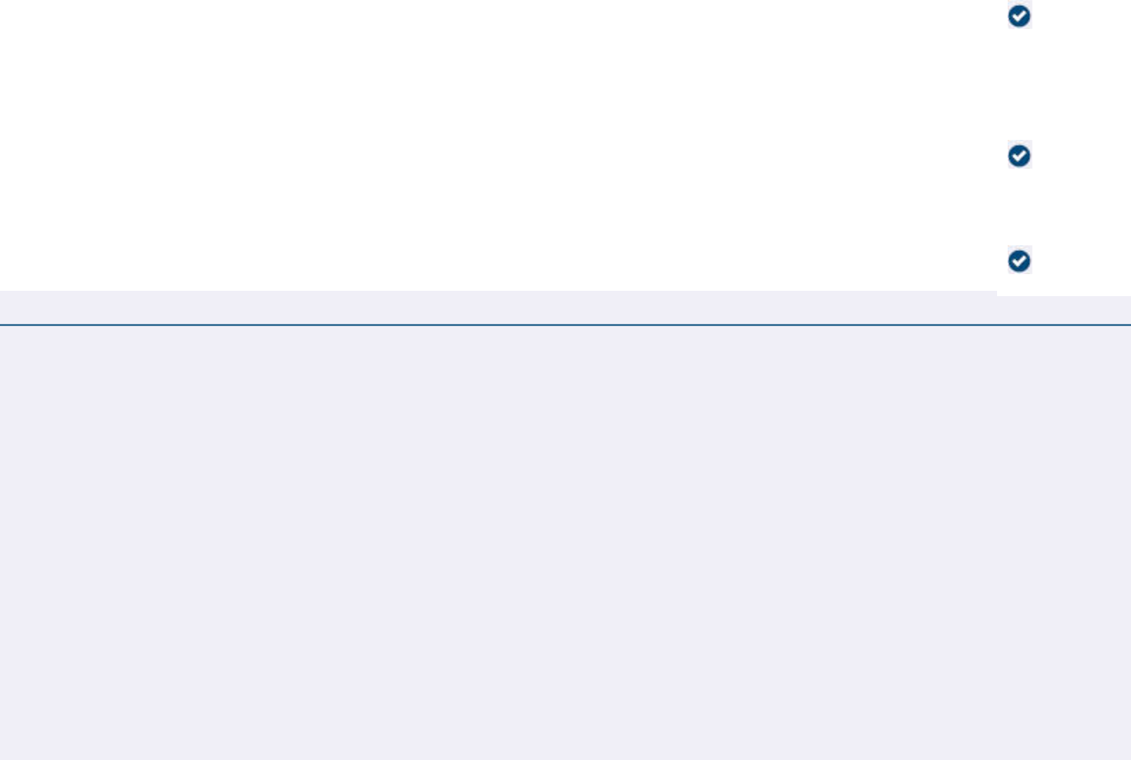
NOTE: Such other business as may properly come before the meeting or any adjournment or postponement thereof.

Prefer to receive an email instead? While voting on www.ProxyVote.com, be sure to click “Delivery Settings”.

V07273-P87524

