UNITED STATES
SECURITIES AND EXCHANGE COMMISSION
WASHINGTON, D.C. 20549

FORM 8-K

CURRENT REPORT
Pursuant to Section 13 or 15(d)
of the Securities Exchange Act of 1934
Date of report (Date of earliest event reported): March 22, 2024

Invivyd, Inc.
(Exact Name of Registrant as Specified in its Charter)

Delaware |  | 001-40703 |  | 85-1403134
(State or Other Jurisdiction  of Incorporation) |  | (Commission  File Number) |  | (IRS Employer  Identification No.)

1601 Trapelo Road, Suite 178  Waltham, MA |  | 02451
(Address of Principal Executive Offices) |  | (Zip Code)
Registrant’s telephone number, including area code: (781) 819-0080
Not applicable
(Former Name or Former Address, if Changed Since Last Report)

Check the appropriate box below if the Form 8-K filing is intended to simultaneously satisfy the filing obligation of the registrant under any of the following provisions:

☐ | Written communications pursuant to Rule 425 under the Securities Act (17 CFR 230.425)

☐ | Soliciting material pursuant to Rule 14a-12 under the Exchange Act (17 CFR 240.14a-12)

☐ | Pre-commencement communications pursuant to Rule 14d-2(b) under the Exchange Act (17 CFR 240.14d-2(b))

☐ | Pre-commencement communications pursuant to Rule 13e-4(c) under the Exchange Act (17 CFR 240.13e-4(c))
Securities registered pursuant to Section 12(b) of the Act:

Title of each class |  | Trading  Symbol(s) |  | Name of each exchange  on which registered
Common stock, par value $0.0001 per share |  | IVVD |  | The Nasdaq Stock Market LLC
Indicate by check mark whether the registrant is an emerging growth company as defined in Rule 405 of the Securities Act of 1933 (§230.405 of this chapter) or Rule 12b-2 of the Securities Exchange Act of 1934 (§240.12b-2 of this chapter).
Emerging growth company ☒
If an emerging growth company, indicate by check mark if the registrant has elected not to use the extended transition period for complying with any new or revised financial accounting standards provided pursuant to Section 13(a) of the Exchange Act. ☐

Item 2.02. | Results of Operations and Financial Condition.
On March 22, 2024, Invivyd, Inc. (the “Company”) issued a press release entitled “Invivyd Announces FDA Authorization for Emergency Use of PEMGARDA™ (Formerly VYD222) for Pre-exposure Prophylaxis (PrEP) of COVID-19” (the “Press Release”), which included the Company’s estimated cash and cash equivalents as of December 31, 2023. The amounts included in the Press Release are preliminary, have not been audited and are subject to change upon completion of the Company’s audited financial statements for the year ended December 31, 2023. Additional information and disclosures would be required for a more complete understanding of the Company’s financial position and results of operations as of December 31, 2023. A copy of the Press Release is filed herewith as Exhibit 99.1 and is incorporated by reference in this Item 2.02.

Item 8.01. | Other Events.
On March 22, 2024, the Company issued the Press Release, a copy of which is filed herewith as Exhibit 99.1 and is incorporated by reference in this Item 8.01.
On March 22, 2024, the Company issued a press release entitled “Invivyd Announces Interim Exploratory Data on VYD222 from Ongoing CANOPY Clinical Trial.” A copy of the press release is filed herewith as Exhibit 99.2 and is incorporated by reference in this Item 8.01.
On March 22, 2024, the Company posted an updated corporate presentation on its website at www.invivyd.com. A copy of the presentation is filed herewith as Exhibit 99.3 and is incorporated by reference in this Item 8.01.

Item 9.01. | Financial Statements and Exhibits.
(d) Exhibits

Exhibit  No. |  | Description
99.1 |  | Press Release, dated March 22, 2024
99.2 |  | Press Release, dated March 22, 2024
99.3 |  | Corporate Presentation, dated March 22, 2024
104 |  | Cover Page Interactive Data File (embedded within the Inline XBRL document)

SIGNATURES
Pursuant to the requirements of the Securities Exchange Act of 1934, as amended, the registrant has duly caused this report to be signed on its behalf by the undersigned hereunto duly authorized.

 |  |  |  | INVIVYD, INC.
Date: March 22, 2024 |  |  |  | By: |  | /s/ Jill Andersen
 |  |  |  |  |  | Jill Andersen
 |  |  |  |  |  | Chief Legal Officer and Corporate Secretary
Exhibit 99.1

Invivyd Announces FDA Authorization for Emergency Use of PEMGARDA (Formerly VYD222) for Pre-exposure Prophylaxis (PrEP) of COVID-19

 |  |  | PEMGARDA (pemivibart) is authorized in the U.S. for PrEP of COVID-19 in certain adults and adolescents with moderate-to-severe immune compromise

 |  |  | Emergency use authorization based on positive immunobridging data and on safety data from the CANOPY clinical trial along with ongoing in vitro neutralizing activity against major SARS-CoV-2 variants, including JN.1

 |  |  | PEMGARDA is the first PrEP monoclonal antibody (mAb) to receive EUA from the U.S. FDA based on a novel, rapid, repeatable immunobridging trial design

 |  |  | PEMGARDA is the first authorized mAb from Invivyds novel technology platform approach designed to address the challenge of rapid viral evolution

 |  |  | Product availability in the U.S. anticipated imminently

 |  |  | Estimated cash and cash equivalents of $200.6 million as of December 31, 2023

 |  |  | In February 2024, the Company sold shares totaling $40.5 million in gross proceeds under its At-the-Market facility further strengthening its balance sheet ahead of PEMGARDA launch

 |  |  | Conference call today at 4pm ET to discuss the EUA and commercial launch of PEMGARDA
WALTHAM, Mass., March 22, 2024 (GLOBE NEWSWIRE)  Invivyd, Inc. (Nasdaq: IVVD), a biopharmaceutical company on a mission to protect the vulnerable from serious viral infectious diseases, today announced that PEMGARDA (pemivibart), formerly VYD222, a half-life extended monoclonal antibody (mAb), has received emergency use authorization (EUA) from the U.S. Food and Drug Administration (FDA) for the pre-exposure prophylaxis (prevention) of COVID-19 in adults and adolescents (12 years of age and older weighing at least 40 kg) who have moderate-to-severe immune compromise due to certain medical conditions or receipt of certain immunosuppressive medications or treatments and are unlikely to mount an adequate immune response to COVID-19 vaccination. Recipients should not be currently infected with or have had a known recent exposure to an individual infected with SARS-CoV-2.
The PEMGARDA EUA marks a transformational moment for Invivyd and for the many moderately to severely immunocompromised people who are vulnerable to COVID-19 disease in the U.S. This EUA milestone represents strategic proof-of-concept for our company and platform, affirming the unique strategy we embarked on over a year ago: to use rapid innovation and surrogate markers to bring new antibodies to market repeatedly, said Dave Hering, Chief Executive Officer of Invivyd. PEMGARDA is the first authorized monoclonal antibody from our proprietary platform approach. We are committed to ongoing process improvement while working with global regulatory agencies with the aim to increase the speed and efficiency of new mAb candidate development even further. Additionally, we are planning to explore the protective clinical benefits of mAb prophylaxis for symptomatic COVID-19 disease in future studies.
Mr. Hering added, We are proud that roughly one year after initiating the Phase 1 trial of our mAb now known as PEMGARDA, we are expecting to have product available for order imminently, with initial supply already packaged and awaiting final release at our U.S.-based third-party logistics provider. Im

deeply grateful to our dedicated team members who made this achievement possible and everyone else who has supported our work, especially our clinical trial participants and investigators. Finally, we also appreciate the continuous engagement from the FDA as they have worked with urgency to make this medicine available to populations in serious need.
People who are immunocompromised continue to be disproportionally impacted by COVID-19 even after receiving multiple vaccine doses, said Cameron R. Wolfe, M.B.B.S., M.P.H., Professor of Medicine, Transplant Infectious Disease at Duke University School of Medicine. Im excited to have PEMGARDA as an additional COVID-19 preventive option for moderately to severely immunocompromised adult and adolescent patients, such as solid organ transplant recipients and those with hematological malignancies. These types of patients, among others, continue to have both an impaired response to vaccines and a higher risk for severe COVID-19 outcomes.
COVID-19 continues to pose a significant threat and major concern to those who are moderately to severely immunocompromised, said Jorey Berry, President and CEO of the Immune Deficiency Foundation and a steering committee member of the Immunocompromised Collaborative. As such, we are delighted that a new monoclonal antibody for pre-exposure prophylaxis of COVID-19 will be available soon for certain vulnerable populations.
Multiple medical conditions or treatments may result in moderate-to-severe immune compromise and an impaired immune response to COVID-19 vaccination including, for example, hematologic malignancies (blood cancers) or treatment with immunosuppressive therapy after a solid organ or stem cell transplant.1 Observational studies have demonstrated that people with immune dysfunction have a higher risk of COVID-19-related hospitalization and death, despite vaccination, than the general population.2-3
The EUA of PEMGARDA is based on the totality of scientific evidence available, such as data showing that immunobridging was established in the CANOPY clinical trial and that the calculated serum neutralizing antibody titers against JN.1 were consistent with the titer levels associated with efficacy in prior clinical trials of adintrevimab (ADG20), the parent mAb for VYD222, and other monoclonal antibody products. JN.1 is currently the dominant variant circulating in the U.S. according to estimates from the Centers for Disease Control and Prevention (CDC).4 PEMGARDA (pemivibart) (4500 mg) is administered as an intravenous (IV) infusion.
PEMGARDA is Invivyds first authorized mAb and the first mAb to receive EUA based on a rapid immunobridging trial design that is expected to be repeatable to help address the need to mitigate ongoing viral evolution. It was developed using INVYMABTM, the companys platform approach which combines state-of-the-art viral surveillance and predictive modeling with advanced antibody engineering. INVYMAB is designed to enable the rapid, serial generation of durable mAbs targeting conserved epitopes that could be deployed to keep pace with SARS-CoV-2 viral evolution or other viral threats. With a commitment to serial innovation, Invivyd aims to ensure that vulnerable populations, such as immunocompromised people, have continuous access to innovative antibody therapies.
The Company estimates it had approximately $200.6 million of cash and cash equivalents as of December 31, 2023. The estimated amounts are preliminary, have not been audited and are subject to change upon completion of the Companys audited financial statements for the year ended December 31, 2023. In February 2024, the Company sold shares of common stock totaling $40.5 million in gross

proceeds under its At-the-Market facility further strengthening the Companys balance sheet ahead of PEMGARDA launch. Based on current operating plans and excluding anticipated cash collections from PEMGARDA sales, Invivyd expects its existing total cash and cash equivalents will enable the company to fund its operating expenses and capital expenditure requirements into the fourth quarter of 2024.
Interim CANOPY Clinical Data Update
CANOPY is an ongoing Phase 3 clinical trial of VYD222 (PEMGARDA) for the pre-exposure prophylaxis of COVID-19 which enrolled adults ≥18 years of age in two cohorts. Cohort A is a single-arm, open-label trial in adults who have moderate-to-severe immune compromise (n=306); Cohort B is a 2:1 randomized, placebo-controlled trial in which adults who do not have moderate-to-severe immune compromise received VYD222 (n=317) or placebo (n=162). The interim data presented below are subject to further analysis.
Summary of CANOPY immunobridging data
An immunobridging approach was used in the CANOPY clinical trial, utilizing the relationship between serum virus neutralizing antibody (sVNA) titers and clinical efficacy that was demonstrated in the previous EVADE clinical trial of adintrevimab (ADG20), the parent mAb for VYD222, and clinical trials of other mAbs that were previously authorized by the FDA. EVADE was a Phase 2/3 randomized, double-blind, placebo-controlled clinical trial of adintrevimab for PrEP and post-exposure prophylaxis of symptomatic COVID-19 in SARS-CoV-2 naïve, unvaccinated individuals, which showed that a neutralizing titer of 3514 on Day 90 was associated with approximately 70% clinical efficacy in the PrEP cohort (approximately 70% relative risk reduction in development of symptomatic COVID-19 between the adintrevimab and placebo arms).
The CANOPY trial was designed to utilize current relevant SARS-CoV-2 variants in the analyses of neutralizing titers. The primary immunobridging endpoint for Cohort A was based on calculated sVNA titers on Day 28 following VYD222 administration compared with the calculated Day 28 reference titer derived from historical Day 90 data from the EVADE trial. The most relevant SARS-CoV-2 variant circulating in the U.S. at the time of the analysis (JN.1), was selected as the variant for the analysis of the primary immunobridging endpoint.
Summary of initial CANOPY immunobridging data from Cohort A (immunocompromised cohort):

 |  |  | The Day 28 calculated sVNA titer for VYD222 against JN.1 was 7365 (90% CI: 7148, 7589).

 |  |  | The ratio between the Day 28 titer for VYD222 against JN.1 of 7365 and a Day 28 adintrevimab reference titer of 8944 was 0.82 (90% CI: 0.80, 0.85), showing that immunobridging was established in the CANOPY clinical trial.

 |  |  | The Day 90 calculated sVNA titer for VYD222 against JN.1, prior to redosing, was 3199 (90% CI: 2995, 3418).

 |  |  | The titers against JN.1 are projected to stay above the reference titer of 3514 for approximately 77 days (median) following a single dose of VYD222 (Figure 1).

 |  |  | The range of titers achieved against JN.1 for 3 months following administration of VYD222 were consistent with the titer levels associated with efficacy of other SARS-CoV-2 targeting mAbs in prior clinical trials.6

Figure 1. Calculated sVNA titers against JN.1 based on observed pharmacokinetic concentration by timepoints (Cohort A)

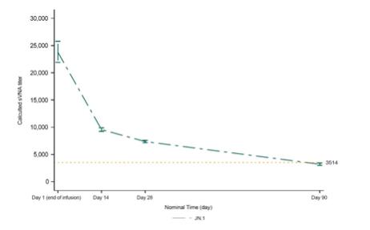
Summary of CANOPY safety data
The safety of VYD222 (PEMGARDA) is based on exposure of 623 participants who received at least one dose of VYD222 4500 mg IV in one of two cohorts in the ongoing CANOPY trial. Cohort A is a single-arm, open-label trial in adults who have moderate-to-severe immune compromise including complex underlying medical conditions (n=306). Cohort B is a randomized, placebo-controlled cohort that recruited adults without moderate-to-severe immune compromise who are at risk of acquiring SARS-CoV-2 due to regular unmasked face-to-face interactions in indoor settings. Cohort B participants were randomized 2:1 to VYD222 (n=317) or placebo (n=162). Interim safety data presented today included 296 people in Cohort A who received a second dose of VYD222 three months after the initial dose. In Cohort B, 450 participants received a second dose of VYD222 or placebo three months after the initial dose. Cumulative safety with the first two doses of VYD222 is assessed only in Cohort A because unblinded safety data in Cohort B were not available after Day 28.
Anaphylaxis was observed in four of 623 (0.6%) participants in CANOPY, all in Cohort A. Two participants had anaphylaxis during the first infusion, for whom treatment included diphenhydramine. Two participants had anaphylaxis during the second infusion. All four reactions led to permanent discontinuation of VYD222. Three participants had complete resolution, and one participant had acute resolution with sequelae related to a flare of an underlying condition. For the two participants who experienced anaphylaxis with the second dose, both incidents were reported as life-threatening, and they experienced symptoms during the infusion and following discontinuation of the infusion. Both participants were treated with diphenhydramine and epinephrine. One participant also received oral prednisone and metoprolol for an associated flare of an underlying condition. Please see PEMGARDA Important Safety Information below, including a boxed warning for anaphylaxis.

The systemic infusion-related reactions and hypersensitivity reactions observed in Cohort A are summarized in Table 1. The severity of the reactions was generally mild (17/27) or moderate (8/27), but two reactions were life-threatening.
Table 1. Cohort A (Open-label cohort with moderate-to-severe immune compromise)  Systemic infusion-related reactions and hypersensitivity reactions

Cohort A (n=306) |  | VYD222 First Dose |  | VYD222 First & Second Dose,  Cumulatively
Systemic infusion-related and hypersensitivity reactions |  | 20 total (20/306 = 7%)  (20 mild or moderate,  including 2 anaphylaxis*) |  | 27 total (27/306 = 9%)  (17 mild and 8 moderate, including 2 anaphylaxis*; plus 2 life-threatening anaphylaxis)
*These two events were initially classified as mild or moderate hypersensitivity adverse reactions. Subsequently, during the review of the EUA application, the FDA reclassified these hypersensitivity adverse reactions as anaphylaxis adverse reactions.
Safety data through Day 28 from Cohort B (post-first dose only) were also analyzed in support of the EUA filing, including randomized data on systemic infusion-related and hypersensitivity reactions, as shown in Table 2. As of Day 28, there were no observations of anaphylaxis in the Cohort B VYD222 arm. Unblinded safety data in Cohort B were not available yet after Day 28.
Table 2. Cohort B (Randomized, placebo-controlled cohort without moderate-to-severe immune compromise at risk of acquiring SARS-CoV-2 due to regular unmasked face-to-face interactions)  Systemic infusion-related reactions and hypersensitivity reactions

Cohort B (n=479) |  | VYD222 First Dose (n=317) |  | Placebo First Dose (n=162)
Systemic infusion-related and hypersensitivity reactions |  | 4 total (4/317 =1%)  (3 mild and 1 moderate) |  | 0 total
Other than systemic infusion-related reactions and hypersensitivity reactions described previously for Cohort A, the most common (≥2%) treatment-emergent adverse events in Cohort A across both the first and second dose cumulatively, irrespective of causality, observed with VYD222 in participants who have moderate-to-severe immune compromise in CANOPY were upper respiratory tract infection (6%), infusion site infiltration/extravasation/vein rupture (5%), viral infection (4%), influenza-like illness (3%), fatigue (3%), headache (2%), nausea (2%), and local infusion site reactions (2%).
This press release features downloadable multimedia content. View the full suite of assets here: https://www.multivu.com/players/English/9254151-invivyd-announces-fda-authorization-pemgarda-formerly-vyd222-pre-exposure-prophylaxis-covid-19/

Conference Call & Webcast
Invivyd will host a conference call and webcast today, Friday, March 22 at 4pm ET. A live audio webcast will be available at https://investors.invivyd.com/. Listeners can register for the webcast via this link. Analysts wishing to participate in the question-and-answer session should use this link. A replay of the webcast will be available in the investor section of the companys website approximately two hours after the end of the call. Those who plan on participating are advised to join 15 minutes prior to the start time.
IMPORTANT SAFETY INFORMATION
WARNING: ANAPHYLAXIS

 |  |  | Anaphylaxis has been observed with PEMGARDA in 0.6% (4/623) of participants in a clinical trial.

 |  |  | Anaphylaxis was reported during the first and second infusion of PEMGARDA.

 |  |  | Anaphylaxis can be life-threatening.

 |  |  | Prior to administering PEMGARDA, consider the potential benefit of COVID-19 prevention along with the risk of anaphylaxis.

 |  |  | Administer PEMGARDA only in settings in which healthcare providers have immediate access to medications to treat anaphylaxis and the ability to activate the emergency medical system (EMS), as necessary.

 |  |  | Clinically monitor individuals during the infusion and for at least two hours after completion of the infusion.

 |  |  | Discontinue PEMGARDA immediately if signs or symptoms of anaphylaxis or any severe systemic reaction are observed and initiate appropriate medications and/or supportive therapy.
CONTRAINDICATIONS
PEMGARDA is contraindicated in individuals with previous severe hypersensitivity reactions, including anaphylaxis, to any component of PEMGARDA.
WARNINGS AND PRECAUTIONS
Hypersensitivity Including Anaphylaxis and Infusion-Related Reactions
Serious hypersensitivity reactions, including anaphylaxis, have been observed with PEMGARDA. If signs and symptoms of a clinically significant hypersensitivity reaction or anaphylaxis occur, immediately discontinue administration, and initiate appropriate medications and/or supportive therapy. Clinically monitor individuals during infusion and observe for at least two hours after infusion is complete.
Risk of Cross-Hypersensitivity With COVID-19 Vaccines
PEMGARDA contains polysorbate 80, which is in some COVID-19 vaccines and is structurally similar to polyethylene glycol (PEG), an ingredient in other COVID-19 vaccines. For individuals with a history of severe hypersensitivity reaction to a COVID-19 vaccine, consider consultation with an allergist-immunologist prior to PEMGARDA administration.

Risk for COVID-19 Due to SARS-CoV-2 Viral Variants Not Neutralized by PEMGARDA
Certain SARS-CoV-2 viral variants may emerge that are not neutralized by monoclonal antibodies such as PEMGARDA. PEMGARDA may not be effective at preventing COVID-19 caused by these SARS-CoV-2 viral variants. Inform individuals of the increased risk, compared to other variants, for COVID-19 due to emergent SARS-CoV-2 viral variants not neutralized by PEMGARDA. If signs and symptoms of COVID-19 occur, advise individuals to test for COVID-19 and seek medical attention, including starting treatment for COVID-19 as appropriate.
ADVERSE REACTIONS
The most common adverse events (all grades, incidence ≥2%) observed in participants who have moderate-to-severe immune compromise treated with PEMGARDA included systemic and local infusion-related or hypersensitivity reactions, upper respiratory tract infection, viral infection, influenza-like illness, fatigue, headache, and nausea.
USE IN SPECIFIC POPULATIONS
Pregnancy
There are insufficient data to evaluate a drug-associated risk of major birth defects, miscarriage, or adverse maternal or fetal outcomes. PEMGARDA should only be used during pregnancy if the potential benefit outweighs the potential risk for the mother and the fetus.
Lactation
There are no available data on the presence of PEMGARDA in human or animal milk, the effects on the breastfed infant, or the effects on milk production. Maternal IgG is known to be present in human milk. The developmental and health benefits of breastfeeding should be considered along with the mothers clinical need for PEMGARDA and any potential adverse effects on the breastfed infant from PEMGARDA.
Pediatric Use
PEMGARDA is not authorized for use in pediatric patients less than 12 years of age or weighing less than 40 kg. The safety and effectiveness of PEMGARDA has not been established in pediatrics.
EMERGENCY USE AUTHORIZATION (EUA) FOR PEMGARDA
The U.S. Food and Drug Administration (FDA) has issued an EUA for the emergency use of the unapproved product PEMGARDA for the pre-exposure prophylaxis of COVID-19 in adults and adolescents (12 years of age and older weighing at least 40 kg):

 |  |  | Who are not currently infected with SARS-CoV-2 and who have not had a known recent exposure to an individual infected with SARS-CoV-2 and

 |  |  | Who have moderate-to-severe immune compromise due to a medical condition or receipt of immunosuppressive medications or treatments and are unlikely to mount an adequate response to COVID-19 vaccination.
LIMITATIONS OF AUTHORIZED USE

 |  |  | PEMGARDA is not authorized for use:

 |  |  | For treatment of COVID-19, or

 |  |  | For post-exposure prophylaxis of COVID-19 in individuals who have been exposed to someone infected with SARS-CoV-2.

 |  |  | Pre-exposure prophylaxis with PEMGARDA is not a substitute for vaccination in individuals for whom COVID-19 vaccination is recommended. Individuals for whom COVID-19 vaccination is recommended, including individuals with moderate-to-severe immune compromise who may derive benefit from COVID-19 vaccination, should receive COVID-19 vaccination.

 |  |  | In individuals who have recently received a COVID-19 vaccine, PEMGARDA should be administered at least 2 weeks after vaccination.
PEMGARDA may only be prescribed for an individual patient by physicians, advanced practice registered nurses, and physician assistants that are licensed or authorized under state law to prescribe drugs.
PEMGARDA has been authorized by FDA for the emergency use described above.
PEMGARDA is not FDA-approved for any use, including use for pre-exposure prophylaxis of COVID-19.
PEMGARDA is authorized only for the duration of the declaration that circumstances exist justifying the authorization of the emergency use of PEMGARDA under Section 564(b)(1) of the Federal Food Drug, and Cosmetic Act, 21 U.S.C. § 360bbb 3(b)(1), unless the authorization is terminated or revoked sooner.
See full Fact Sheet for Healthcare Providers and Fact Sheet for Patients, Parents, and Caregivers for examples of medical conditions or treatments that may result in moderate to severe immune compromise and an inadequate immune response to COVID-19 vaccination, the justification for emergency use of drugs during the COVID-19 pandemic, information on available alternatives, and additional information on COVID-19. The FDA Letter of Authorization is also available for reference.
The prescribing healthcare provider and/or the providers designee is/are responsible for mandatory reporting of all serious adverse events* and medication errors potentially related to PEMGARDA within 7 calendar days from the healthcare providers awareness of the event, using FDA Form 3500 (for information on how to access this form, see below). The FDA requires that such reports, using FDA Form 3500, include the following:

 |  |  | Patient demographics and baseline characteristics (e.g., patient identifier, age or date of birth, sex, weight, ethnicity, and race).

 |  |  | A statement PEMGARDA use for the pre-exposure prophylaxis of COVID-19 under Emergency Use Authorization (EUA) under the Describe Event, Problem, or Product Use/Medication Error heading.

 |  |  | Information about the serious adverse event or medication error (e.g., signs and symptoms, test/laboratory data, complications, timing of drug initiation in relation to the occurrence of the event, duration of the event, treatment required to mitigate the event, evidence of event improvement/disappearance after stopping or reducing the dosage, evidence of event reappearance after reintroduction, clinical outcomes).

 |  |  | Patients preexisting medical conditions and use of concomitant products.

 |  |  | Information about the product (e.g., dosage, route of administration, NDC #).

Submit serious adverse event and medication error reports using FDA Form 3500 to FDA MedWatch using one of the following methods:

 |  |  | Complete and submit the report online: www.fda.gov/medwatch/report.htm.

 |  |  | Complete and submit a postage-paid FDA Form 3500 (https://www.fda.gov/media/76299/download) and return by:

 |  |  | Mail to MedWatch, 5600 Fishers Lane, Rockville, MD 20852-9787, or

 |  |  | Fax to 1-800-FDA (332)-0178, or

 |  |  | Call 1-800-FDA (332)-1088 to request a reporting form.
In addition, please provide a copy of all FDA MedWatch forms to:
Invivyd, Inc.
Email: pv@invivyd.com
Or call Invivyd, Inc. at 1-800-890-3385 to report serious adverse events.
The prescribing healthcare provider and/or the providers designee is/are responsible for mandatory responses to requests from FDA for information about serious adverse events and medication errors following receipt of PEMGARDA.

* | Serious adverse events are defined as:

 |  |  | Death

 |  |  | A life-threatening adverse event

 |  |  | Inpatient hospitalization or prolongation of existing hospitalization

 |  |  | A persistent or significant incapacity or substantial disruption of the ability to conduct normal life functions

 |  |  | A congenital anomaly/birth defect

 |  |  | Other important medical events, which may require a medical or surgical intervention to prevent death, a life-threatening event, hospitalization, disability, or congenital anomaly
You may report side effects related to Invivyd, Inc. products by sending an email to medinfo@invivyd.com.
About PEMGARDA
PEMGARDA (pemivibart), formerly known as VYD222, is a half-life extended investigational monoclonal antibody (mAb). PEMGARDA was engineered from adintrevimab, Invivyds investigational mAb that has a robust safety data package and demonstrated clinically meaningful results in global Phase 2/3 clinical trials for both the prevention and treatment of COVID-19. PEMGARDA was designed for broad activity and has demonstrated in vitro neutralizing activity in pseudotyped virus-like particle and authentic virus neutralization assays against major SARS-CoV-2 variants, including JN.1, the dominant variant in the U.S. currently according to estimates from the Centers for Disease Control and Prevention. PEMGARDA targets the SARS-CoV-2 spike protein receptor binding domain (RBD), thereby inhibiting virus attachment to the human ACE2 receptor on host cells.
PEMGARDA (pemivibart) injection (4500 mg), for intravenous use is an investigational mAb with emergency use authorization in the U.S. for the pre-exposure prophylaxis (prevention) of COVID-19 in adults and adolescents (12 years of age and older weighing at least 40 kg) who have moderate-to-severe immune compromise due to certain medical conditions or receipt of certain immunosuppressive medications or treatments and are unlikely to mount an adequate immune response to COVID-19

vaccination. Recipients should not be currently infected with or have had a known recent exposure to an individual infected with SARS-CoV-2. Anaphylaxis has been observed with PEMGARDA and the PEMGARDA Fact Sheet for Healthcare Providers includes a boxed warning for anaphylaxis. The most common adverse events (all grades, incidence ≥2%) observed in participants who have moderate-to-severe immune compromise treated with PEMGARDA included systemic and local infusion-related or hypersensitivity reactions, upper respiratory tract infection, viral infection, influenza-like illness, fatigue, headache, and nausea.
About Invivyd
Invivyd, Inc. (Nasdaq: IVVD) is commercial-stage company on a mission to rapidly and perpetually deliver antibody-based therapies that protect vulnerable people from the devastating consequences of circulating viral threats, beginning with SARS-CoV-2. The companys proprietary INVYMAB platform approach combines state-of-the-art viral surveillance and predictive modeling with advanced antibody engineering. INVYMAB is designed to facilitate the rapid, serial generation of new monoclonal antibodies (mAbs) to keep pace with evolving viral threats. In March 2024, Invivyd received emergency use authorization (EUA) from the U.S. FDA for its first mAb in a planned series of innovative antibody candidates. Visit https://invivyd.com/ to learn more.
References

1. | Centers for Disease Control and Prevention. People Who Are Immunocompromised. Available at: https://www.cdc.gov/coronavirus/2019-ncov/need-extra-precautions/people-who-are-immunocompromised.html. Last accessed January 2024.

2. | Evans, Rachael A et al. Impact of COVID-19 on immunocompromised populations during the Omicron era: insights from the observational population-based INFORM study. The Lancet regional health. Europe vol. 35 100747. 13 Oct. 2023.

3. | Singson, Jason Robert C et al. Factors Associated with Severe Outcomes Among Immunocompromised Adults Hospitalized for COVID-19COVID-NET, 10 States, March 2020-February 2022. MMWR. Morbidity and mortality weekly report vol. 71,27 878-884. 8 Jul. 2022.

4. | Centers for Disease Control and Prevention. Covid Data Tracker. Available at: https://covid.cdc.gov/covid-data-tracker/#variant-proportions. Last accessed: March 2024.

5. | Schmidt, Pete et al. Antibody-mediated protection against symptomatic COVID-19 can be achieved at low serum neutralizing titers. Sci. Transl. Med.15, eadg2783 (2023).

6. | Stadler, Eva et al. Monoclonal antibody levels and protection from COVID-19. Nature communications vol. 14,1 4545. 28 Jul. 2023, doi:10.1038/s41467-023-40204-1.
Cautionary Note Regarding Forward Looking Statements
This press release contains forward-looking statements within the meaning of the Private Securities Litigation Reform Act of 1995. Words such as anticipates, believes, could, expects, estimates, intends, potential, projects, and future or similar expressions (as well as other words or expressions referencing future events, conditions or circumstances) are intended to identify forward-looking statements. Forward-looking statements include statements concerning, among other things, the potential of PEMGARDA as a mAb for pre-exposure prophylaxis (prevention) of COVID-19 in adults and adolescents who have moderate-to-severe immune compromise; the companys plans related to the

commercialization of PEMGARDA, including its expectations regarding availability and supply of PEMGARDA; the ability of the companys INVYMAB platform approach to enable the rapid, serial generation of durable mAbs targeting conserved epitopes that could be deployed to keep pace with SARS-CoV-2 viral evolution or other viral threats; the companys ongoing research and clinical development efforts and future plans, and the timing thereof; the companys expectation that PEMGARDA is the first mAb in a planned series of innovative antibody candidates; the potential repeatability of an immunobridging trial design for mAb candidates to help address the need to mitigate ongoing viral evolution; the companys commitment to ongoing process improvement while working with global regulatory agencies with the aim to increase the speed and efficiency of new mAb candidate development; the future of the COVID-19 landscape, particularly for vulnerable populations; the companys aim to ensure vulnerable populations have continuous access to innovative antibody therapies; the ongoing in vitro neutralizing activity of PEMGARDA against major SARS-CoV-2 variants; the companys mission to rapidly and perpetually deliver antibody-based therapies that protect vulnerable people from the devastating consequences of circulating viral threats, beginning with SARS-CoV-2; the companys preliminary estimate of its cash and cash equivalents balance as of December 31, 2023; the anticipated timeline of the companys cash runway; the companys business strategies and objectives; and other statements that are not historical fact. The company may not actually achieve the plans, intentions or expectations disclosed in the companys forward-looking statements and you should not place undue reliance on the companys forward-looking statements. These forward-looking statements involve risks and uncertainties that could cause the companys actual results to differ materially from the results described in or implied by the forward-looking statements, including, without limitation: how long the EUA granted by the FDA for PEMGARDA will remain in effect and whether the EUA is revoked or revised by the FDA; the companys ability to build and maintain sales, marketing and distribution capabilities to successfully commercialize PEMGARDA; changes in expected or existing competition; the timing and progress of the companys discovery, preclinical and clinical development activities; the outcome of the companys engagement with regulators regarding mAb candidate development; whether the company is able to utilize an immunobridging trial design for future mAb candidates; the uncertainties and timing of the regulatory authorization or approval process, and available development and regulatory pathways for authorization or approval of the companys product candidates; changes in the regulatory environment; unexpected safety or efficacy data observed during preclinical studies or clinical trials; the ability to maintain a continued acceptable safety, tolerability and efficacy profile of PEMGARDA or any other product candidate following regulatory authorization or approval; the predictability of clinical success of the companys product candidates based on neutralizing activity in preclinical studies; the risk that results of preclinical studies or clinical trials may not be predictive of future results, and interim data are subject to further analysis; the companys reliance on third parties with respect to virus assay creation and product candidate testing and with respect to its clinical trials; variability of results in models used to predict activity against SARS-CoV-2 variants; whether PEMGARDA or any other product candidate is able to demonstrate and sustain neutralizing activity against major SARS-CoV-2 variants, particularly in the face of viral evolution; the complexities of manufacturing mAb therapies; the companys dependence on third parties to manufacture, label, package, store and distribute clinical and commercial supplies of its product candidates; whether the company is able to provide sufficient commercial supply of PEMGARDA to meet market demand; whether the company can obtain and maintain third-party coverage and adequate reimbursement for PEMGARDA or any other product candidate; the companys ability to leverage its INVYMAB platform approach to enable the

rapid, serial generation of durable mAbs that keep pace with SARS-CoV-2 viral evolution or other viral threats; any litigation and other proceedings or government investigations relating to the company; any change in the preliminary estimate of the companys cash and cash equivalents balance as of December 31, 2023 upon completion of the companys audited financial statements for the year ended December 31, 2023; the companys ability to continue as a going concern; and whether the company has adequate funding to meet future operating expenses and capital expenditure requirements. Other factors that may cause the companys actual results to differ materially from those expressed or implied in the forward-looking statements in this press release are described under the heading Risk Factors in the companys Annual Report on Form 10-K for the year ended December 31, 2022 filed with the Securities and Exchange Commission (SEC), and in the companys other filings with the SEC, and in its future reports to be filed with the SEC and available at www.sec.gov. Forward-looking statements contained in this press release are made as of this date, and Invivyd undertakes no duty to update such information whether as a result of new information, future events or otherwise, except as required under applicable law.
This press release contains hyperlinks to information that is not deemed to be incorporated by reference in this press release.
###
Contacts:
Media Relations
(781) 208-1747
media@invivyd.com
Investor Relations
(781) 208-1747
investors@invivyd.com
Exhibit 99.2

Invivyd Announces Interim Exploratory Data on VYD222 from Ongoing
CANOPY Clinical Trial

 |  |  | Analysis of secondary endpoint of symptomatic COVID-19 events in CANOPY is unrelated to regulatory filing or review, but may be hypothesis generating for future Invivyd discovery and development work

 |  |  | Todays update on Day 67 and Day 90 event rates is the first of two planned public updates on symptomatic COVID-19 events in CANOPY; Invivyd plans to analyze all future events at Day 180

 |  |  | Further defining the relationship between serum virus neutralizing antibody titers and clinical protection that prospectively builds on published data is an anticipated goal of future clinical trials
WALTHAM, Mass., March 22, 2024 (GLOBE NEWSWIRE)  Invivyd, Inc. (Nasdaq: IVVD), a biopharmaceutical company on a mission to protect the vulnerable from serious viral infectious diseases, today announced interim exploratory COVID-19 clinical event data for VYD222, an investigational, monoclonal antibody (mAb) in development for the pre-exposure prophylaxis of COVID-19. The data announced today from the ongoing Phase 3 CANOPY clinical trial reflect and add further to the initial potential signal of clinical protection from symptomatic COVID-19 shared in December 2023, and may be useful in updating prior published work that analyzed the relationships between serum virus neutralizing antibody (sVNA) titers and protection in patients who had no prior exposure to vaccination or natural infection.1
While these interim clinical efficacy data are exploratory and not part of the primary immunobridging endpoint of the CANOPY clinical trial, we believe they further our efforts to understand the relationship between sVNA titers and clinical efficacy in individuals who have some level of vaccine- or infection-induced immunity, said Dave Hering, Chief Executive Officer. As we continue to build out our company and advance the science describing monoclonal antibody pre-exposure prophylaxis (PrEP), we believe we can incorporate these findings into future prospectively designed clinical studies that seek to establish formal relationships between neutralizing titers and protection. Exploratory data such as provided in todays update are important for broad reflection as they represent some of the first data from a clinical trial conducted with a monoclonal antibody in a population that has acquired prior immune exposure from either vaccination or natural infection. By contrast, studies of prior authorized COVID-19 PrEP mAbs largely relied on participants required by protocol to be naïve to vaccination or prior infection2. As such, these people would presumably have no baseline titers. We continue to explore how measured titers compare with calculated titers and look to assess if higher levels of protection in future studies may be possible with lower levels of additional titers conferred from mAbs.
The ongoing CANOPY Phase 3 clinical trial is designed to evaluate the safety and tolerability of VYD222 and to assess immunobridging from VYD222 to certain historical data from the companys previous Phase 2/3 clinical trial of adintrevimab (ADG20) for the prevention of symptomatic COVID-19 (EVADE). Symptomatic COVID-19 event collection in the CANOPY clinical trial is a secondary exploratory endpoint designed to allow Invivyd to contemplate further discovery and development work only. The CANOPY

clinical trial enrolled participants in two cohorts. Cohort A is a single-arm, open-label trial in adults who have moderate-to-severe immune compromise including complex underlying medical conditions (n=306). Cohort B is a randomized, placebo-controlled cohort that enrolled adults without moderate-to-severe immune compromise who are at risk of acquiring SARS-CoV-2 due to regular unmasked face-to-face interactions in indoor settings. All CANOPY Cohort A participants received VYD222 administered via intravenous (IV) infusion. Cohort B participants were randomized 2:1 to receive VYD222 or placebo administered via IV infusion.
Updated Findings
As previously disclosed by the company in December 2023, a potential early signal of clinical protection from symptomatic COVID-19 confirmed by RT-PCR was observed. Invivyd is now providing an update on the clinical cases of confirmed symptomatic COVID-19 through Day 90. Beyond todays update, additional cases of COVID-19 have occurred in Cohorts A and B post Day 90. These data are planned to be analyzed at Day 180 and presented when available.
Cohort B (Randomized, placebo-controlled cohort without moderate-to-severe immune compromise at risk of acquiring SARS-CoV-2 due to regular unmasked face-to-face interactions)  Proportion of participants with RT-PCR-confirmed symptomatic COVID-19 (exploratory data):

 |  | As of December 1, 2023 |  | Through Day 90
 |  | (median 67 days follow-up) |  | Through Day 90
VYD222 |  | 0% (0/322) |  | 0.3% (1/314)
Placebo |  | 3% (5/162) |  | 5% (8/159)
Cohort A (Open-label cohort with moderate-to-severe immune compromise)  Proportion of participants with RT-PCR-confirmed symptomatic COVID-19 (exploratory data):

 |  | As of December 1, 2023 |  | Through Day 90
 |  | (median 35 days follow-up) |  | Through Day 90
VYD222 |  | 0% (0/306) |  | 1% (3/298)
Additional COVID-19 events have occurred in Cohort A (unblinded) and Cohort B (randomized, not yet analyzed) post Day 90, but the company has not yet analyzed the data. Invivyd plans to provide a Day 180 update and a more complete analysis of the observed relationships between sVNA titers, both calculated and measured, and events of confirmed symptomatic COVID-19 when these data are available.
About VYD222
VYD222 is a neutralizing, half-life extended monoclonal antibody (mAb) candidate being investigated for the pre-exposure prophylaxis (prevention) of COVID-19 in immunocompromised adults and adolescents. VYD222 was designed for broad activity and has demonstrated in vitro neutralizing activity in pseudotyped virus-like particle and authentic virus neutralization assays against various pre-Omicron and Omicron variants, including JN.1. VYD222 was engineered from adintrevimab, Invivyds investigational mAb that has a robust safety data package and demonstrated clinically meaningful results in global Phase 2/3 clinical trials for both the prevention and treatment of COVID-19.

About Invivyd
Invivyd, Inc. (Nasdaq: IVVD) is a biopharmaceutical company on a mission to rapidly and perpetually deliver antibody-based therapies that protect vulnerable people from the devastating consequences of circulating viral threats, beginning with SARS-CoV-2. The companys proprietary INVYMAB platform approach combines state-of-the-art viral surveillance and predictive modeling with advanced antibody engineering. Leveraging its INVYMAB platform approach, the company is generating a robust pipeline of product candidates which could be used in prevention or treatment of serious viral diseases, starting with COVID-19 and expanding into influenza and other high-need indications. Visit https://invivyd.com/ to learn more.
References

1. | Schmidt, Pete et al. Antibody-mediated protection against symptomatic COVID-19 can be achieved at low serum neutralizing titers. Sci. Transl. Med.15, eadg2783 (2023); Follmann, Dean et al. Examining protective effects of SARS-CoV-2 neutralizing antibodies after vaccination or monoclonal antibody administration. Nature communications vol. 14,1 3605. 17 Jun. 2023.

2. | Ison, Michael, et al. Prevention of COVID-19 Following a Single Intramuscular Administration of Adintrevimab: Results From a Phase 2/3 Randomized, Double-Blind, Placebo-Controlled Trial (EVADE). Open Forum Infectious Diseases, Volume 10, Issue 7, July 2023; Levin, Myron J et al. Intramuscular AZD7442 (Tixagevimab-Cilgavimab) for Prevention of Covid-19. The New England Journal of Medicine vol. 386,23 (2022): 2188-2200.
Cautionary Note Regarding Forward Looking Statements
This press release contains forward-looking statements within the meaning of the Private Securities Litigation Reform Act of 1995. Words such as anticipates, believes, could, expects, estimates, intends, potential, projects, and future or similar expressions (as well as other words or expressions referencing future events, conditions or circumstances) are intended to identify forward-looking statements. Forward-looking statements include statements concerning, among other things, the companys ongoing research and clinical development activities, as well as future potential research and clinical development efforts; the potential of VYD222 for clinical protection from symptomatic COVID-19 based on early signals shown by interim data from the CANOPY clinical trial; the companys plans to provide any future public updates on symptomatic COVID-19 events in the CANOPY clinical trial, including the timing thereof; the potential for exploratory clinical efficacy data from the CANOPY clinical trial to be hypothesis generating for future discovery and development work of the company, and the possibility of updating prior published work that analyzed the relationships between sVNA titers and protection; the in vitro neutralizing activity of VYD222 against major SARS-CoV-2 variants; the companys mission to rapidly and perpetually deliver antibody-based therapies that protect vulnerable people from the devastating consequences of circulating viral threats, beginning with SARS-CoV-2; the ability of the company to leverage its INVYMAB platform approach to generate a robust pipeline of product candidates which, if authorized or approved, could be used in prevention or treatment of serious viral diseases, starting with COVID-19 and expanding into influenza and other high-need indications; the companys business strategies and objectives; and other statements that are not historical fact. The

company may not actually achieve the plans, intentions or expectations disclosed in the companys forward-looking statements and you should not place undue reliance on the companys forward-looking statements. These forward-looking statements involve risks and uncertainties that could cause the companys actual results to differ materially from the results described in or implied by the forward-looking statements, including, without limitation: the timing and progress of the companys discovery, preclinical and clinical development activities; the risk that results of preclinical studies or clinical trials may not be predictive of future results, and interim data are subject to further analysis; unexpected safety or efficacy data observed during preclinical studies or clinical trials; the predictability of clinical success of the companys product candidates based on neutralizing activity in preclinical studies; the companys reliance on third parties with respect to virus assay creation and product candidate testing and with respect to its clinical trials; variability of results in models used to predict activity against SARS-CoV-2 variants; whether VYD222 or any other product candidate is able to demonstrate and sustain neutralizing activity against major SARS-CoV-2 variants, particularly in the face of viral evolution; the companys ability to leverage its INVYMAB platform approach to generate a robust pipeline of product candidates which, if authorized or approved, could be used in prevention or treatment of serious viral diseases; the uncertainties and timing of the regulatory authorization or approval process, and available development and regulatory pathways for authorization or approval of the companys product candidates; changes in the regulatory environment; the companys ability to continue as a going concern; and whether the company has adequate funding to meet future operating expenses and capital expenditure requirements. Other factors that may cause the companys actual results to differ materially from those expressed or implied in the forward-looking statements in this press release are described under the heading Risk Factors in the companys Annual Report on Form 10-K for the year ended December 31, 2022 filed with the Securities and Exchange Commission (SEC), and in the companys other filings with the SEC, and in its future reports to be filed with the SEC and available at www.sec.gov. Forward-looking statements contained in this press release are made as of this date, and Invivyd undertakes no duty to update such information whether as a result of new information, future events or otherwise, except as required under applicable law.
This press release contains hyperlinks to information that is not deemed to be incorporated by reference in this press release.
# # #
Contacts:
Scott Young
(781) 208-1747
syoung@invivyd.com
Gabriella Linville-Engler
(781) 208-0160
gengler@invivyd.com
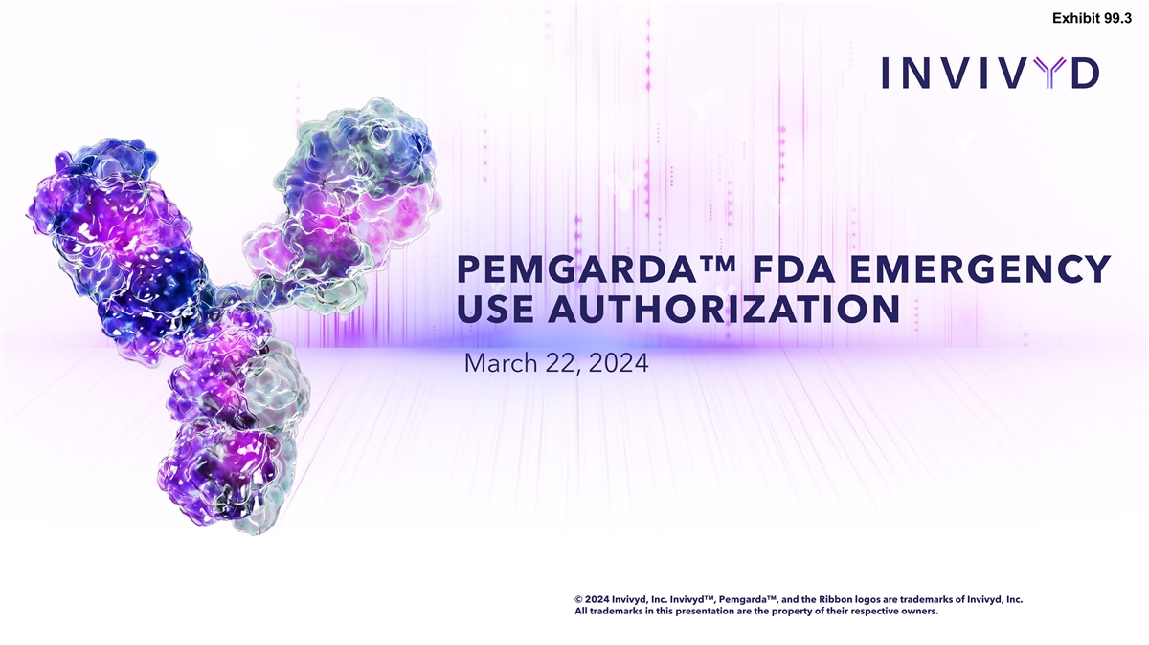
Exhibit 99.3 PEMGARDA FDA EMERGENCY USE AUTHORIZATION March 22, 2024 © 2024 Invivyd, Inc. Invivyd , Pemgarda , and the Ribbon logos are trademarks of Invivyd, Inc. All trademarks in this presentation are the property of their respective owners.

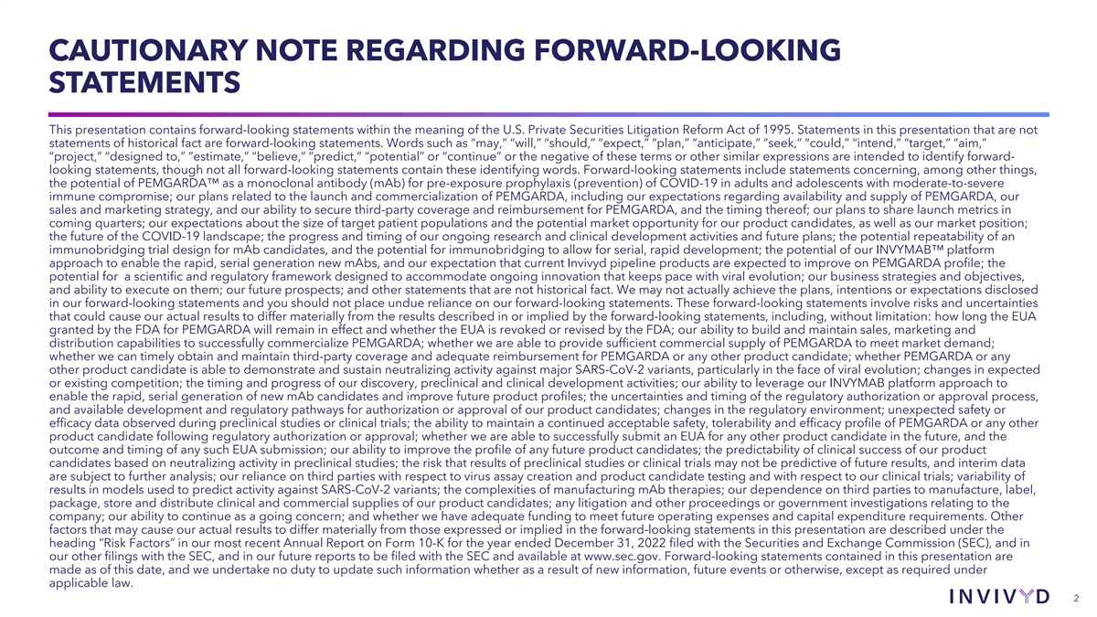
CAUTIONARY NOTE REGARDING FORWARD-LOOKING STATEMENTS This presentation contains forward-looking statements within the meaning of the U.S. Private Securities Litigation Reform Act of 1995. Statements in this presentation that are not statements of historical fact are forward-looking statements. Words such as “may,” “will,” “should,” “expect,” “plan,” “anticipate,” “seek,” “could,” “intend,” “target,” “aim,” “project,” “designed to,” “estimate,” “believe,” “predict,” “potential” or “continue” or the negative of these terms or other similar expressions are intended to identify forward- looking statements, though not all forward-looking statements contain these identifying words. Forward-looking statements include statements concerning, among other things, the potential of PEMGARDA as a monoclonal antibody (mAb) for pre-exposure prophylaxis (prevention) of COVID-19 in adults and adolescents with moderate-to-severe immune compromise; our plans related to the launch and commercialization of PEMGARDA, including our expectations regarding availability and supply of PEMGARDA, our sales and marketing strategy, and our ability to secure third-party coverage and reimbursement for PEMGARDA, and the timing thereof; our plans to share launch metrics in coming quarters; our expectations about the size of target patient populations and the potential market opportunity for our product candidates, as well as our market position; the future of the COVID-19 landscape; the progress and timing of our ongoing research and clinical development activities and future plans; the potential repeatability of an immunobridging trial design for mAb candidates, and the potential for immunobridging to allow for serial, rapid development; the potential of our INVYMAB platform approach to enable the rapid, serial generation new mAbs, and our expectation that current Invivyd pipeline products are expected to improve on PEMGARDA profile; the potential for a scientific and regulatory framework designed to accommodate ongoing innovation that keeps pace with viral evolution; our business strategies and objectives, and ability to execute on them; our future prospects; and other statements that are not historical fact. We may not actually achieve the plans, intentions or expectations disclosed in our forward-looking statements and you should not place undue reliance on our forward-looking statements. These forward-looking statements involve risks and uncertainties that could cause our actual results to differ materially from the results described in or implied by the forward-looking statements, including, without limitation: how long the EUA granted by the FDA for PEMGARDA will remain in effect and whether the EUA is revoked or revised by the FDA; our ability to build and maintain sales, marketing and distribution capabilities to successfully commercialize PEMGARDA; whether we are able to provide sufficient commercial supply of PEMGARDA to meet market demand; whether we can timely obtain and maintain third-party coverage and adequate reimbursement for PEMGARDA or any other product candidate; whether PEMGARDA or any other product candidate is able to demonstrate and sustain neutralizing activity against major SARS-CoV-2 variants, particularly in the face of viral evolution; changes in expected or existing competition; the timing and progress of our discovery, preclinical and clinical development activities; our ability to leverage our INVYMAB platform approach to enable the rapid, serial generation of new mAb candidates and improve future product profiles; the uncertainties and timing of the regulatory authorization or approval process, and available development and regulatory pathways for authorization or approval of our product candidates; changes in the regulatory environment; unexpected safety or efficacy data observed during preclinical studies or clinical trials; the ability to maintain a continued acceptable safety, tolerability and efficacy profile of PEMGARDA or any other product candidate following regulatory authorization or approval; whether we are able to successfully submit an EUA for any other product candidate in the future, and the outcome and timing of any such EUA submission; our ability to improve the profile of any future product candidates; the predictability of clinical success of our product candidates based on neutralizing activity in preclinical studies; the risk that results of preclinical studies or clinical trials may not be predictive of future results, and interim data are subject to further analysis; our reliance on third parties with respect to virus assay creation and product candidate testing and with respect to our clinical trials; variability of results in models used to predict activity against SARS-CoV-2 variants; the complexities of manufacturing mAb therapies; our dependence on third parties to manufacture, label, package, store and distribute clinical and commercial supplies of our product candidates; any litigation and other proceedings or government investigations relating to the company; our ability to continue as a going concern; and whether we have adequate funding to meet future operating expenses and capital expenditure requirements. Other factors that may cause our actual results to differ materially from those expressed or implied in the forward-looking statements in this presentation are described under the heading “Risk Factors” in our most recent Annual Report on Form 10-K for the year ended December 31, 2022 filed with the Securities and Exchange Commission (SEC), and in our other filings with the SEC, and in our future reports to be filed with the SEC and available at www.sec.gov. Forward-looking statements contained in this presentation are made as of this date, and we undertake no duty to update such information whether as a result of new information, future events or otherwise, except as required under applicable law. 2


AGENDA 1. Opening remarks & business updates − Dave Hering, Chief Executive Officer 2. Commercial launch plans − Jeremy Gowler, Chief Operating & Commercial Officer 3. Q&A 3

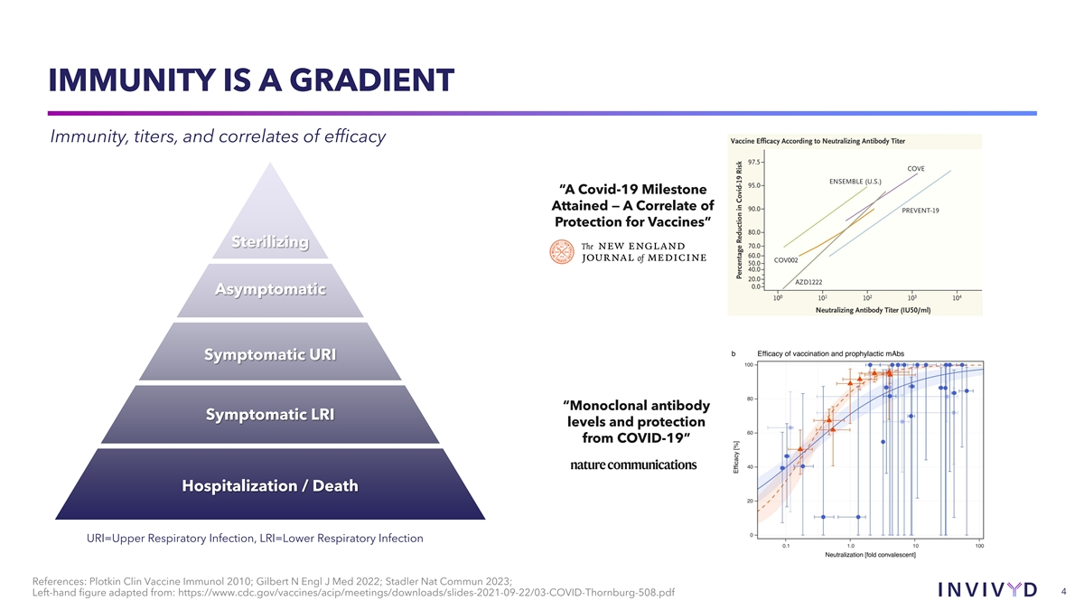
IMMUNITY IS A GRADIENT Immunity, titers, and correlates of efficacy “A Covid-19 Milestone Attained — A Correlate of Protection for Vaccines” Sterilizing Asymptomatic Symptomatic URI “Monoclonal antibody Symptomatic LRI levels and protection from COVID-19” Hospitalization / Death URI=Upper Respiratory Infection, LRI=Lower Respiratory Infection References: Plotkin Clin Vaccine Immunol 2010; Gilbert N Engl J Med 2022; Stadler Nat Commun 2023; 4 Left-hand figure adapted from: https://www.cdc.gov/vaccines/acip/meetings/downloads/slides-2021-09-22/03-COVID-Thornburg-508.pdf

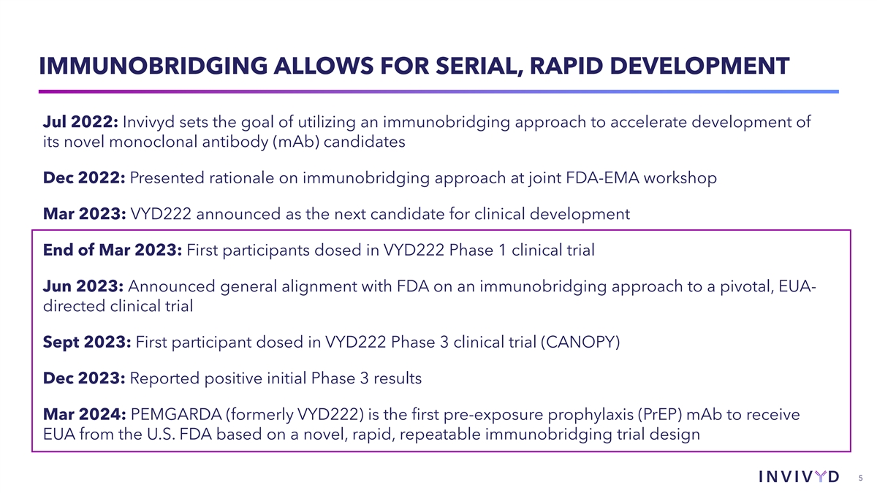
IMMUNOBRIDGING ALLOWS FOR SERIAL, RAPID DEVELOPMENT Jul 2022: Invivyd sets the goal of utilizing an immunobridging approach to accelerate development of its novel monoclonal antibody (mAb) candidates Dec 2022: Presented rationale on immunobridging approach at joint FDA-EMA workshop Mar 2023: VYD222 announced as the next candidate for clinical development End of Mar 2023: First participants dosed in VYD222 Phase 1 clinical trial Jun 2023: Announced general alignment with FDA on an immunobridging approach to a pivotal, EUA- directed clinical trial Sept 2023: First participant dosed in VYD222 Phase 3 clinical trial (CANOPY) Dec 2023: Reported positive initial Phase 3 results Mar 2024: PEMGARDA (formerly VYD222) is the first pre-exposure prophylaxis (PrEP) mAb to receive EUA from the U.S. FDA based on a novel, rapid, repeatable immunobridging trial design 5

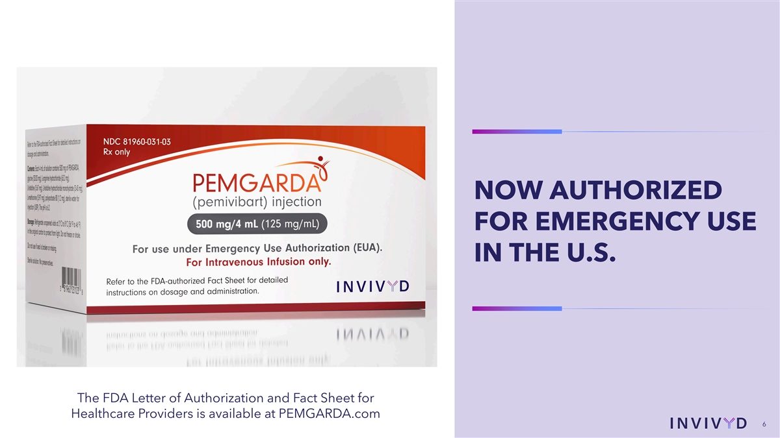
NOW AUTHORIZED FOR EMERGENCY USE IN THE U.S. The FDA Letter of Authorization and Fact Sheet for Healthcare Providers is available at PEMGARDA.com 6 6

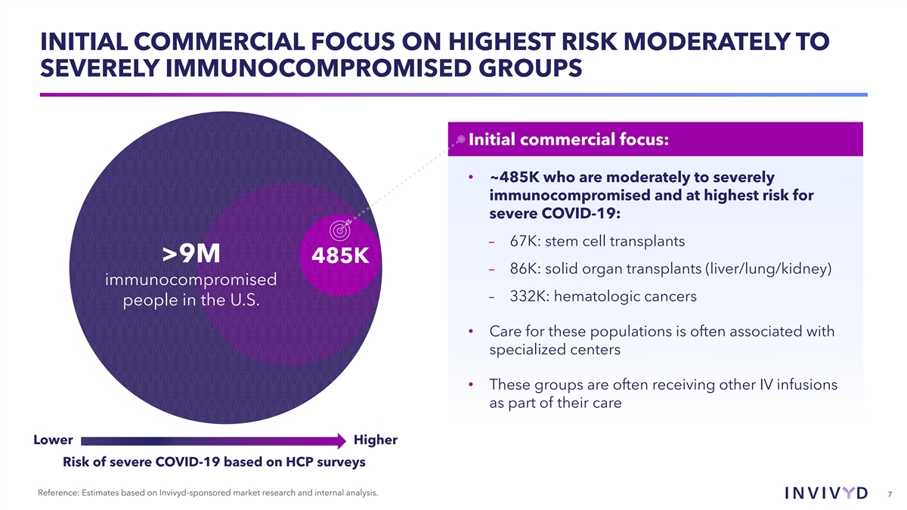
INITIAL COMMERCIAL FOCUS ON HIGHEST RISK MODERATELY TO SEVERELY IMMUNOCOMPROMISED GROUPS Initial commercial focus: • ~485K who are moderately to severely immunocompromised and at highest risk for severe COVID-19: – 67K: stem cell transplants >9M 485K – 86K: solid organ transplants (liver/lung/kidney) immunocompromised – 332K: hematologic cancers people in the U.S. • Care for these populations is often associated with specialized centers • These groups are often receiving other IV infusions as part of their care Lower Higher Risk of severe COVID-19 based on HCP surveys Reference: Estimates based on Invivyd-sponsored market research and internal analysis. 7

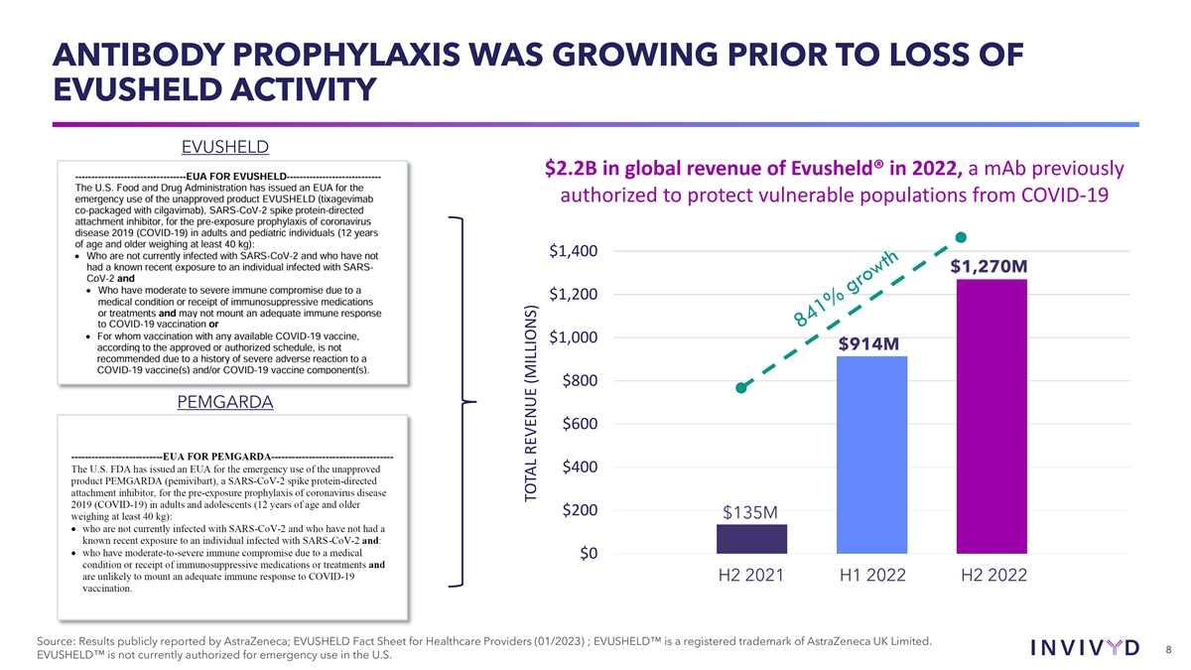
ANTIBODY PROPHYLAXIS WAS GROWING PRIOR TO LOSS OF EVUSHELD ACTIVITY EVUSHELD $2.2B in global revenue of Evusheld® in 2022, a mAb previously authorized to protect vulnerable populations from COVID-19 $1,400 $1,270M $1,200 $1,000 $914M $800 PEMGARDA $600 $400 $200 $135M $0 H2 2021 H1 2022 H2 2022 Source: Results publicly reported by AstraZeneca; EVUSHELD Fact Sheet for Healthcare Providers (01/2023) ; EVUSHELD is a registered trademark of AstraZeneca UK Limited. 8 EVUSHELD is not currently authorized for emergency use in the U.S. TOTAL REVENUE (MILLIONS)


CANOPY Interim Data Update 9

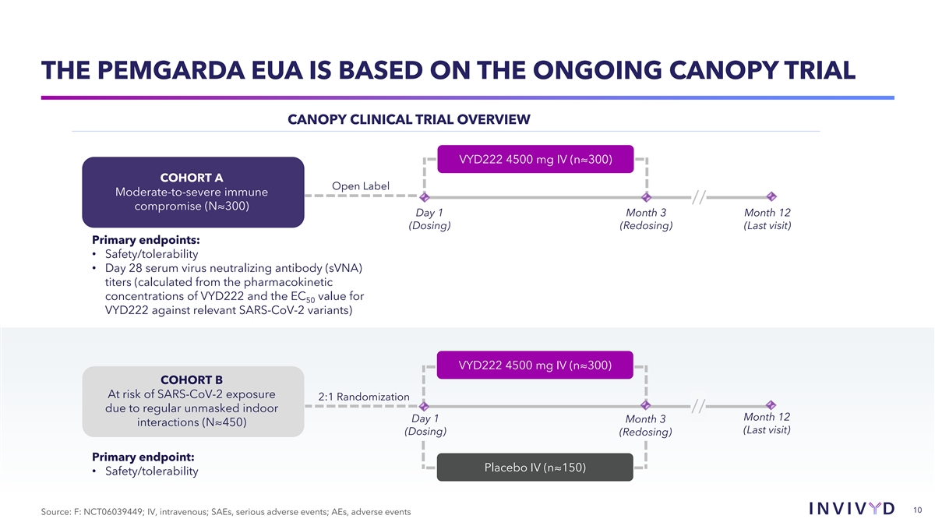
THE PEMGARDA EUA IS BASED ON THE ONGOING CANOPY TRIAL CANOPY CLINICAL TRIAL OVERVIEW VYD222 4500 mg IV (n≈300) COHORT A Open Label Moderate-to-severe immune // compromise (N≈300) Day 1 Month 3 Month 12 (Dosing) (Redosing) (Last visit) Primary endpoints: • Safety/tolerability • Day 28 serum virus neutralizing antibody (sVNA) titers (calculated from the pharmacokinetic concentrations of VYD222 and the EC value for 50 VYD222 against relevant SARS-CoV-2 variants) VYD222 4500 mg IV (n≈300) COHORT B At risk of SARS-CoV-2 exposure 2:1 Randomization due to regular unmasked indoor // Month 12 Day 1 Month 3 interactions (N≈450) (Last visit) (Dosing) (Redosing) Primary endpoint: Placebo IV (n≈150) • Safety/tolerability 10 Source: F: NCT06039449; IV, intravenous; SAEs, serious adverse events; AEs, adverse events

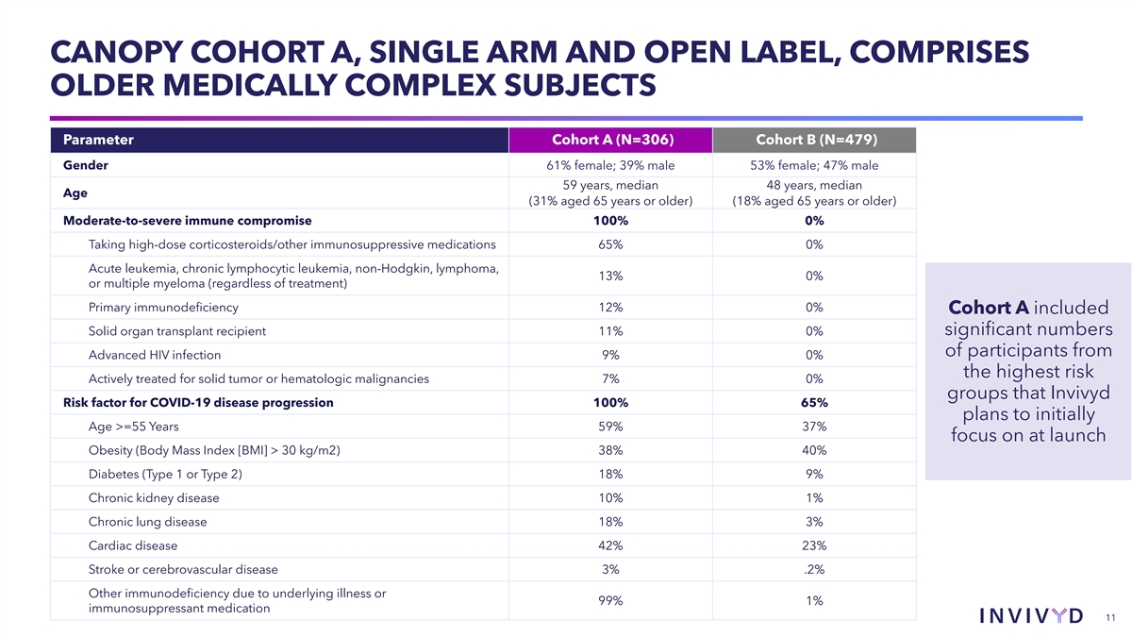
CANOPY COHORT A, SINGLE ARM AND OPEN LABEL, COMPRISES OLDER MEDICALLY COMPLEX SUBJECTS Parameter Cohort A (N=306) Cohort B (N=479) Gender 61% female; 39% male 53% female; 47% male 59 years, median 48 years, median Age (31% aged 65 years or older) (18% aged 65 years or older) Moderate-to-severe immune compromise 100% 0% Taking high-dose corticosteroids/other immunosuppressive medications 65% 0% Acute leukemia, chronic lymphocytic leukemia, non-Hodgkin, lymphoma, 13% 0% or multiple myeloma (regardless of treatment) Primary immunodeficiency 12% 0% Cohort A included Solid organ transplant recipient 11% 0% significant numbers of participants from Advanced HIV infection 9% 0% the highest risk Actively treated for solid tumor or hematologic malignancies 7% 0% groups that Invivyd Risk factor for COVID-19 disease progression 100% 65% plans to initially Age >=55 Years 59% 37% focus on at launch Obesity (Body Mass Index [BMI] > 30 kg/m2) 38% 40% Diabetes (Type 1 or Type 2) 18% 9% Chronic kidney disease 10% 1% Chronic lung disease 18% 3% Cardiac disease 42% 23% Stroke or cerebrovascular disease 3% .2% Other immunodeficiency due to underlying illness or 99% 1% immunosuppressant medication 11

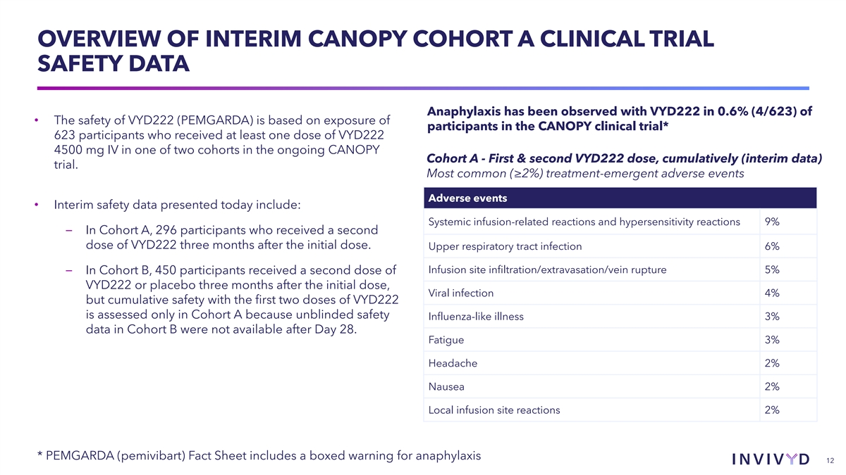
OVERVIEW OF INTERIM CANOPY COHORT A CLINICAL TRIAL SAFETY DATA Anaphylaxis has been observed with VYD222 in 0.6% (4/623) of • The safety of VYD222 (PEMGARDA) is based on exposure of participants in the CANOPY clinical trial* 623 participants who received at least one dose of VYD222 4500 mg IV in one of two cohorts in the ongoing CANOPY Cohort A - First & second VYD222 dose, cumulatively (interim data) trial. Most common (≥2%) treatment-emergent adverse events Adverse events • Interim safety data presented today include: Systemic infusion-related reactions and hypersensitivity reactions 9% – In Cohort A, 296 participants who received a second dose of VYD222 three months after the initial dose. Upper respiratory tract infection 6% Infusion site infiltration/extravasation/vein rupture 5% – In Cohort B, 450 participants received a second dose of VYD222 or placebo three months after the initial dose, Viral infection 4% but cumulative safety with the first two doses of VYD222 is assessed only in Cohort A because unblinded safety Influenza-like illness 3% data in Cohort B were not available after Day 28. Fatigue 3% Headache 2% Nausea 2% Local infusion site reactions 2% * PEMGARDA (pemivibart) Fact Sheet includes a boxed warning for anaphylaxis 12

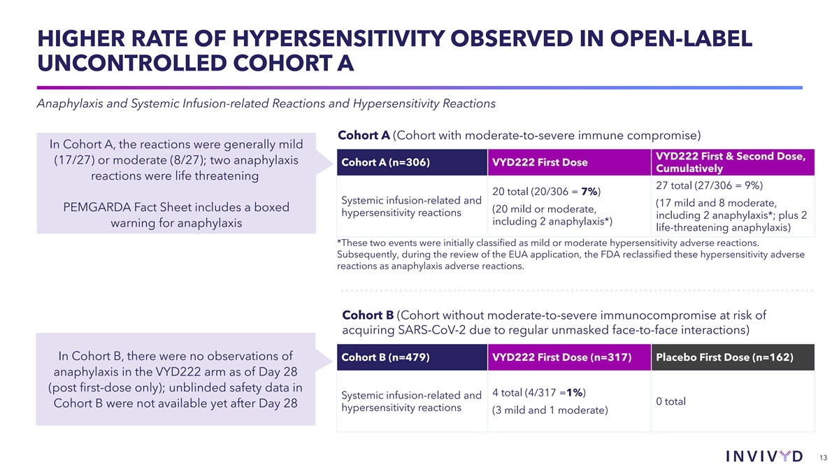
HIGHER RATE OF HYPERSENSITIVITY OBSERVED IN OPEN-LABEL UNCONTROLLED COHORT A Anaphylaxis and Systemic Infusion-related Reactions and Hypersensitivity Reactions Cohort A (Cohort with moderate-to-severe immune compromise) In Cohort A, the reactions were generally mild VYD222 First & Second Dose, (17/27) or moderate (8/27); two anaphylaxis Cohort A (n=306) VYD222 First Dose Cumulatively reactions were life threatening 27 total (27/306 = 9%) 20 total (20/306 = 7%) Systemic infusion-related and (17 mild and 8 moderate, PEMGARDA Fact Sheet includes a boxed (20 mild or moderate, hypersensitivity reactions including 2 anaphylaxis*; plus 2 including 2 anaphylaxis*) warning for anaphylaxis life-threatening anaphylaxis) *These two events were initially classified as mild or moderate hypersensitivity adverse reactions. Subsequently, during the review of the EUA application, the FDA reclassified these hypersensitivity adverse reactions as anaphylaxis adverse reactions. Cohort B (Cohort without moderate-to-severe immunocompromise at risk of acquiring SARS-CoV-2 due to regular unmasked face-to-face interactions) In Cohort B, there were no observations of Cohort B (n=479) VYD222 First Dose (n=317) Placebo First Dose (n=162) anaphylaxis in the VYD222 arm as of Day 28 (post first-dose only); unblinded safety data in 4 total (4/317 =1%) Systemic infusion-related and 0 total Cohort B were not available yet after Day 28 hypersensitivity reactions (3 mild and 1 moderate) 13

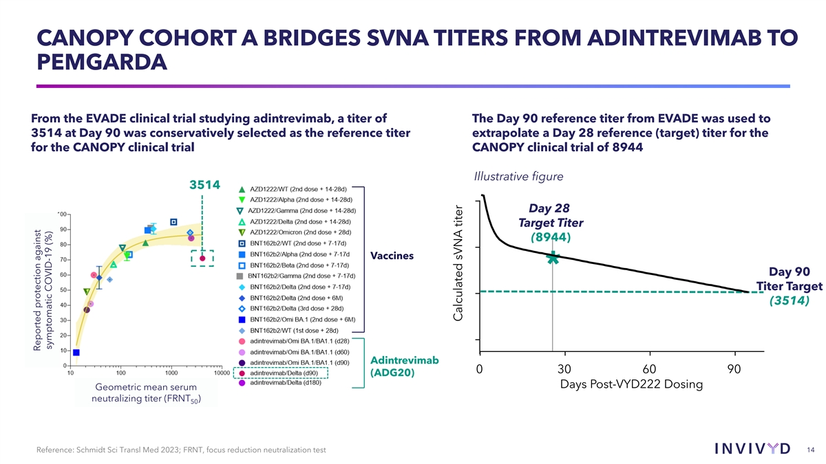
CANOPY COHORT A BRIDGES SVNA TITERS FROM ADINTREVIMAB TO PEMGARDA From the EVADE clinical trial studying adintrevimab, a titer of The Day 90 reference titer from EVADE was used to 3514 at Day 90 was conservatively selected as the reference titer extrapolate a Day 28 reference (target) titer for the for the CANOPY clinical trial CANOPY clinical trial of 8944 Illustrative figure 3514 Day 28 Target Titer (8944) Vaccines * Day 90 Titer Target (3514) Adintrevimab 0 30 60 90 (ADG20) Days Post-VYD222 Dosing Geometric mean serum neutralizing titer (FRNT ) 50 14 Reference: Schmidt Sci Transl Med 2023; FRNT, focus reduction neutralization test Reported protection against symptomatic COVID-19 (%) Calculated sVNA titer

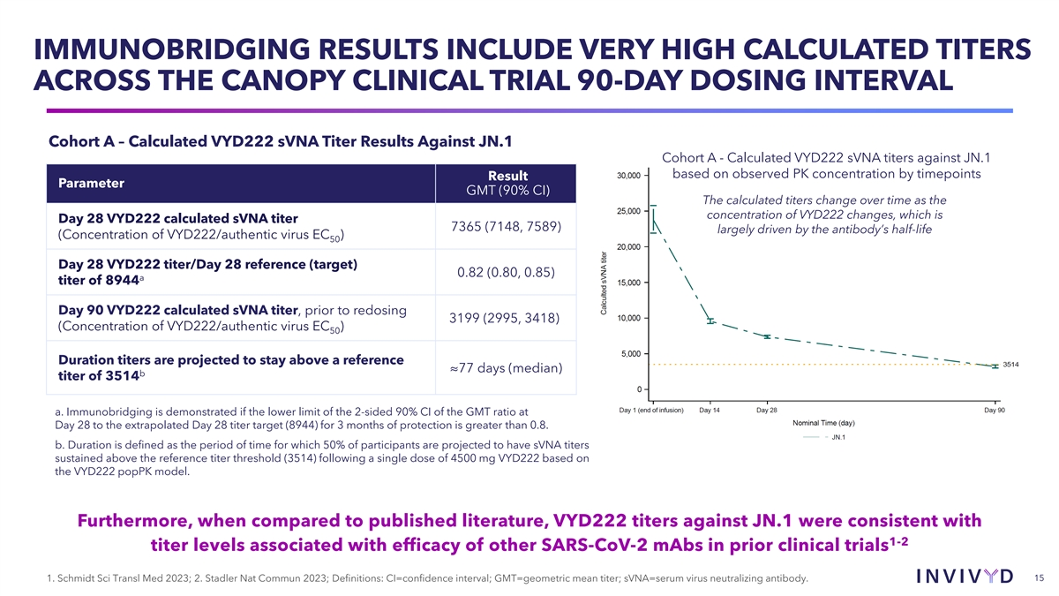
IMMUNOBRIDGING RESULTS INCLUDE VERY HIGH CALCULATED TITERS ACROSS THE CANOPY CLINICAL TRIAL 90-DAY DOSING INTERVAL Cohort A – Calculated VYD222 sVNA Titer Results Against JN.1 Cohort A - Calculated VYD222 sVNA titers against JN.1 based on observed PK concentration by timepoints Result Parameter GMT (90% CI) The calculated titers change over time as the concentration of VYD222 changes, which is Day 28 VYD222 calculated sVNA titer 7365 (7148, 7589) largely driven by the antibody’s half-life (Concentration of VYD222/authentic virus EC ) 50 Day 28 VYD222 titer/Day 28 reference (target) 0.82 (0.80, 0.85) a titer of 8944 Day 90 VYD222 calculated sVNA titer, prior to redosing 3199 (2995, 3418) (Concentration of VYD222/authentic virus EC ) 50 Duration titers are projected to stay above a reference ≈77 days (median) b titer of 3514 a. Immunobridging is demonstrated if the lower limit of the 2-sided 90% CI of the GMT ratio at Day 28 to the extrapolated Day 28 titer target (8944) for 3 months of protection is greater than 0.8. b. Duration is defined as the period of time for which 50% of participants are projected to have sVNA titers sustained above the reference titer threshold (3514) following a single dose of 4500 mg VYD222 based on the VYD222 popPK model. Furthermore, when compared to published literature, VYD222 titers against JN.1 were consistent with 1-2 titer levels associated with efficacy of other SARS-CoV-2 mAbs in prior clinical trials 15 1. Schmidt Sci Transl Med 2023; 2. Stadler Nat Commun 2023; Definitions: CI=confidence interval; GMT=geometric mean titer; sVNA=serum virus neutralizing antibody.

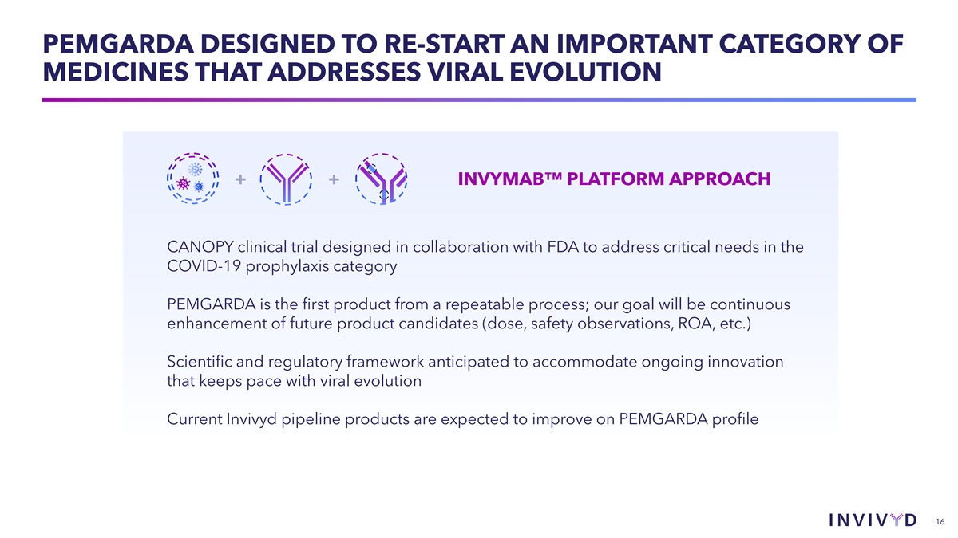
PEMGARDA DESIGNED TO RE-START AN IMPORTANT CATEGORY OF MEDICINES THAT ADDRESSES VIRAL EVOLUTION + + INVYMAB PLATFORM APPROACH CANOPY clinical trial designed in collaboration with FDA to address critical needs in the COVID-19 prophylaxis category PEMGARDA is the first product from a repeatable process; our goal will be continuous enhancement of future product candidates (dose, safety observations, ROA, etc.) Scientific and regulatory framework anticipated to accommodate ongoing innovation that keeps pace with viral evolution Current Invivyd pipeline products are expected to improve on PEMGARDA profile 16


Commercial Launch Plans Jeremy Gowler Chief Operating & Commercial Officer 17

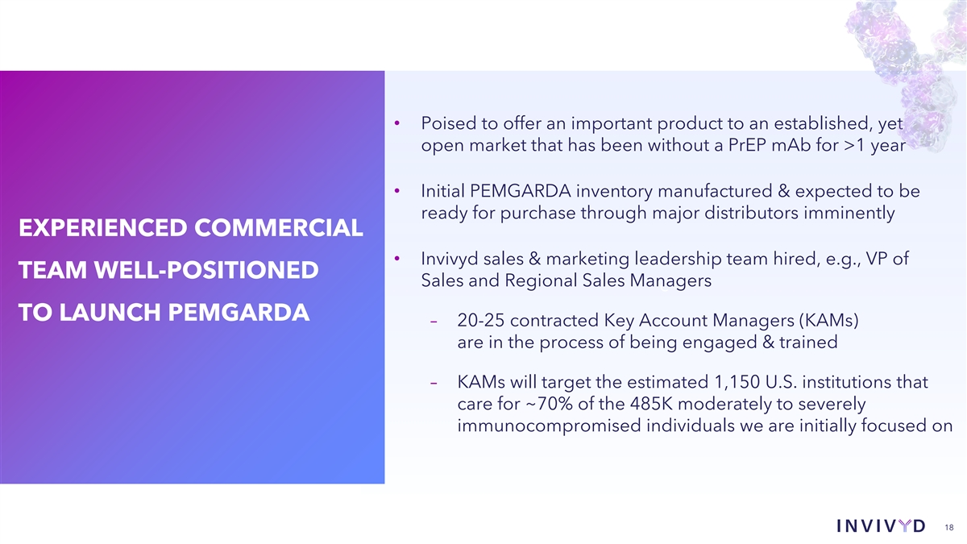
• Poised to offer an important product to an established, yet open market that has been without a PrEP mAb for >1 year • Initial PEMGARDA inventory manufactured & expected to be ready for purchase through major distributors imminently EXPERIENCED COMMERCIAL • Invivyd sales & marketing leadership team hired, e.g., VP of TEAM WELL-POSITIONED Sales and Regional Sales Managers c TO LAUNCH PEMGARDA – 20-25 contracted Key Account Managers (KAMs) are in the process of being engaged & trained – KAMs will target the estimated 1,150 U.S. institutions that care for ~70% of the 485K moderately to severely immunocompromised individuals we are initially focused on 18

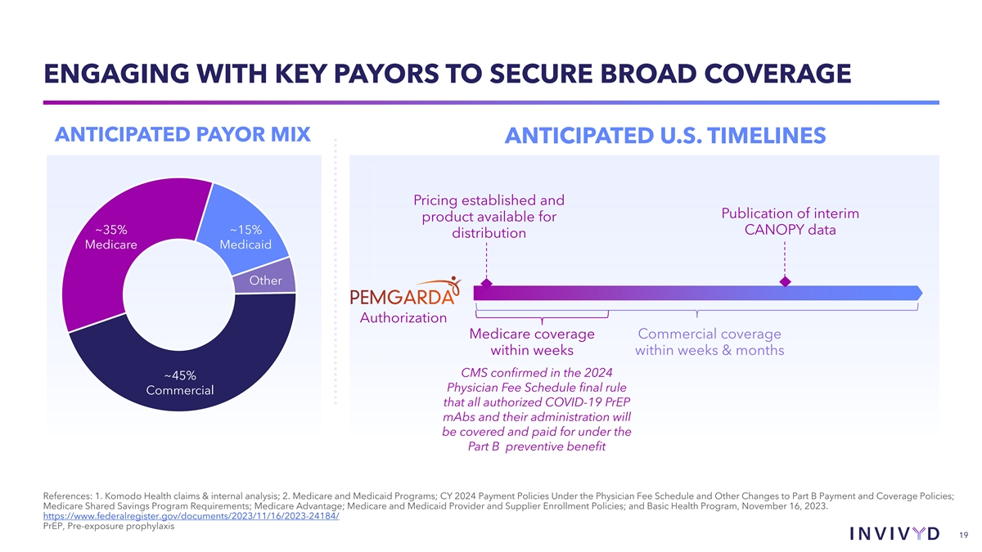
ENGAGING WITH KEY PAYORS TO SECURE BROAD COVERAGE ANTICIPATED PAYOR MIX ANTICIPATED U.S. TIMELINES Pricing established and Publication of interim product available for ~35% ~15% CANOPY data distribution Medicare Medicaid Other Authorization Medicare coverage Commercial coverage within weeks within weeks & months CMS confirmed in the 2024 ~45% Physician Fee Schedule final rule Commercial that all authorized COVID-19 PrEP mAbs and their administration will be covered and paid for under the Part B preventive benefit References: 1. Komodo Health claims & internal analysis; 2. Medicare and Medicaid Programs; CY 2024 Payment Policies Under the Physician Fee Schedule and Other Changes to Part B Payment and Coverage Policies; Medicare Shared Savings Program Requirements; Medicare Advantage; Medicare and Medicaid Provider and Supplier Enrollment Policies; and Basic Health Program, November 16, 2023. https://www.federalregister.gov/documents/2023/11/16/2023-24184/ PrEP, Pre-exposure prophylaxis 19

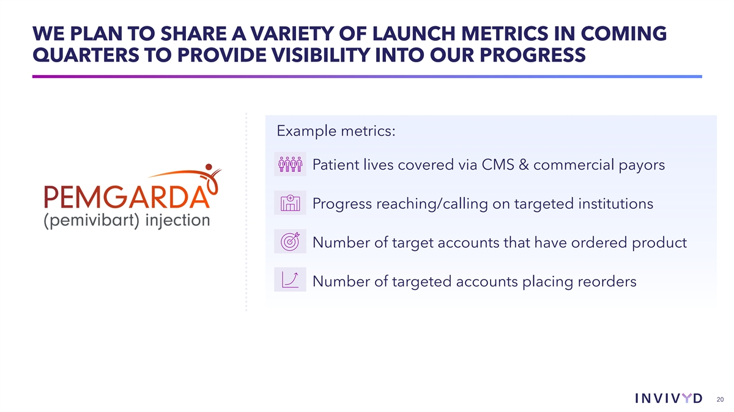
WE PLAN TO SHARE A VARIETY OF LAUNCH METRICS IN COMING QUARTERS TO PROVIDE VISIBILITY INTO OUR PROGRESS Example metrics: Patient lives covered via CMS & commercial payors Progress reaching/calling on targeted institutions Number of target accounts that have ordered product Number of targeted accounts placing reorders 20


Q&A 21

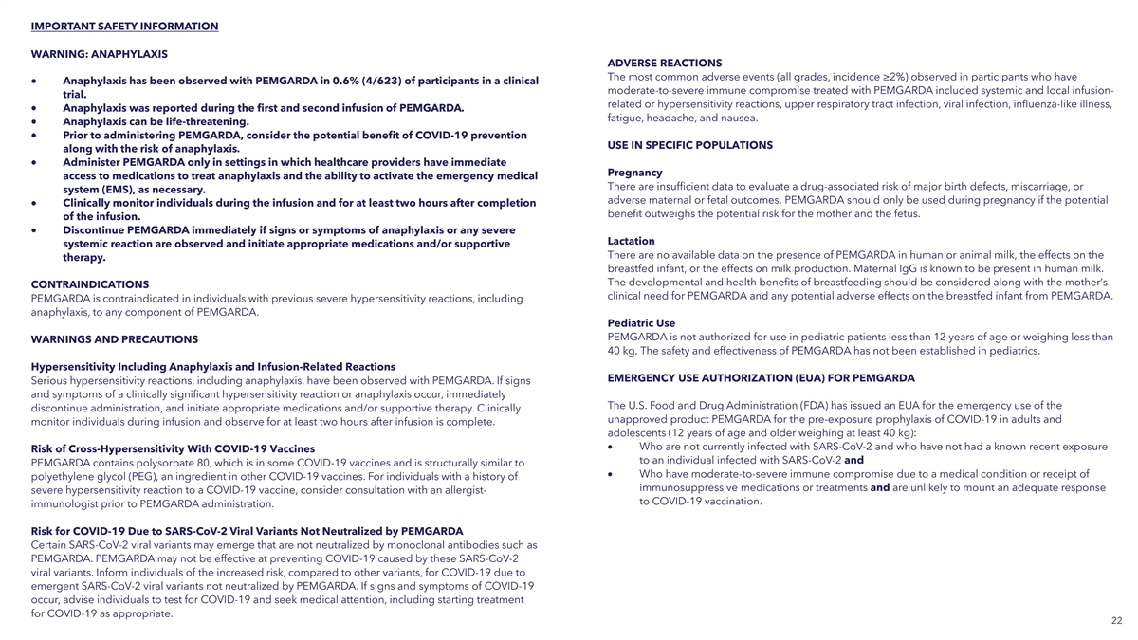
IMPORTANT SAFETY INFORMATION WARNING: ANAPHYLAXIS ADVERSE REACTIONS The most common adverse events (all grades, incidence ≥2%) observed in participants who have • Anaphylaxis has been observed with PEMGARDA in 0.6% (4/623) of participants in a clinical moderate-to-severe immune compromise treated with PEMGARDA included systemic and local infusion- trial. related or hypersensitivity reactions, upper respiratory tract infection, viral infection, influenza-like illness, • Anaphylaxis was reported during the first and second infusion of PEMGARDA. fatigue, headache, and nausea. • Anaphylaxis can be life-threatening. • Prior to administering PEMGARDA, consider the potential benefit of COVID-19 prevention USE IN SPECIFIC POPULATIONS along with the risk of anaphylaxis. • Administer PEMGARDA only in settings in which healthcare providers have immediate Pregnancy access to medications to treat anaphylaxis and the ability to activate the emergency medical There are insufficient data to evaluate a drug-associated risk of major birth defects, miscarriage, or system (EMS), as necessary. adverse maternal or fetal outcomes. PEMGARDA should only be used during pregnancy if the potential • Clinically monitor individuals during the infusion and for at least two hours after completion benefit outweighs the potential risk for the mother and the fetus. of the infusion. • Discontinue PEMGARDA immediately if signs or symptoms of anaphylaxis or any severe Lactation systemic reaction are observed and initiate appropriate medications and/or supportive There are no available data on the presence of PEMGARDA in human or animal milk, the effects on the therapy. breastfed infant, or the effects on milk production. Maternal IgG is known to be present in human milk. The developmental and health benefits of breastfeeding should be considered along with the mother’s CONTRAINDICATIONS clinical need for PEMGARDA and any potential adverse effects on the breastfed infant from PEMGARDA. PEMGARDA is contraindicated in individuals with previous severe hypersensitivity reactions, including anaphylaxis, to any component of PEMGARDA. Pediatric Use PEMGARDA is not authorized for use in pediatric patients less than 12 years of age or weighing less than WARNINGS AND PRECAUTIONS 40 kg. The safety and effectiveness of PEMGARDA has not been established in pediatrics. Hypersensitivity Including Anaphylaxis and Infusion-Related Reactions EMERGENCY USE AUTHORIZATION (EUA) FOR PEMGARDA Serious hypersensitivity reactions, including anaphylaxis, have been observed with PEMGARDA. If signs and symptoms of a clinically significant hypersensitivity reaction or anaphylaxis occur, immediately The U.S. Food and Drug Administration (FDA) has issued an EUA for the emergency use of the discontinue administration, and initiate appropriate medications and/or supportive therapy. Clinically unapproved product PEMGARDA for the pre-exposure prophylaxis of COVID-19 in adults and monitor individuals during infusion and observe for at least two hours after infusion is complete. adolescents (12 years of age and older weighing at least 40 kg): • Who are not currently infected with SARS-CoV-2 and who have not had a known recent exposure Risk of Cross-Hypersensitivity With COVID-19 Vaccines to an individual infected with SARS-CoV-2 and PEMGARDA contains polysorbate 80, which is in some COVID-19 vaccines and is structurally similar to • Who have moderate-to-severe immune compromise due to a medical condition or receipt of polyethylene glycol (PEG), an ingredient in other COVID-19 vaccines. For individuals with a history of immunosuppressive medications or treatments and are unlikely to mount an adequate response severe hypersensitivity reaction to a COVID-19 vaccine, consider consultation with an allergist- to COVID-19 vaccination. immunologist prior to PEMGARDA administration. Risk for COVID-19 Due to SARS-CoV-2 Viral Variants Not Neutralized by PEMGARDA Certain SARS-CoV-2 viral variants may emerge that are not neutralized by monoclonal antibodies such as PEMGARDA. PEMGARDA may not be effective at preventing COVID-19 caused by these SARS-CoV-2 viral variants. Inform individuals of the increased risk, compared to other variants, for COVID-19 due to emergent SARS-CoV-2 viral variants not neutralized by PEMGARDA. If signs and symptoms of COVID-19 occur, advise individuals to test for COVID-19 and seek medical attention, including starting treatment for COVID-19 as appropriate. 22

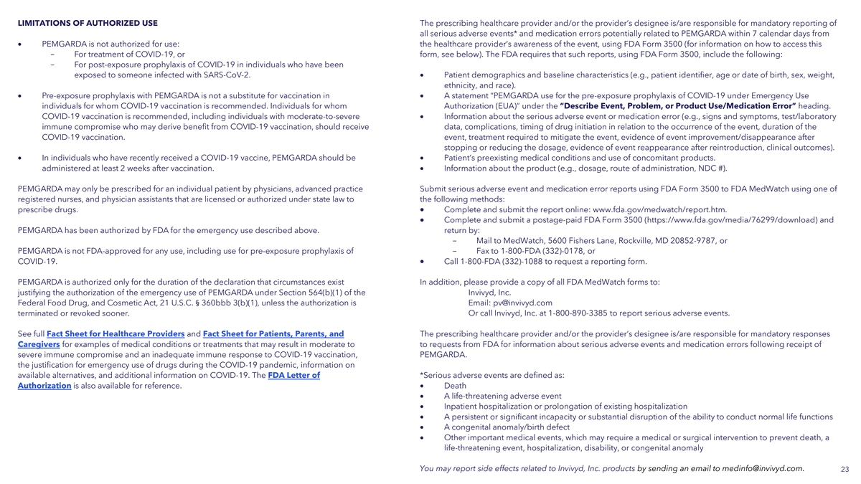
LIMITATIONS OF AUTHORIZED USE The prescribing healthcare provider and/or the provider’s designee is/are responsible for mandatory reporting of all serious adverse events* and medication errors potentially related to PEMGARDA within 7 calendar days from • PEMGARDA is not authorized for use: the healthcare provider’s awareness of the event, using FDA Form 3500 (for information on how to access this - For treatment of COVID-19, or form, see below). The FDA requires that such reports, using FDA Form 3500, include the following: - For post-exposure prophylaxis of COVID-19 in individuals who have been exposed to someone infected with SARS-CoV-2.• Patient demographics and baseline characteristics (e.g., patient identifier, age or date of birth, sex, weight, ethnicity, and race). • Pre-exposure prophylaxis with PEMGARDA is not a substitute for vaccination in • A statement “PEMGARDA use for the pre-exposure prophylaxis of COVID-19 under Emergency Use individuals for whom COVID-19 vaccination is recommended. Individuals for whom Authorization (EUA)” under the “Describe Event, Problem, or Product Use/Medication Error” heading. COVID-19 vaccination is recommended, including individuals with moderate-to-severe • Information about the serious adverse event or medication error (e.g., signs and symptoms, test/laboratory immune compromise who may derive benefit from COVID-19 vaccination, should receive data, complications, timing of drug initiation in relation to the occurrence of the event, duration of the COVID-19 vaccination. event, treatment required to mitigate the event, evidence of event improvement/disappearance after stopping or reducing the dosage, evidence of event reappearance after reintroduction, clinical outcomes). • In individuals who have recently received a COVID-19 vaccine, PEMGARDA should be • Patient’s preexisting medical conditions and use of concomitant products. administered at least 2 weeks after vaccination.• Information about the product (e.g., dosage, route of administration, NDC #). PEMGARDA may only be prescribed for an individual patient by physicians, advanced practice Submit serious adverse event and medication error reports using FDA Form 3500 to FDA MedWatch using one of registered nurses, and physician assistants that are licensed or authorized under state law to the following methods: prescribe drugs.• Complete and submit the report online: www.fda.gov/medwatch/report.htm. • Complete and submit a postage-paid FDA Form 3500 (https://www.fda.gov/media/76299/download) and PEMGARDA has been authorized by FDA for the emergency use described above. return by: - Mail to MedWatch, 5600 Fishers Lane, Rockville, MD 20852-9787, or PEMGARDA is not FDA-approved for any use, including use for pre-exposure prophylaxis of - Fax to 1-800-FDA (332)-0178, or COVID-19.• Call 1-800-FDA (332)-1088 to request a reporting form. PEMGARDA is authorized only for the duration of the declaration that circumstances exist In addition, please provide a copy of all FDA MedWatch forms to: justifying the authorization of the emergency use of PEMGARDA under Section 564(b)(1) of the Invivyd, Inc. Federal Food Drug, and Cosmetic Act, 21 U.S.C. § 360bbb 3(b)(1), unless the authorization is Email: pv@invivyd.com terminated or revoked sooner. Or call Invivyd, Inc. at 1-800-890-3385 to report serious adverse events. See full Fact Sheet for Healthcare Providers and Fact Sheet for Patients, Parents, and The prescribing healthcare provider and/or the provider’s designee is/are responsible for mandatory responses Caregivers for examples of medical conditions or treatments that may result in moderate to to requests from FDA for information about serious adverse events and medication errors following receipt of severe immune compromise and an inadequate immune response to COVID-19 vaccination, PEMGARDA. the justification for emergency use of drugs during the COVID-19 pandemic, information on available alternatives, and additional information on COVID-19. The FDA Letter of *Serious adverse events are defined as: Authorization is also available for reference. • Death • A life-threatening adverse event • Inpatient hospitalization or prolongation of existing hospitalization • A persistent or significant incapacity or substantial disruption of the ability to conduct normal life functions • A congenital anomaly/birth defect • Other important medical events, which may require a medical or surgical intervention to prevent death, a life-threatening event, hospitalization, disability, or congenital anomaly You may report side effects related to Invivyd, Inc. products by sending an email to medinfo@invivyd.com. 23


THANK YOU!

