UNITED STATES
SECURITIES AND EXCHANGE COMMISSION
WASHINGTON, D.C. 20549

FORM 8-K

CURRENT REPORT
Pursuant to Section 13 or 15(d)
of the Securities Exchange Act of 1934

Date of report (Date of earliest event reported): September 29, 2026

Invivyd, Inc.
(Exact Name of Registrant as Specified in its Charter)
Delaware |  | 001-40703 |  | 85-1403134
(State or Other Jurisdiction  of Incorporation) |  | (Commission  File Number) |  | (IRS Employer  Identification No.)
205 Church Street  New Haven, CT |  | 06510
(Address of Principal Executive Offices) |  | (Zip Code)

Registrant’s telephone number, including area code: (781) 819-0080

Not applicable
(Former Name or Former Address, if Changed Since Last Report)
Check the appropriate box below if the Form 8-K filing is intended to simultaneously satisfy the filing obligation of the registrant under any of the following provisions:
☐ | Written communications pursuant to Rule 425 under the Securities Act (17 CFR 230.425)
☐ | Soliciting material pursuant to Rule 14a-12 under the Exchange Act (17 CFR 240.14a-12)
☐ | Pre-commencement communications pursuant to Rule 14d-2(b) under the Exchange Act (17 CFR 240.14d-2(b))
☐ | Pre-commencement communications pursuant to Rule 13e-4(c) under the Exchange Act (17 CFR 240.13e-4(c))

Securities registered pursuant to Section 12(b) of the Act:
Title of each class |  | Trading  Symbol(s) |  | Name of each exchange  on which registered
Common stock, par value $0.0001 per share |  | IVVD |  | The Nasdaq Stock Market LLC

Indicate by check mark whether the registrant is an emerging growth company as defined in Rule 405 of the Securities Act of 1933 (§230.405 of this chapter) or Rule 12b-2 of the Securities Exchange Act of 1934 (§240.12b-2 of this chapter).
Emerging growth company ☒

If an emerging growth company, indicate by check mark if the registrant has elected not to use the extended transition period for complying with any new or revised financial accounting standards provided pursuant to Section 13(a) of the Exchange Act. ☐

Item 8.01 Other Events.

On September 29, 2026, Invivyd, Inc. (the “Company”) issued a press release entitled “Invivyd Announces Positive Topline Results from LIBERTY Phase 3 Study Demonstrating VYD2311 Safety and Tolerability Superior to mRNA-based COVID-19 Vaccine; Announces Regulatory Submission Plans for VYD2311.” A copy of the press release is filed as Exhibit 99.1 to this Current Report on Form 8-K and is incorporated by reference into this Item 8.01.

On September 29, 2026, the Company posted an updated corporate presentation on its website at www.invivyd.com. A copy of the presentation is filed as Exhibit 99.2 to this Current Report on Form 8-K and is incorporated by reference into this Item 8.01.

Item 9.01 Financial Statements and Exhibits.

(d) Exhibits
Exhibit  No. |  | Description
99.1 |  | Press Release, dated September 29, 2026
99.2 |  | Corporate Presentation, dated September 29, 2026
104 |  | Cover Page Interactive Data File (embedded within the Inline XBRL document)

SIGNATURES
Pursuant to the requirements of the Securities Exchange Act of 1934, as amended, the registrant has duly caused this report to be signed on its behalf by the undersigned hereunto duly authorized.
 |  | INVIVYD, INC.
Date: September 29, 2026 |  | By: | /s/ Jill Andersen
 |  |  | Jill Andersen
 |  |  | Chief Legal Officer and Corporate Secretary

Exhibit 99.1


Invivyd Announces Positive Topline Results from LIBERTY Phase 3 Study Demonstrating VYD2311 Safety and Tolerability Superior to mRNA-based COVID-19 Vaccine; Announces Regulatory Submission Plans for VYD2311
•
VYD2311 met all primary and secondary endpoints comparing VYD2311 to an mRNA-based COVID-19 vaccine, demonstrating VYD2311 safety and tolerability that is clinically and statistically superior to the safety and tolerability of an mRNA-based COVID-19 vaccine
•
VYD2311 combined with an mRNA-based COVID-19 vaccine demonstrated no interference with vaccine-induced neutralizing titers, and instead added substantially to vaccine-induced neutralizing titers
•
VYD2311 observed profile in LIBERTY indicates high measured antiviral activity supporting the target profile for VYD2311 under study in the DECLARATION pivotal clinical study
•
Invivyd plans for DECLARATION and LIBERTY clinical studies to be the basis of a planned Biologics License Application (BLA) submission for VYD2311 to the U.S. Food and Drug Administration via Accelerated Approval Program following a recent Type C meeting; DECLARATION topline data on safety and immunogenicity to support the submission are now expected in October; DECLARATION clinical efficacy data will be planned to be unblinded post-Accelerated Approval, if granted, subject to clinical event accrual
•
Investor call to be held at 8:30 am ET on September 29, 2026

NEW HAVEN, Conn., Sept. 29, 2026 (GLOBE NEWSWIRE) -- Invivyd, Inc. (Nasdaq: IVVD) today announced positive, clinically meaningful, and statistically significant topline data from the LIBERTY Phase 3, randomized, double-blind, active controlled study evaluating the safety and tolerability of (1) VYD2311, Invivyd’s investigational COVID-directed monoclonal antibody candidate, (2) mRNA-based COVID-19 vaccine COMIRNATY® (mRNA-based COVID-19 vaccine, COVID-19 mRNA vaccine, or COVID vaccine), and (3) VYD2311 co-administered with mRNA-based COVID-19 vaccine. The study also evaluated the potential for immunologic interference between VYD2311 and mRNA-based COVID-19 vaccine. LIBERTY is a companion study to DECLARATION, the ongoing placebo-controlled pivotal study of VYD2311 for pre-exposure prophylaxis of symptomatic COVID-19.
LIBERTY’s co-primary endpoints evaluated the proportion of subjects experiencing a treatment-emergent adverse event (TEAE), injection site reaction (ISR), or hypersensitivity reaction over the first 6 days following dosing, and the proportion of subjects experiencing a systemic adverse event (AE) solicited via an e-diary over the first 6 days following dosing. The key secondary endpoint evaluated the proportion of subjects experiencing a TEAE, ISR, or hypersensitivity reaction over the full 56 days of the study following dosing.
“We are thrilled to report on this landmark study. LIBERTY has generated the first Phase 3, randomized, blinded, controlled data we are aware of in history that compare different mechanisms for achieving immunization in vulnerable humans: the specific, highly potent

investigational monoclonal antibody VYD2311, and an approved mRNA-based COVID-19 vaccine currently in wide clinical use. The observed profile of VYD2311 in LIBERTY and measured in vitro potency data of VYD2311 against circulating variants leave us confident and looking forward to the placebo-controlled safety and immunogenicity data we expect shortly in the DECLARATION study,” said Marc Elia, Chairman and CEO of Invivyd. “We want to move as quickly as possible to the regulatory filings required to bring Americans a new choice in protection from COVID.”
LIBERTY recruited 210 healthy adults (18-49 years) and randomized subjects 1:1:1 to receive a single intramuscular dose of either 250mg VYD2311, COMIRNATY® (COVID-19 vaccine, mRNA), or the combination of VYD2311 and mRNA-based COVID-19 vaccine. Both single dose arms were blinded with a concomitant placebo injection such that every subject in LIBERTY received two injections irrespective of treatment arm. All subjects were dosed using intramuscular needles consistent with COVID-19 vaccination, and, for blinding purposes, placebo injections were volume-matched to either VYD2311 (2mL) or COVID-19 vaccine (0.5mL). The 250mg VYD2311 dose studied in LIBERTY is the same dose under evaluation in the DECLARATION study in single and multiple-dose arms.
Clinical Data
Primary and key secondary endpoint data from LIBERTY along with accompanying statistical analysis results are provided below:
Co-Primary Endpoint 1: Short Term (6 Days) Overall Safety and Tolerability
Percent of subjects experiencing any TEAE, ISR, or hypersensitivity for 6 days post-administration
Treatment Arm | % | Comparator | % | Significance
VYD2311 | 56.5% | COVID-19 mRNA vaccine | 91.4% | P <0.0001
Combination VYD2311 + COVID-19 mRNA vaccine | 78.9% | COVID-19 mRNA vaccine | 91.4% | P = 0.057
COVID-19 mRNA vaccine | 91.4% | N/A

Co-Primary Endpoint 2: Short Term (6 Days) Systemic AEs
Percent of subjects experiencing systemic AEs solicited via e-diary for 6 days post-administration
Treatment Arm | % | Comparator | % | Significance
VYD2311 | 44.1% | COVID-19 mRNA vaccine | 68.1% | P = 0.008
Combination VYD2311 + COVID-19 mRNA vaccine | 50.0% | COVID-19 mRNA vaccine | 68.1% | P = 0.023
COVID-19 mRNA vaccine | 68.1% | N/A

Key Secondary Endpoint: Long Term (56 Days) Overall Safety and Tolerability
Percent of subjects experiencing any TEAE, ISR, or hypersensitivity for 56 days post-administration
Treatment Arm | % | Comparator | % | Significance
VYD2311 | 60.9% | COVID-19 mRNA vaccine | 91.4% | P <0.0001

Combination VYD2311 + COVID-19 mRNA vaccine | 83.1% | COVID-19 mRNA vaccine | 91.4% | P = 0.21
COVID-19 mRNA vaccine | 91.4% | N/A

LIBERTY data demonstrate the favorable safety and tolerability of VYD2311 across both early and late follow-up time periods compared to COVID-19 mRNA vaccine. Of note, no AEs related to VYD2311 were higher than Grade 2, and no hypersensitivity or anaphylaxis was observed with VYD2311 or in any arm of the LIBERTY study.
Vaccine-induced neutralizing antiviral titers were analyzed to identify any immunologic interference between VYD2311 and COVID-19 mRNA vaccine. The data demonstrate that VYD2311 added to the COVID-19 mRNA vaccine increased the neutralizing titers from COVID-19 mRNA vaccine alone by approximately 2.5x over the 56-day study. To identify the vaccine’s role within the combination neutralizing titers, Invivyd removed VYD2311 from the combination samples. Neutralizing titers from these VYD2311-depleted samples are essentially identical to the neutralizing titers observed in the monotherapy mRNA-based COVID-19 vaccine arm, confirming lack of immunologic interference.
VYD2311 observed pharmacokinetics, while pending definitive demonstration in the DECLARATION study, demonstrated results in LIBERTY consistent with Invivyd’s expectations. These data, combined with VYD2311 in vitro potency data against circulating variants, allow Invivyd to estimate antiviral titers consistent with Invivyd’s target profile of VYD2311 under evaluation in DECLARATION.
The VYD2311 and COVID-19 mRNA vaccine combination arm data and comparative analyses suggest that dosing VYD2311 concomitant with COVID-19 mRNA vaccine may improve the safety and tolerability of COVID-19 mRNA vaccine while also adding substantially to antiviral titers from the combination. This finding provides an area of potential future clinical study for Invivyd within COVID and other disease areas, consistent with Invivyd’s broad early-stage antiviral monoclonal antibody pipeline.
VYD2311 Regulatory Submission Plans
Invivyd has been in constructive ongoing dialogue with the U.S. Food and Drug Administration (FDA) regarding regulatory pathways for VYD2311, including a recent Type C meeting in September and other discussions with FDA leadership. As a result of those discussions, Invivyd intends to submit a BLA under the Accelerated Approval Program pending results from the ongoing DECLARATION pivotal study.
Invivyd, therefore, plans to unblind and report the placebo-controlled safety and antiviral activity of VYD2311 in the DECLARATION study, while keeping blinded clinical events collected to date. If the data are supportive, Invivyd intends to pursue Accelerated Approval based on DECLARATION and LIBERTY data, along with reference to prior Invivyd monoclonal antibody data. Invivyd then plans to continue accumulating PCR-positive symptomatic COVID-19 pooled, blinded events in a post-approval confirmatory randomized cohort to enhance statistical powering of target efficacy (70%-90% relative risk reduction in PCR+ symptomatic COVID-19 versus placebo). Invivyd believes that as an evidence base, data from LIBERTY, and the upcoming safety and neutralizing titers DECLARATION data on VYD2311, if positive, combined with data from previous Invivyd randomized, placebo-controlled trials EVADE (adintrevimab) and CANOPY (pemivibart) compare

favorably to the evidentiary basis routinely used to approve updated COVID vaccines, which also change compositionally to a similar extent as Invivyd monoclonal antibodies.
“The LIBERTY data provide us with high confidence in the profile of VYD2311. With placebo-controlled safety and antiviral activity data for VYD2311 still pending from the DECLARATION study, this formal comparison of VYD2311 to standard of care COVID-19 mRNA vaccine provides an important window into VYD2311’s clinical profile,” commented Michael Mina, M.D., Ph.D., Chief Medical Officer and Chief Epidemiologist of Invivyd. “Today’s LIBERTY data alone, even before DECLARATION data, provide more robust contemporary human clinical information than the data associated with recently approved updated COVID-19 vaccines, leaving us enthusiastic about moving forward toward BLA submission and rapidly serving vulnerable populations, if approved. With regard to the combination of VYD2311 and COVID-19 vaccine, we are intrigued and gratified that the combination may enhance vaccination by reducing unwelcome vaccine-related adverse events, while simultaneously adding the substantial virus neutralizing activity of a highly active monoclonal antibody. This finding suggests potentially broader, as yet unexplored, complementarity between Invivyd monoclonal antibodies and vaccines against COVID-19 and perhaps other pathogens.”
Conference Call & Webcast
Listeners can register for the webcast via this link. Analysts wishing to participate in the question-and-answer session should use this link. A replay of the webcast will be available via the company’s investor website approximately two hours after the call’s conclusion. Those who plan on participating are advised to join 15 minutes prior to the start time.
About VYD2311
VYD2311 is a novel monoclonal antibody (mAb) candidate being developed for COVID-19 to continue to address the urgent need for new prophylactic and therapeutic options. The pharmacokinetic profile and antiviral potency of VYD2311 may offer the ability to deliver clinically meaningful titer levels through more patient-friendly means such as an intramuscular route of administration.
VYD2311 was engineered using Invivyd’s proprietary integrated technology platform and is the product of serial molecular evolution designed to generate an antibody optimized for neutralizing contemporary virus lineages. VYD2311 leverages the same antibody backbone as pemivibart, Invivyd’s investigational mAb granted emergency use authorization in the U.S. for the pre-exposure prophylaxis (PrEP) of symptomatic COVID-19 in certain immunocompromised patients, and adintrevimab, Invivyd’s investigational mAb that has a robust safety data package and demonstrated clinically meaningful results in global Phase 2/3 clinical trials for the prevention and treatment of COVID-19.
About LIBERTY
LIBERTY is a Phase 3, randomized, double-blind clinical trial to evaluate the safety, serum virus neutralizing antibody responses, and pharmacokinetics of VYD2311, an mRNA COVID vaccine, and co-administered VYD2311 with an mRNA COVID vaccine. Total enrollment of the trial is approximately 210 participants.
About DECLARATION
DECLARATION is a Phase 3, randomized, triple-blind, placebo-controlled trial to evaluate VYD2311 efficacy and safety in prevention of symptomatic COVID in a broad population of

participants including adults and adolescents both with and without risk factors for progression to severe COVID-19 at three months. Participants will receive either a single dose or monthly doses of VYD2311, each administered via intramuscular (IM) injection, compared to placebo. Total enrollment of the trial is approximately 2,400 participants.
About Invivyd
Invivyd, Inc. (Nasdaq: IVVD) is a biopharmaceutical company devoted to delivering protection from serious viral infectious diseases, beginning with SARS-CoV-2. Invivyd deploys a proprietary integrated technology platform unique in the industry designed to assess, monitor, develop, and adapt to create best in class antibodies. In March 2024, Invivyd received emergency use authorization (EUA) from the U.S. FDA for a monoclonal antibody (mAb) in its pipeline of innovative antibody candidates. Visit https://invivyd.com/ to learn more.
Trademarks are the property of their respective owners.
Cautionary Note Regarding Forward-Looking Statements
This press release contains forward-looking statements within the meaning of the Private Securities Litigation Reform Act of 1995. Words such as “anticipates,” “believes,” “could,” “expects,” “estimates,” “intends,” “plans,” “potential,” “predicts,” “projects,” “future,” and “target” or similar expressions (as well as other words or expressions referencing future events, conditions or circumstances) are intended to identify forward-looking statements. Forward-looking statements include statements concerning, among other things, plans related to the company’s research and development activities, and the timing and potential results thereof, including with respect to the DECLARATION pivotal clinical trial; expectations regarding the company’s anticipated regulatory pathway, product profile, indication, patient populations, and administration paradigm for VYD2311, including the company’s plans to submit a BLA for VYD2311 to the FDA via Accelerated Approval Program; expectations regarding the public health landscape, potential advantages of mAbs, and potential complementarity between vaccines and Invivyd mAbs; potential future areas of clinical study for Invivyd; the potential of VYD2311 as a novel mAb candidate that may be able to deliver clinically meaningful titer levels through more patient-friendly means, and expectations about the clinical profile of VYD2311; the company’s strategies and objectives; the company’s future prospects; and other statements that are not historical fact. The company may not actually achieve the plans, intentions, or expectations disclosed in the company’s forward-looking statements, and you should not place undue reliance on the company’s forward-looking statements. These forward-looking statements involve risks and uncertainties that could cause the company’s actual results to differ materially from the results described in or implied by the forward-looking statements, including, without limitation: the timing, progress, and results of the company’s discovery, preclinical, and clinical development activities, including implementation of any necessary protocol amendments; uncertainties regarding clinical trial event accumulation rates and statistical powering; the risk that results of nonclinical studies or clinical trials may not be predictive of future results, and interim data are subject to further analysis; unexpected safety or efficacy data observed during preclinical studies or clinical trials; the predictability of clinical success of the company’s product candidates based on neutralizing activity in nonclinical studies; changes in the regulatory environment; the outcome of the company’s engagement with regulators; uncertainties related to the regulatory approval process, and available development and regulatory pathways; the company’s ability to generate the data needed to support its planned BLA submission for VYD2311, and uncertainties regarding the FDA’s acceptance and review of any such BLA submission; potential variability in neutralizing activity of product candidates tested in different

assays, such as pseudovirus assays and authentic assays; variability of results in models and methods used to predict activity against SARS-CoV-2 variants; whether the epitope that VYD2311 targets remains structurally intact and the company’s product candidates are able to demonstrate and sustain neutralizing activity against major SARS-CoV-2 variants, particularly in the face of viral evolution; the ability to maintain a continued acceptable safety, tolerability, and efficacy profile of any product candidate following regulatory authorization or approval; the risk that a lack of awareness of mAb therapies and regulatory scrutiny of mAb therapies may adversely impact the development or commercial success of the company’s product candidates; changes in expected or existing competition; the company’s reliance on third parties; complexities of manufacturing mAb therapies; macroeconomic and political uncertainties; and whether the company has adequate funding to meet future operating expenses and capital expenditure requirements. Other factors that may cause the company’s actual results to differ materially from those expressed or implied in the forward-looking statements in this press release are described under the heading “Risk Factors” in the company’s Annual Report on Form 10-K for the year ended December 31, 2025, and its Quarterly Report on Form 10-Q for the quarter ended June 30, 2026, each as filed with the Securities and Exchange Commission (SEC), and in the company’s other filings with the SEC, and in its future reports to be filed with the SEC and available at www.sec.gov. Forward-looking statements contained in this press release are made as of this date, and Invivyd undertakes no duty to update such information whether as a result of new information, future events or otherwise, except as required under applicable law.
This press release contains hyperlinks to information that is not deemed to be incorporated by reference in this press release.
Contacts:
Media Relations
(781) 208-0160
media@invivyd.com
Investor Relations
(781) 208-1747
investors@invivyd.com

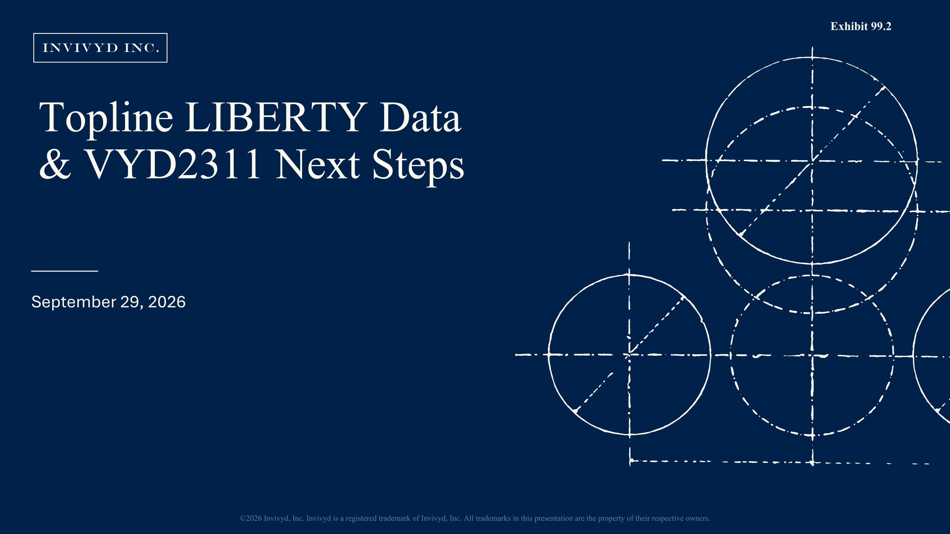
Topline LIBERTY Data ?& VYD2311 Next Steps September 29, 2026 ©2026 Invivyd, Inc. Invivyd is a registered trademark of Invivyd, Inc. All trademarks in this presentation are the property of their respective owners. Exhibit 99.2

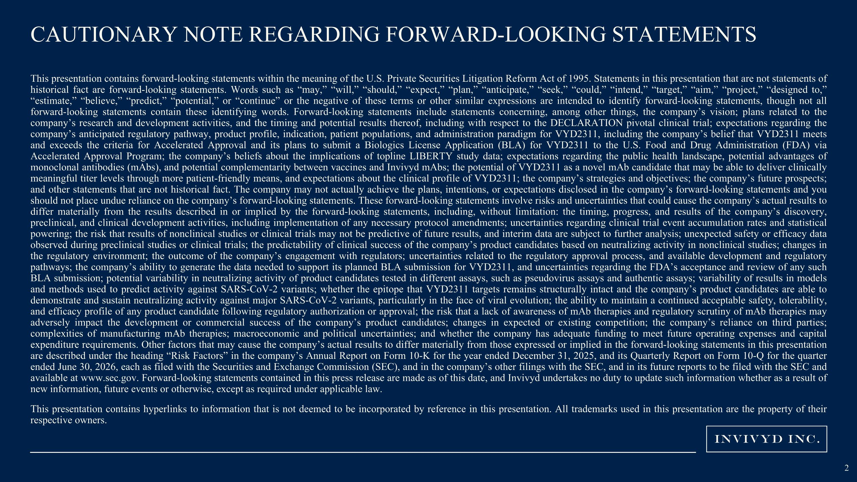
CAUTIONARY NOTE REGARDING FORWARD-LOOKING STATEMENTS This presentation contains forward-looking statements within the meaning of the U.S. Private Securities Litigation Reform Act of 1995. Statements in this presentation that are not statements of historical fact are forward-looking statements. Words such as “may,” “will,” “should,” “expect,” “plan,” “anticipate,” “seek,” “could,” “intend,” “target,” “aim,” “project,” “designed to,” “estimate,” “believe,” “predict,” “potential,” or “continue” or the negative of these terms or other similar expressions are intended to identify forward-looking statements, though not all forward-looking statements contain these identifying words. Forward-looking statements include statements concerning, among other things, the company’s vision; plans related to the company’s research and development activities, and the timing and potential results thereof, including with respect to the DECLARATION pivotal clinical trial; expectations regarding the company’s anticipated regulatory pathway, product profile, indication, patient populations, and administration paradigm for VYD2311, including the company’s belief that VYD2311 meets and exceeds the criteria for Accelerated Approval and its plans to submit a Biologics License Application (BLA) for VYD2311 to the U.S. Food and Drug Administration (FDA) via Accelerated Approval Program; the company’s beliefs about the implications of topline LIBERTY study data; expectations regarding the public health landscape, potential advantages of monoclonal antibodies (mAbs), and potential complementarity between vaccines and Invivyd mAbs; the potential of VYD2311 as a novel mAb candidate that may be able to deliver clinically meaningful titer levels through more patient-friendly means, and expectations about the clinical profile of VYD2311; the company’s strategies and objectives; the company’s future prospects; and other statements that are not historical fact. The company may not actually achieve the plans, intentions, or expectations disclosed in the company’s forward-looking statements and you should not place undue reliance on the company’s forward-looking statements. These forward-looking statements involve risks and uncertainties that could cause the company’s actual results to differ materially from the results described in or implied by the forward-looking statements, including, without limitation: the timing, progress, and results of the company’s discovery, preclinical, and clinical development activities, including implementation of any necessary protocol amendments; uncertainties regarding clinical trial event accumulation rates and statistical powering; the risk that results of nonclinical studies or clinical trials may not be predictive of future results, and interim data are subject to further analysis; unexpected safety or efficacy data observed during preclinical studies or clinical trials; the predictability of clinical success of the company’s product candidates based on neutralizing activity in nonclinical studies; changes in the regulatory environment; the outcome of the company’s engagement with regulators; uncertainties related to the regulatory approval process, and available development and regulatory pathways; the company’s ability to generate the data needed to support its planned BLA submission for VYD2311, and uncertainties regarding the FDA’s acceptance and review of any such BLA submission; potential variability in neutralizing activity of product candidates tested in different assays, such as pseudovirus assays and authentic assays; variability of results in models and methods used to predict activity against SARS-CoV-2 variants; whether the epitope that VYD2311 targets remains structurally intact and the company’s product candidates are able to demonstrate and sustain neutralizing activity against major SARS-CoV-2 variants, particularly in the face of viral evolution; the ability to maintain a continued acceptable safety, tolerability, and efficacy profile of any product candidate following regulatory authorization or approval; the risk that a lack of awareness of mAb therapies and regulatory scrutiny of mAb therapies may adversely impact the development or commercial success of the company’s product candidates; changes in expected or existing competition; the company’s reliance on third parties; complexities of manufacturing mAb therapies; macroeconomic and political uncertainties; and whether the company has adequate funding to meet future operating expenses and capital expenditure requirements. Other factors that may cause the company’s actual results to differ materially from those expressed or implied in the forward-looking statements in this presentation are described under the heading “Risk Factors” in the company’s Annual Report on Form 10-K for the year ended December 31, 2025, and its Quarterly Report on Form 10-Q for the quarter ended June 30, 2026, each as filed with the Securities and Exchange Commission (SEC), and in the company’s other filings with the SEC, and in its future reports to be filed with the SEC and available at www.sec.gov. Forward-looking statements contained in this press release are made as of this date, and Invivyd undertakes no duty to update such information whether as a result of new information, future events or otherwise, except as required under applicable law. This presentation contains hyperlinks to information that is not deemed to be incorporated by reference in this presentation. All trademarks used in this presentation are the property of their respective owners.

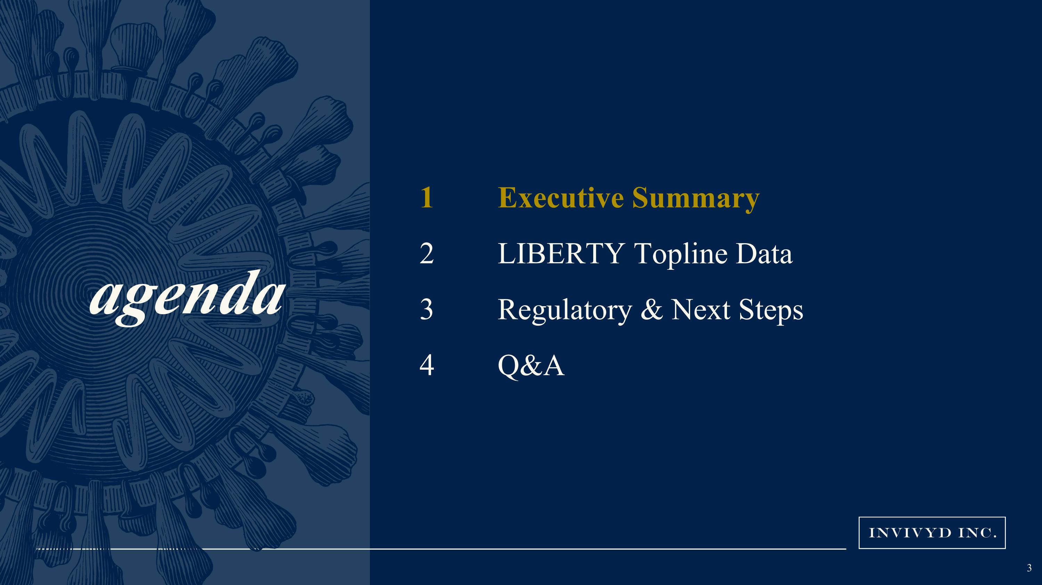
agenda Executive Summary LIBERTY Topline Data Regulatory & Next Steps Q&A

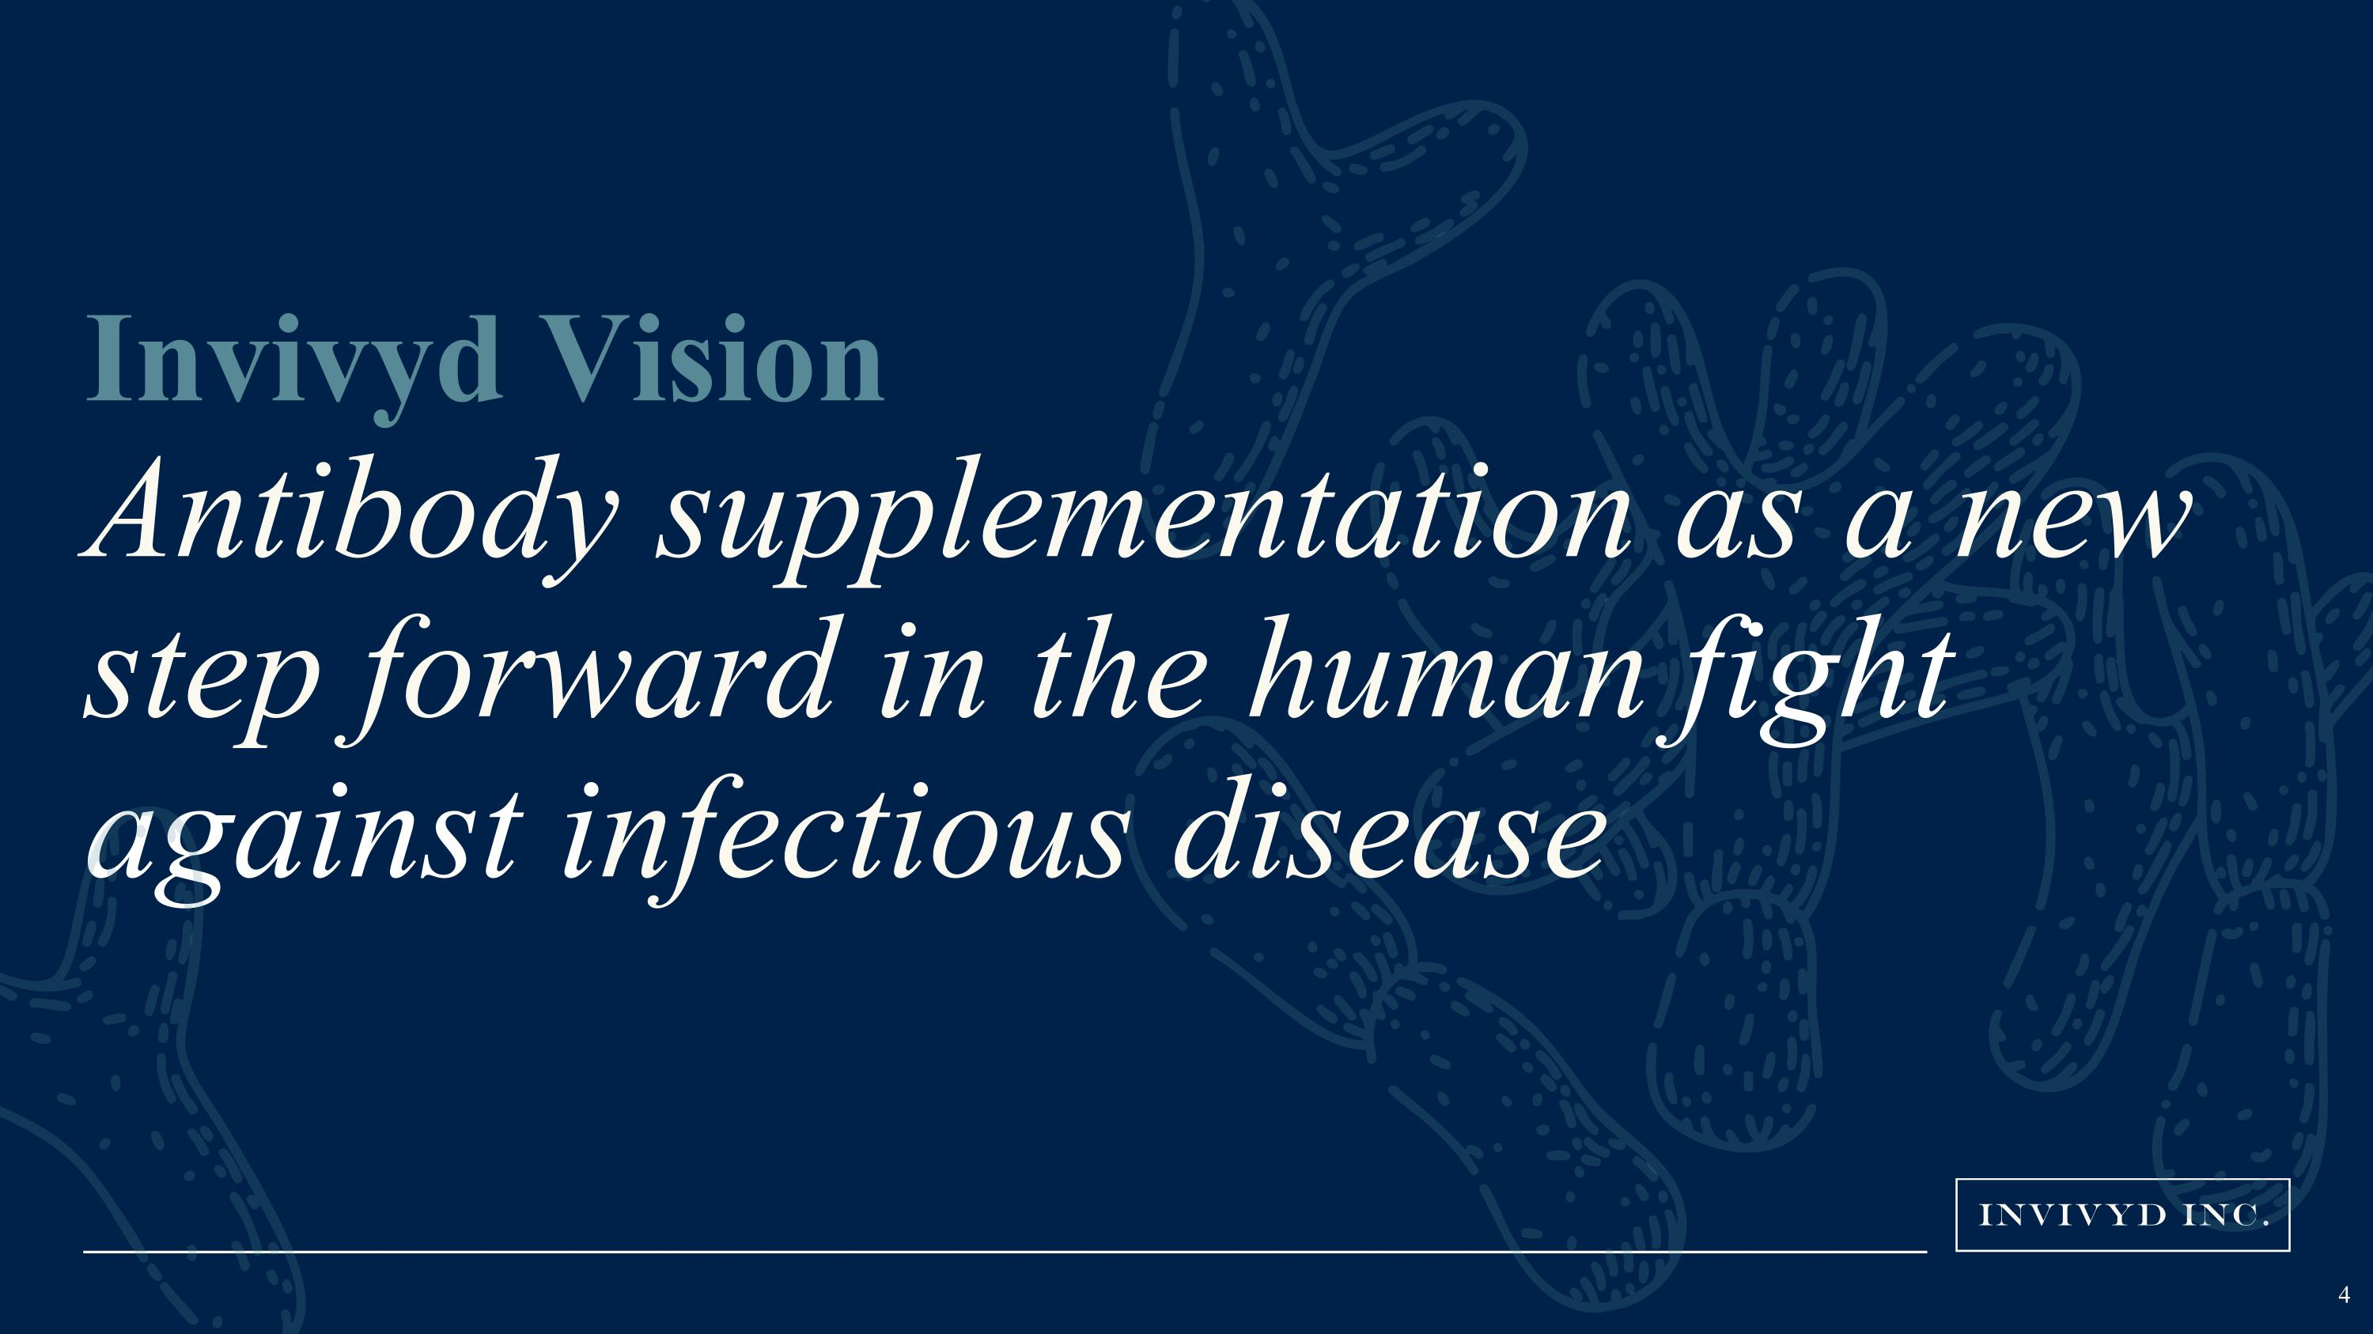
Invivyd Vision?Antibody supplementation as a new step forward in the human fight against infectious disease 4

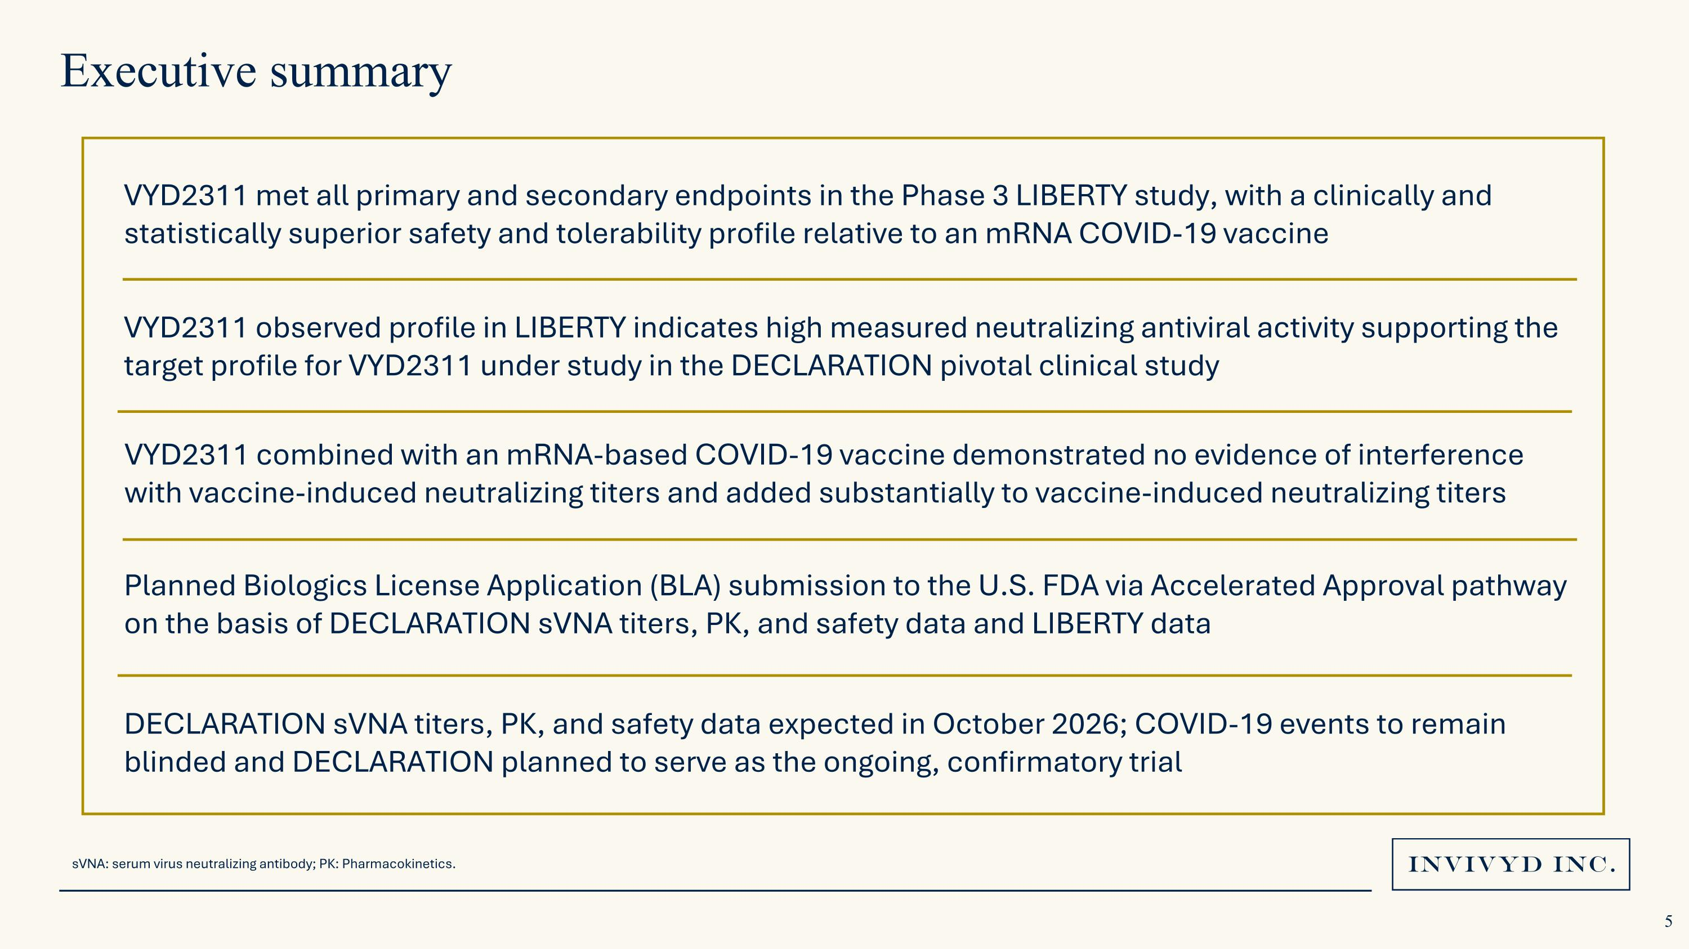
VYD2311 met all primary and secondary endpoints in the Phase 3 LIBERTY study, with a clinically and statistically superior safety and tolerability profile relative to an mRNA COVID-19 vaccine VYD2311 observed profile in LIBERTY indicates high measured neutralizing antiviral activity supporting the target profile for VYD2311 under study in the DECLARATION pivotal clinical study Planned Biologics License Application (BLA) submission to the U.S. FDA via Accelerated Approval pathway on the basis of DECLARATION sVNA titers, PK, and safety data and LIBERTY data DECLARATION sVNA titers, PK, and safety data expected in October 2026; COVID-19 events to remain blinded and DECLARATION planned to serve as the ongoing, confirmatory trial Executive summary VYD2311 combined with an mRNA-based COVID-19 vaccine demonstrated no evidence of interference with vaccine-induced neutralizing titers and added substantially to vaccine-induced neutralizing titers sVNA: serum virus neutralizing antibody; PK: Pharmacokinetics.


agenda Executive Summary LIBERTY Topline Data Regulatory & Next Steps Q&A

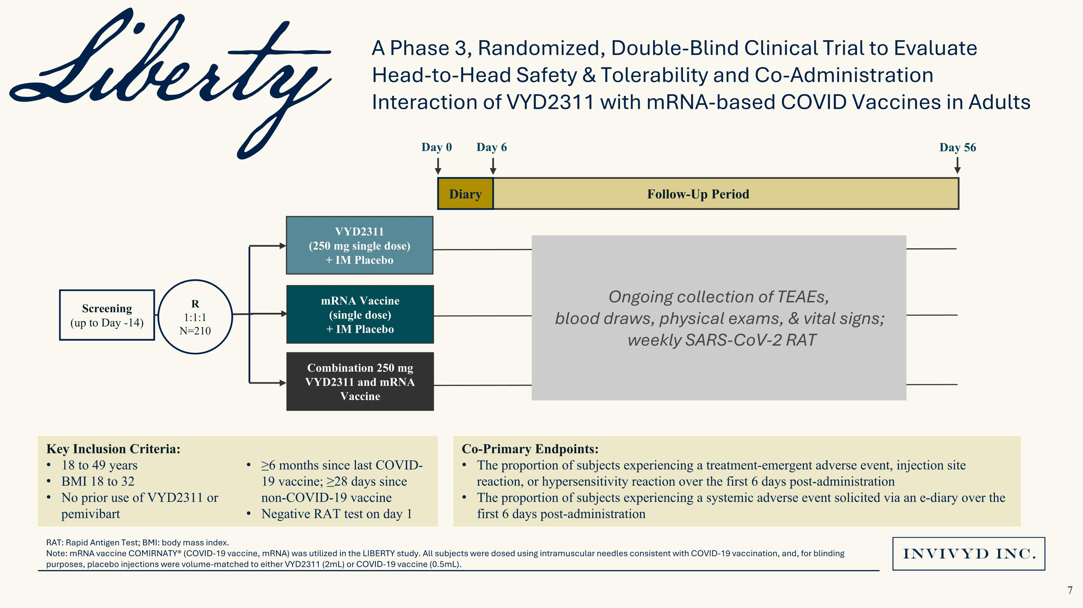
RAT: Rapid Antigen Test; BMI: body mass index. Note: mRNA vaccine COMIRNATY® (COVID-19 vaccine, mRNA) was utilized in the LIBERTY study. All subjects were dosed using intramuscular needles consistent with COVID-19 vaccination, and, for blinding purposes, placebo injections were volume-matched to either VYD2311 (2mL) or COVID-19 vaccine (0.5mL). Co-Primary Endpoints: The proportion of subjects experiencing a treatment-emergent adverse event, injection site reaction, or hypersensitivity reaction over the first 6 days post-administration The proportion of subjects experiencing a systemic adverse event solicited via an e-diary over the first 6 days post-administration A Phase 3, Randomized, Double-Blind Clinical Trial to Evaluate Head-to-Head Safety & Tolerability and Co-Administration Interaction of VYD2311 with mRNA-based COVID Vaccines in Adults Screening (up to Day -14) R 1:1:1 N=210 VYD2311 (250 mg single dose) ?+ IM Placebo mRNA Vaccine (single dose) ?+ IM Placebo Combination 250 mg VYD2311 and mRNA Vaccine Follow-Up Period Day 0 Day 56 Diary Day 6 Key Inclusion Criteria: 18 to 49 years BMI 18 to 32 No prior use of VYD2311 or pemivibart X ≥6 months since last COVID-19 vaccine; ≥28 days since non-COVID-19 vaccine Negative RAT test on day 1 Ongoing collection of TEAEs, blood draws, physical exams, & vital signs;? weekly SARS-CoV-2 RAT

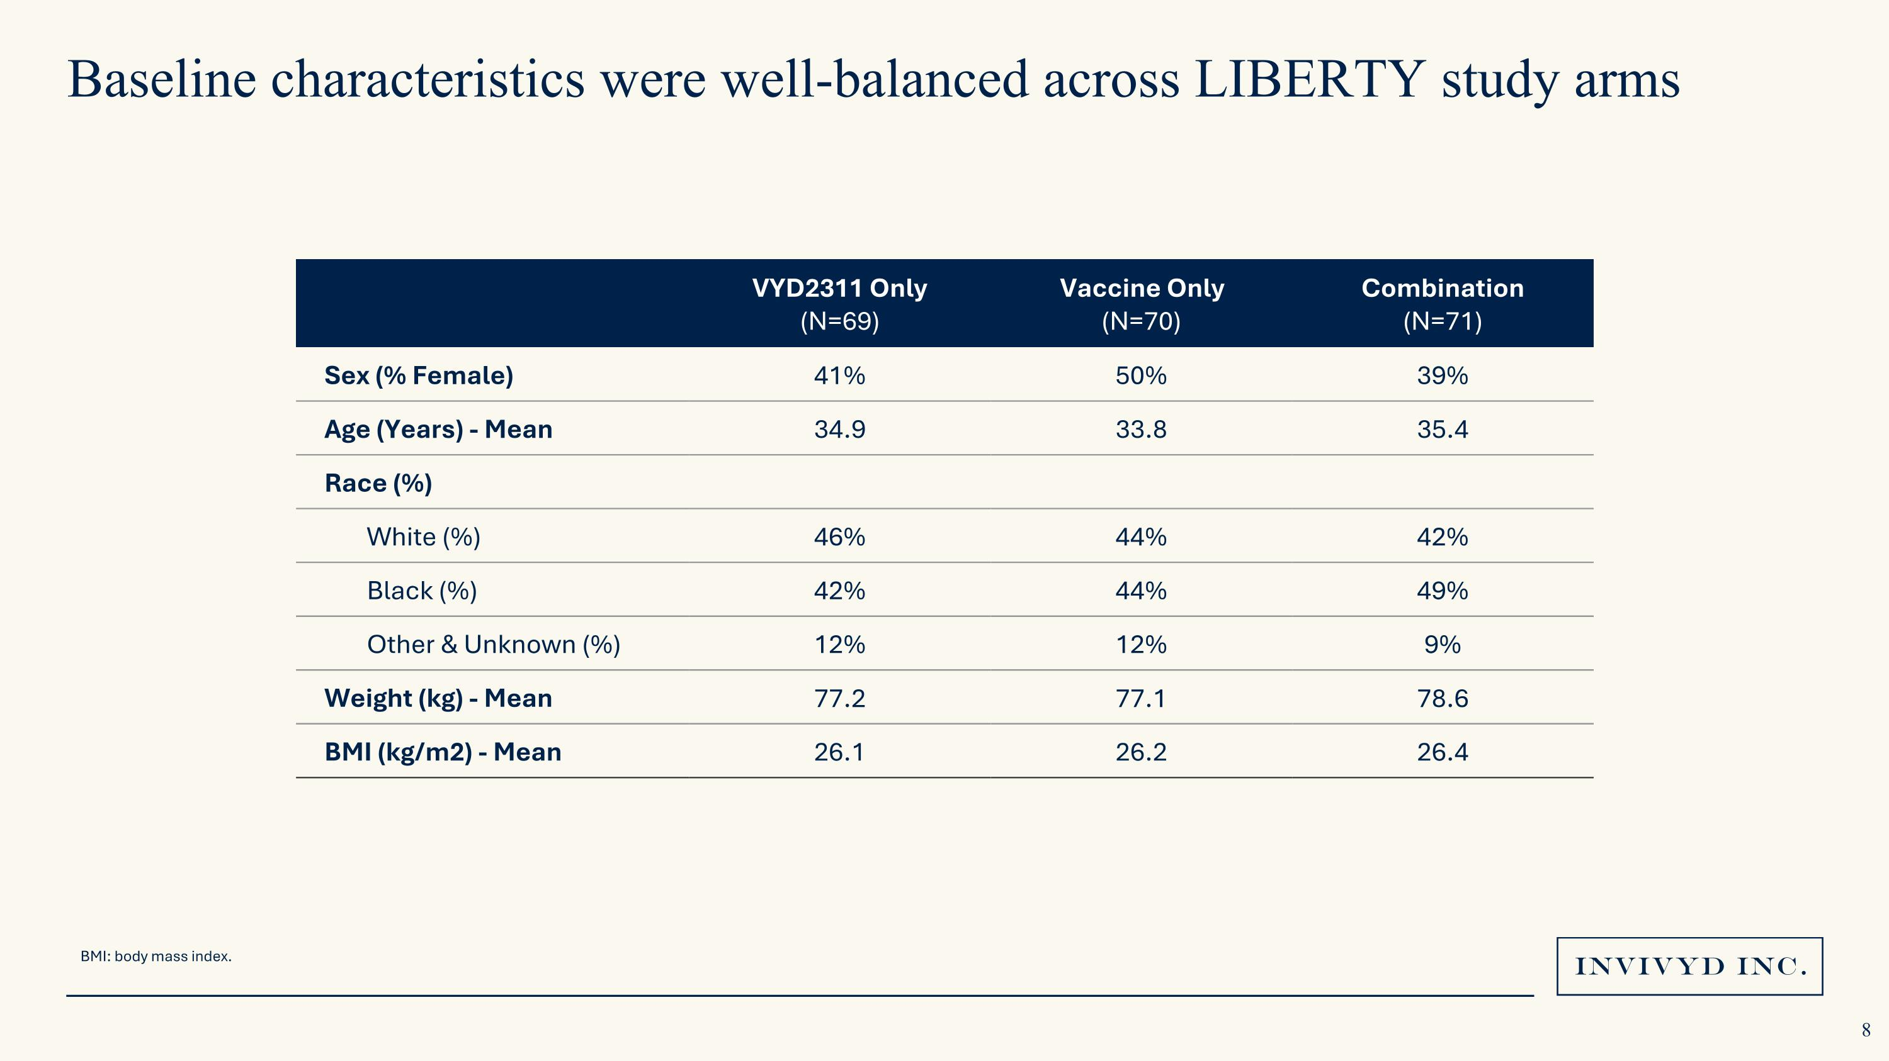
Baseline characteristics were well-balanced across LIBERTY study arms VYD2311 Only (N=69) Vaccine Only (N=70) Combination (N=71) Sex (% Female) 41% 50% 39% Age (Years) - Mean 34.9 33.8 35.4 Race (%) White (%) 46% 44% 42% Black (%) 42% 44% 49% Other & Unknown (%) 12% 12% 9% Weight (kg) - Mean 77.2 77.1 78.6 BMI (kg/m2) - Mean 26.1 26.2 26.4 BMI: body mass index.

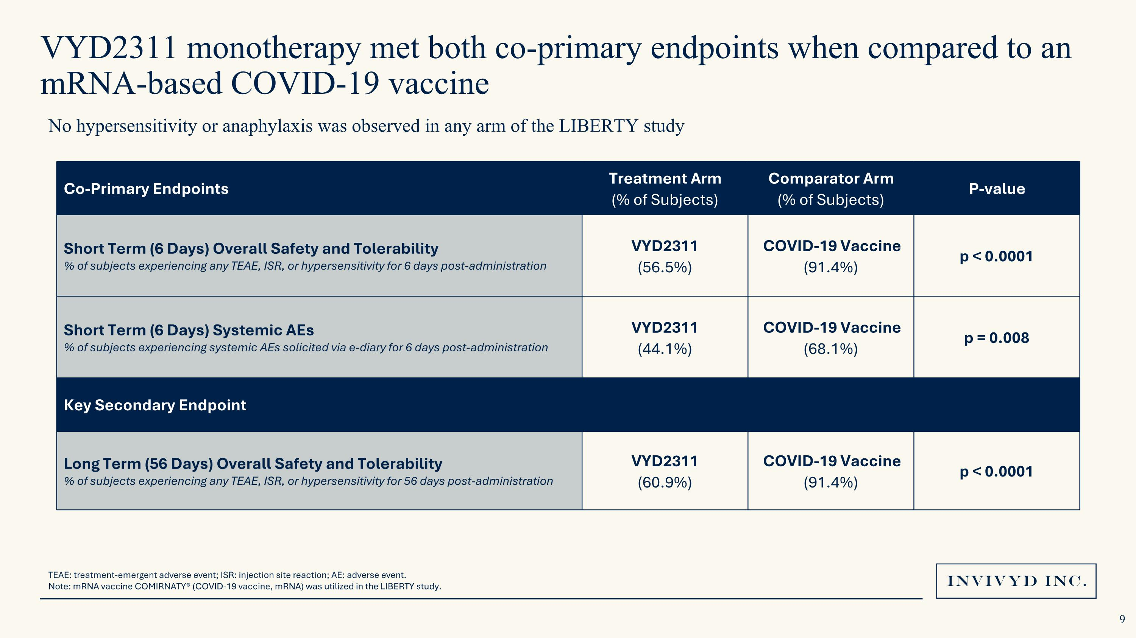
VYD2311 monotherapy met both co-primary endpoints when compared to an mRNA-based COVID-19 vaccine TEAE: treatment-emergent adverse event; ISR: injection site reaction; AE: adverse event. Note: mRNA vaccine COMIRNATY® (COVID-19 vaccine, mRNA) was utilized in the LIBERTY study. No hypersensitivity or anaphylaxis was observed in any arm of the LIBERTY study Co-Primary Endpoints Treatment Arm?(% of Subjects) Comparator Arm?(% of Subjects) P-value Short Term (6 Days) Overall Safety and Tolerability % of subjects experiencing any TEAE, ISR, or hypersensitivity for 6 days post-administration VYD2311?(56.5%) COVID-19 Vaccine ?(91.4%) p < 0.0001 Short Term (6 Days) Systemic AEs?% of subjects experiencing systemic AEs solicited via e-diary for 6 days post-administration VYD2311?(44.1%) COVID-19 Vaccine?(68.1%) p = 0.008 Key Secondary Endpoint Long Term (56 Days) Overall Safety and Tolerability ?% of subjects experiencing any TEAE, ISR, or hypersensitivity for 56 days post-administration VYD2311?(60.9%) COVID-19 Vaccine?(91.4%) p < 0.0001

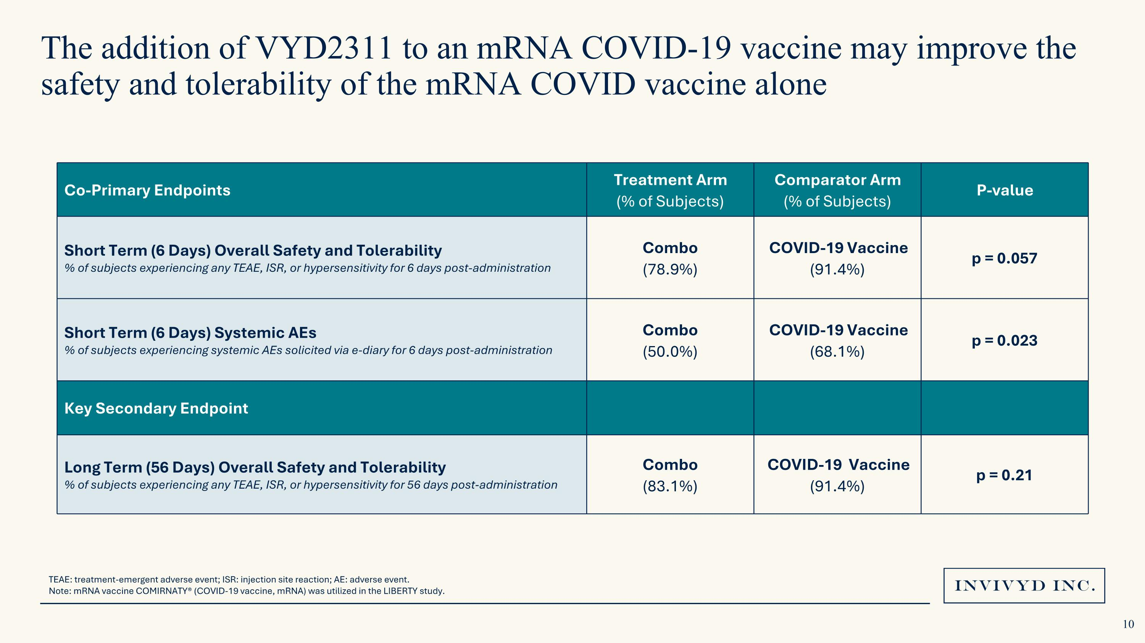
The addition of VYD2311 to an mRNA COVID-19 vaccine may improve the safety and tolerability of the mRNA COVID vaccine alone Co-Primary Endpoints Treatment Arm?(% of Subjects) Comparator Arm?(% of Subjects) P-value Short Term (6 Days) Overall Safety and Tolerability % of subjects experiencing any TEAE, ISR, or hypersensitivity for 6 days post-administration Combo ?(78.9%) COVID-19 Vaccine ?(91.4%) p = 0.057 Short Term (6 Days) Systemic AEs?% of subjects experiencing systemic AEs solicited via e-diary for 6 days post-administration Combo?(50.0%) COVID-19 Vaccine?(68.1%) p = 0.023 Key Secondary Endpoint Long Term (56 Days) Overall Safety and Tolerability ?% of subjects experiencing any TEAE, ISR, or hypersensitivity for 56 days post-administration Combo?(83.1%) COVID-19 Vaccine?(91.4%) p = 0.21 TEAE: treatment-emergent adverse event; ISR: injection site reaction; AE: adverse event. Note: mRNA vaccine COMIRNATY® (COVID-19 vaccine, mRNA) was utilized in the LIBERTY study.

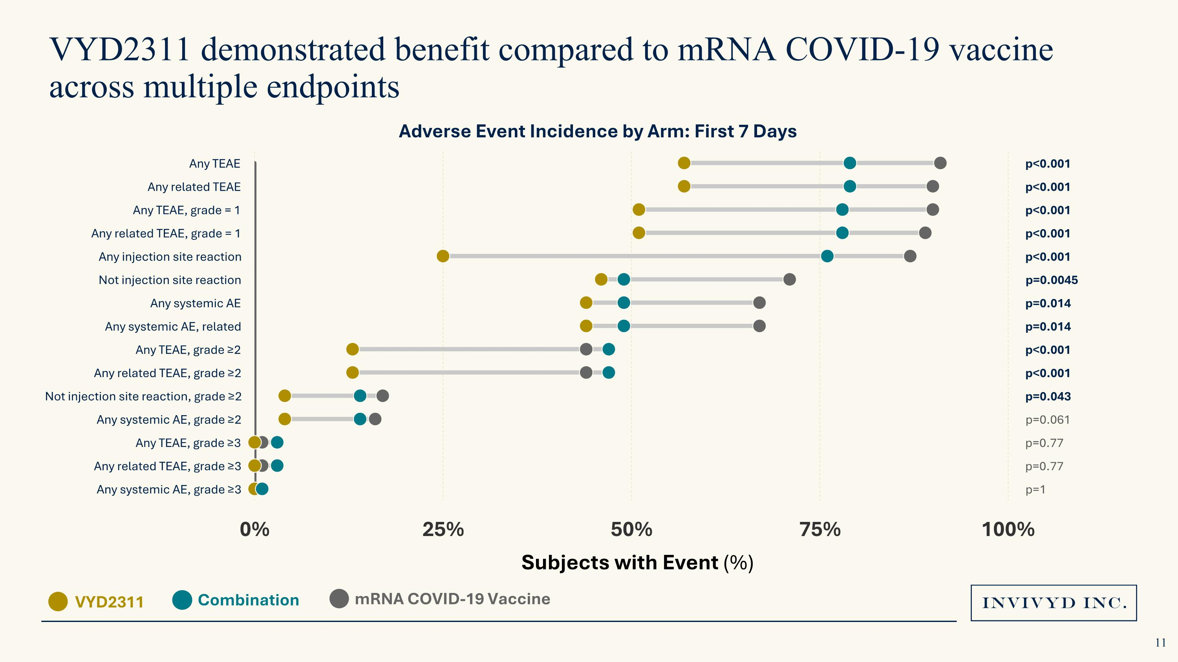
VYD2311 demonstrated benefit compared to mRNA COVID-19 vaccine across multiple endpoints VYD2311 mRNA COVID-19 Vaccine Combination Subjects with Event (%) Adverse Event Incidence by Arm: First 7 Days

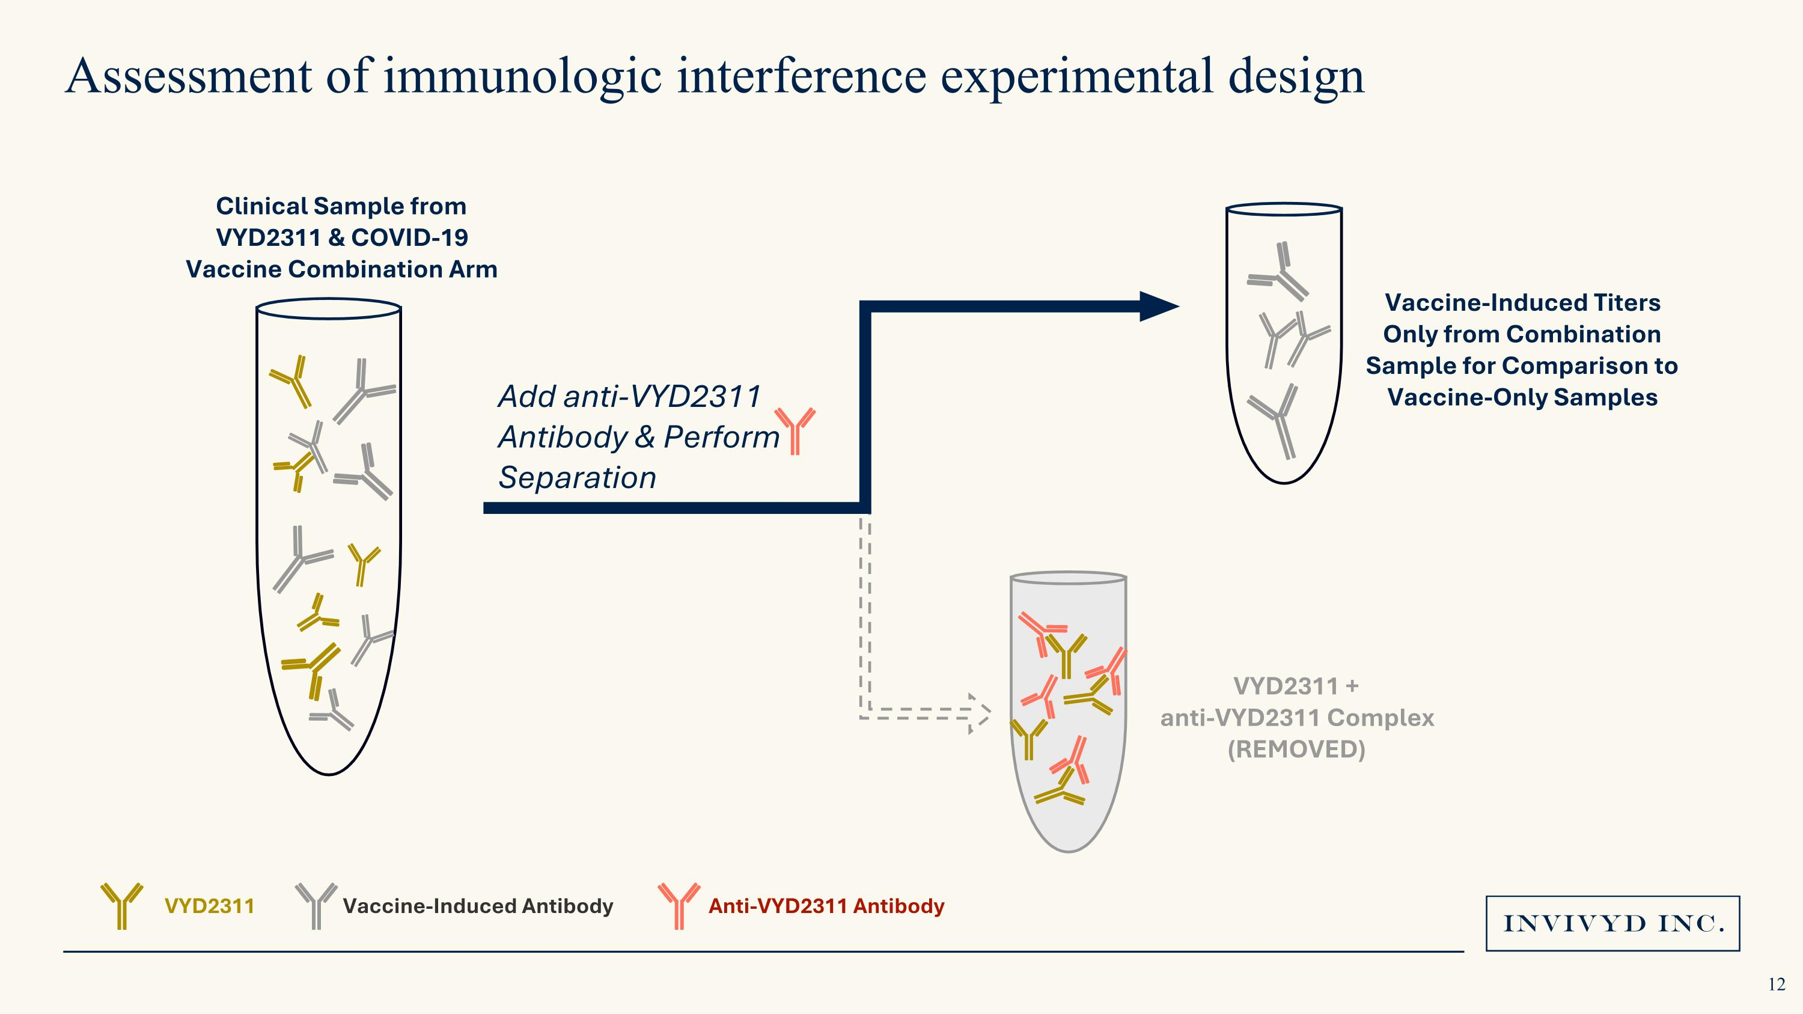
Assessment of immunologic interference experimental design Clinical Sample from ?VYD2311 & COVID-19 Vaccine Combination Arm VYD2311 +?anti-VYD2311 Complex (REMOVED) Vaccine-Induced Titers Only from Combination Sample for Comparison to Vaccine-Only Samples Add anti-VYD2311 ?Antibody & Perform ?Separation VYD2311 Anti-VYD2311 Antibody Vaccine-Induced Antibody

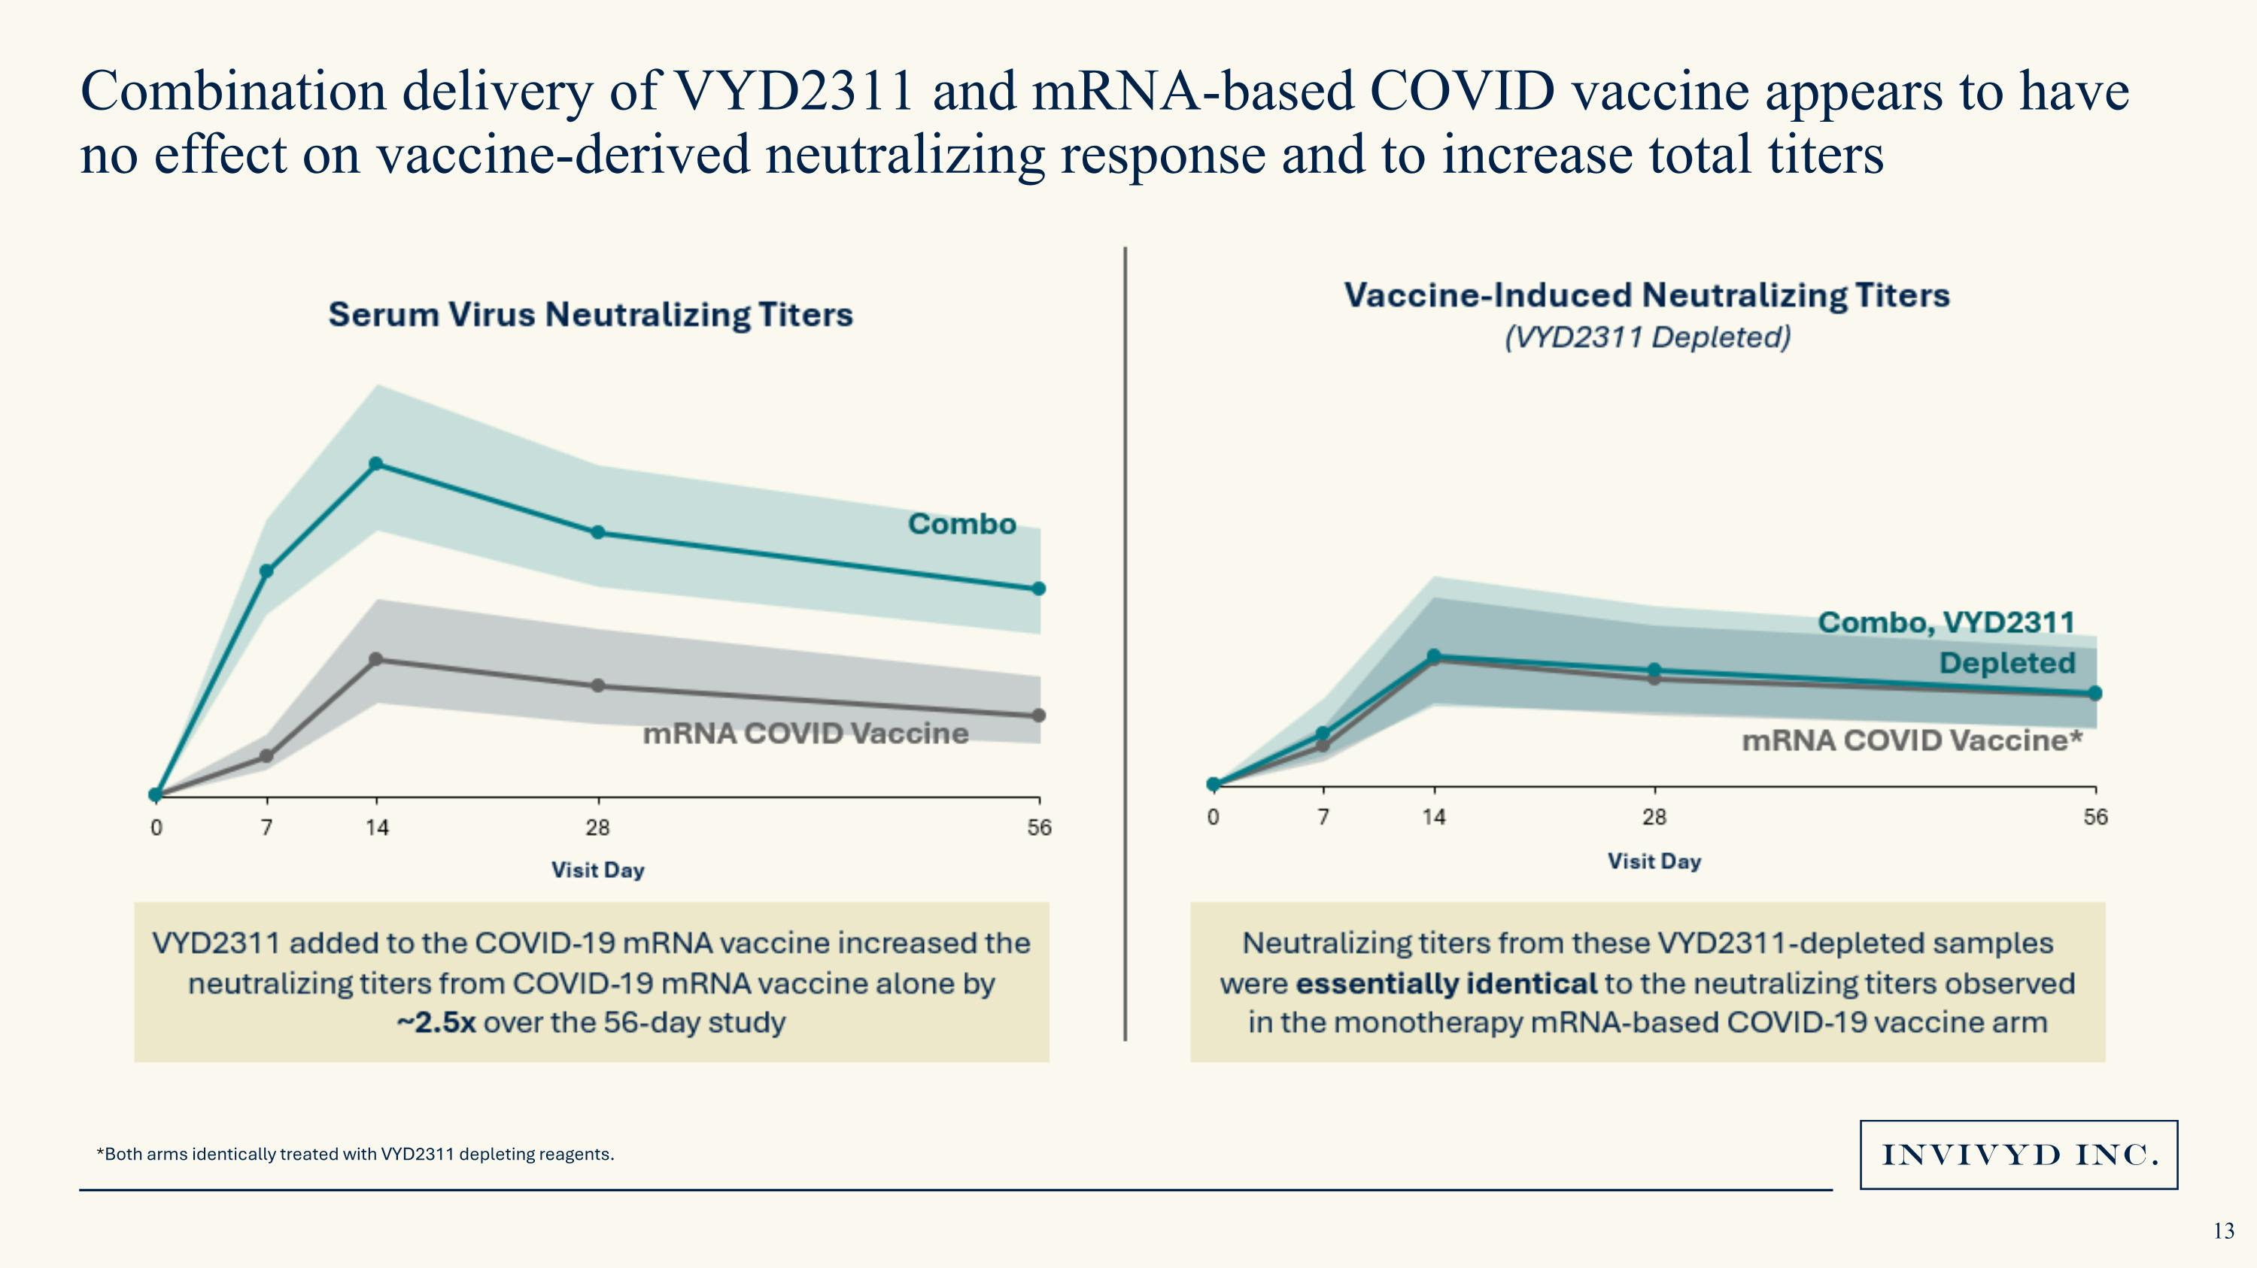
Combination delivery of VYD2311 and mRNA-based COVID vaccine appears to have no effect on vaccine-derived neutralizing response and to increase total titers *Both arms identically treated with VYD2311 depleting reagents.

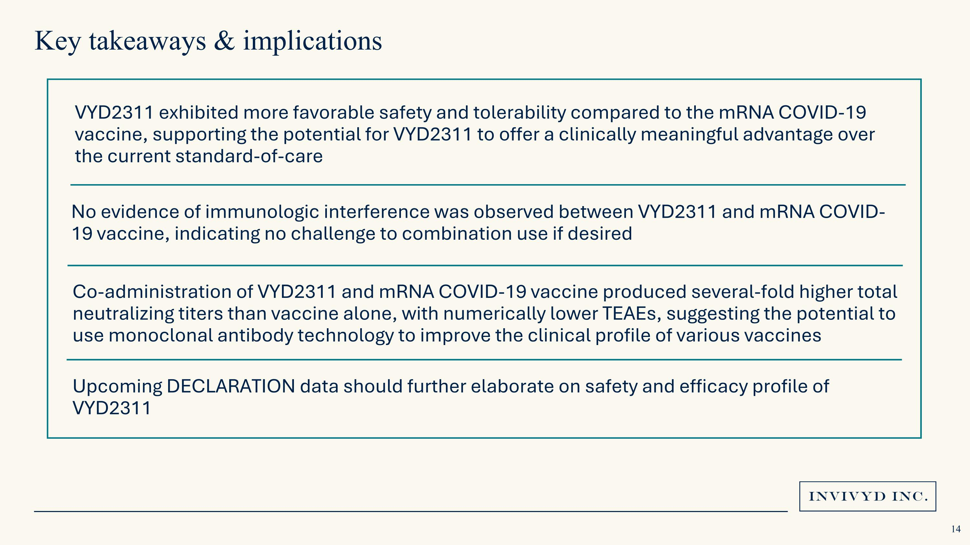
VYD2311 exhibited more favorable safety and tolerability compared to the mRNA COVID-19 vaccine, supporting the potential for VYD2311 to offer a clinically meaningful advantage over the current standard-of-care No evidence of immunologic interference was observed between VYD2311 and mRNA COVID-19 vaccine, indicating no challenge to combination use if desired Upcoming DECLARATION data should further elaborate on safety and efficacy profile of VYD2311 Key takeaways & implications Co-administration of VYD2311 and mRNA COVID-19 vaccine produced several-fold higher total neutralizing titers than vaccine alone, with numerically lower TEAEs, suggesting the potential to use monoclonal antibody technology to improve the clinical profile of various vaccines

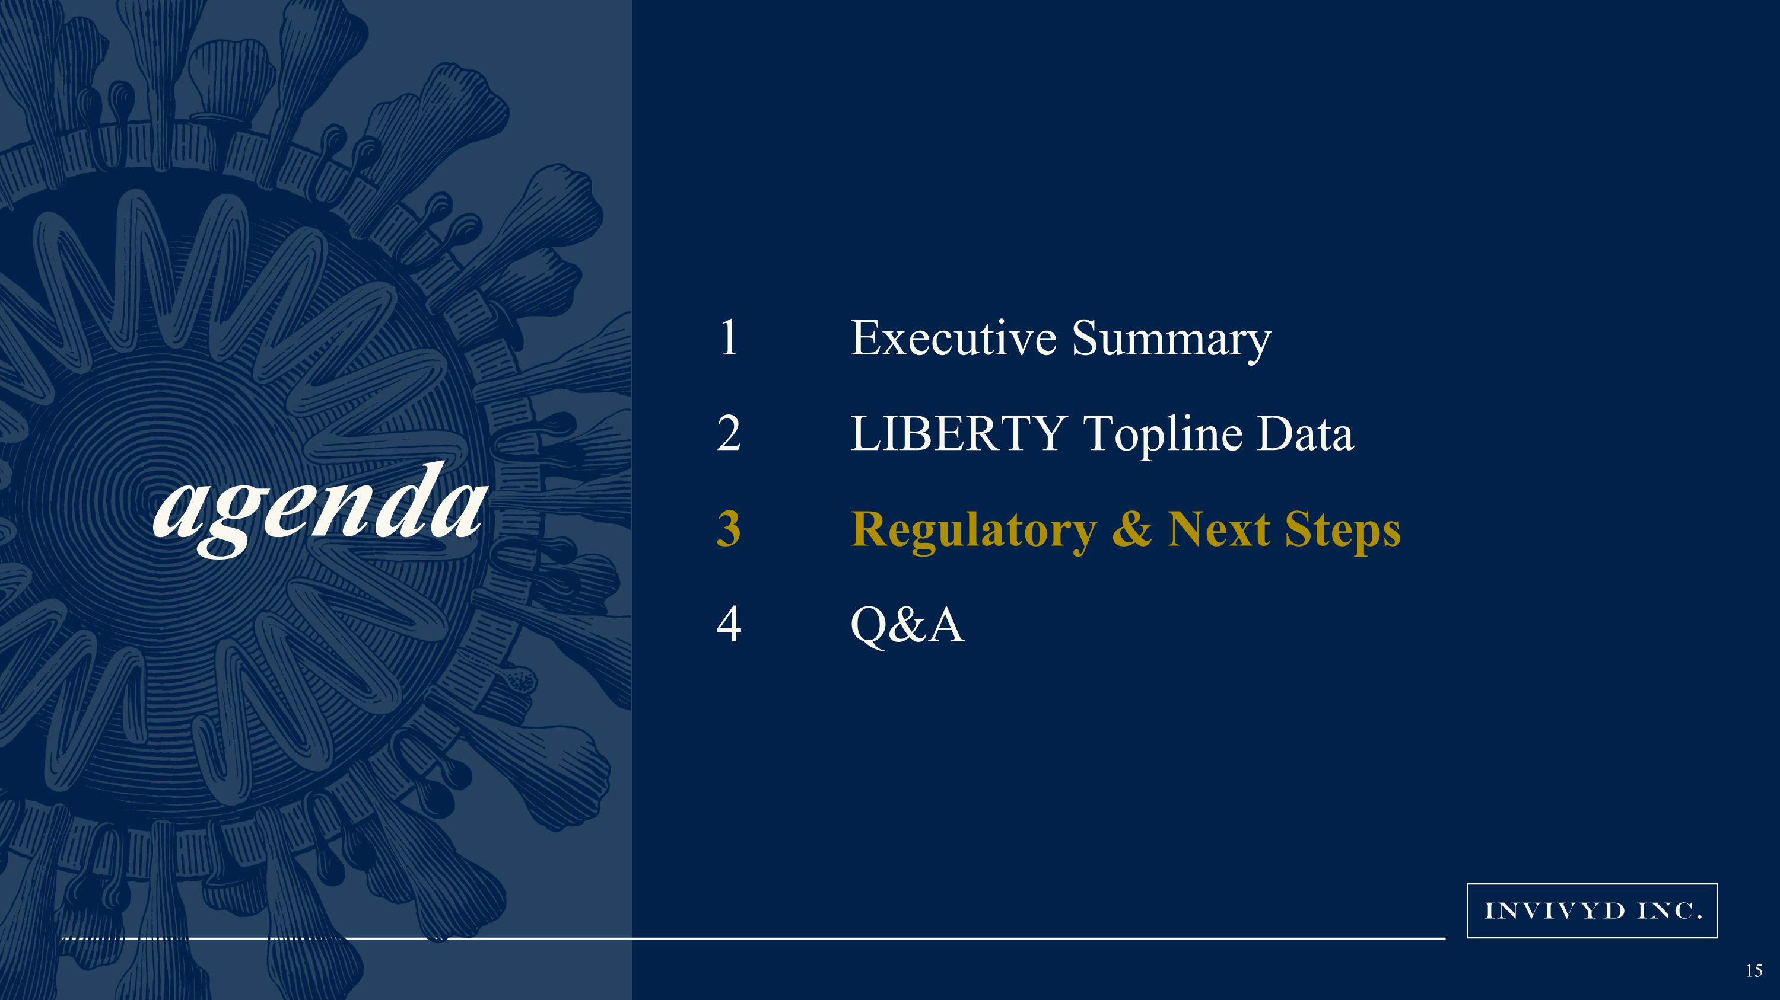
agenda Executive Summary LIBERTY Topline Data Regulatory & Next Steps Q&A

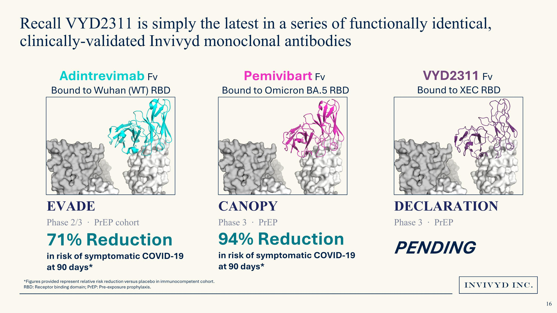
Recall VYD2311 is simply the latest in a series of functionally identical, clinically-validated Invivyd monoclonal antibodies Adintrevimab Fv ?Bound to Wuhan (WT) RBD Pemivibart Fv ?Bound to Omicron BA.5 RBD VYD2311 Fv ?Bound to XEC RBD 71% Reduction in risk of symptomatic COVID-19 at 90 days* 94% Reduction in risk of symptomatic COVID-19 at 90 days* PENDING EVADE Phase 2/3 · PrEP cohort CANOPY Phase 3 · PrEP DECLARATION Phase 3 · PrEP *Figures provided represent relative risk reduction versus placebo in immunocompetent cohort. RBD: Receptor binding domain; PrEP: Pre-exposure prophylaxis.

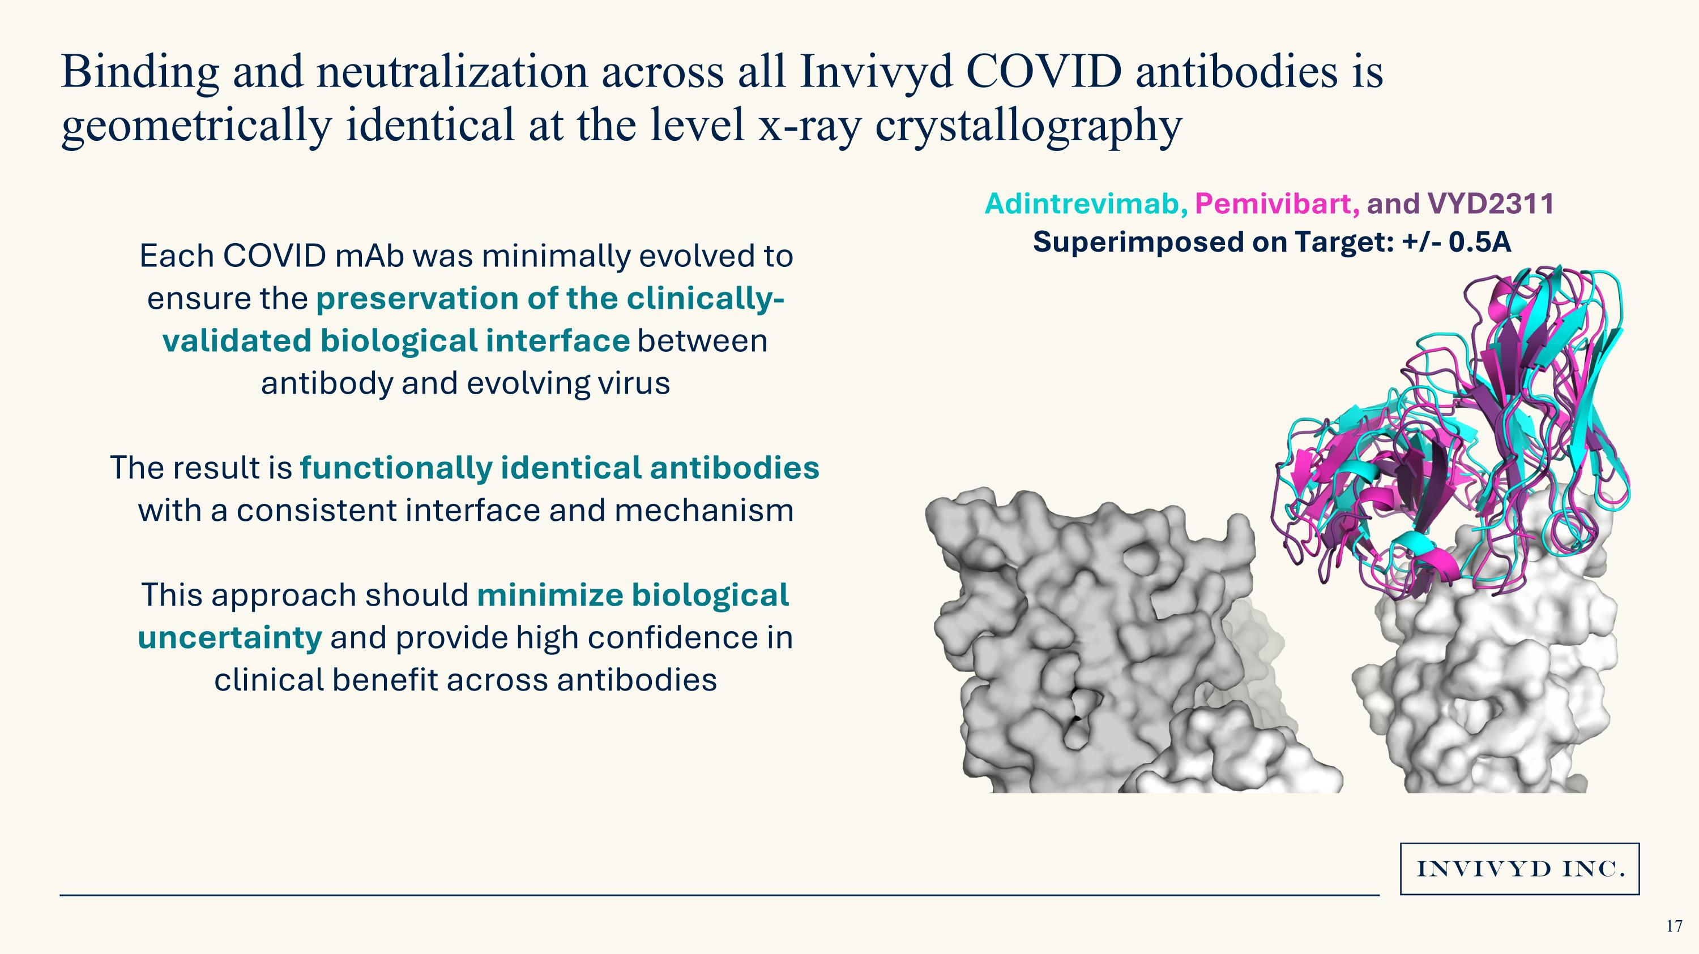
Binding and neutralization across all Invivyd COVID antibodies is geometrically identical at the level x-ray crystallography Adintrevimab, Pemivibart, and VYD2311 Superimposed on Target: +/- 0.5A Each COVID mAb was minimally evolved to ensure the preservation of the clinically-validated biological interface between antibody and evolving virus The result is functionally identical antibodies with a consistent interface and mechanism This approach should minimize biological uncertainty and provide high confidence in clinical benefit across antibodies

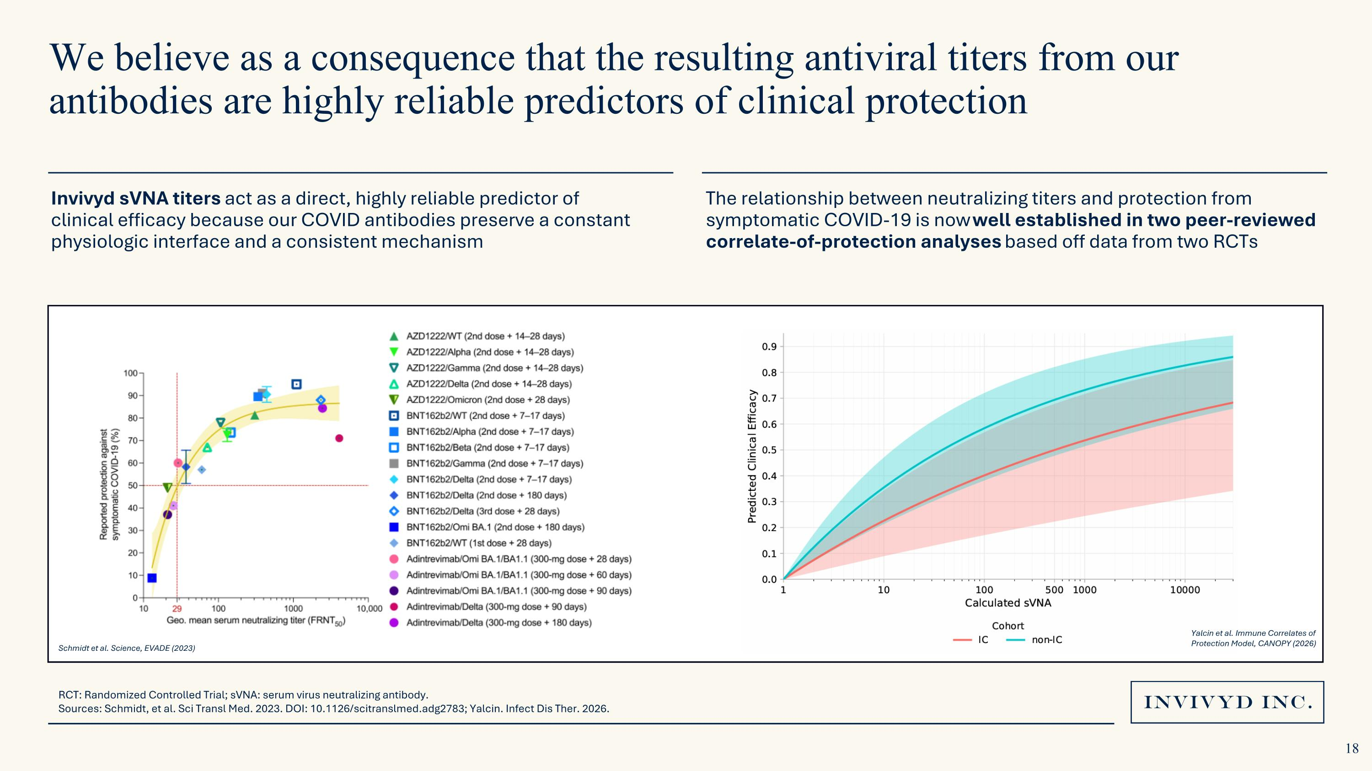
We believe as a consequence that the resulting antiviral titers from our antibodies are highly reliable predictors of clinical protection The relationship between neutralizing titers and protection from symptomatic COVID-19 is now well established in two peer-reviewed correlate-of-protection analyses based off data from two RCTs Yalcin et al. Immune Correlates of ?Protection Model, CANOPY (2026) Schmidt et al. Science, EVADE (2023) RCT: Randomized Controlled Trial; sVNA: serum virus neutralizing antibody. Sources: Schmidt, et al. Sci Transl Med. 2023. DOI: 10.1126/scitranslmed.adg2783; Yalcin. Infect Dis Ther. 2026. Invivyd sVNA titers act as a direct, highly reliable predictor of clinical efficacy because our COVID antibodies preserve a constant physiologic interface and a consistent mechanism

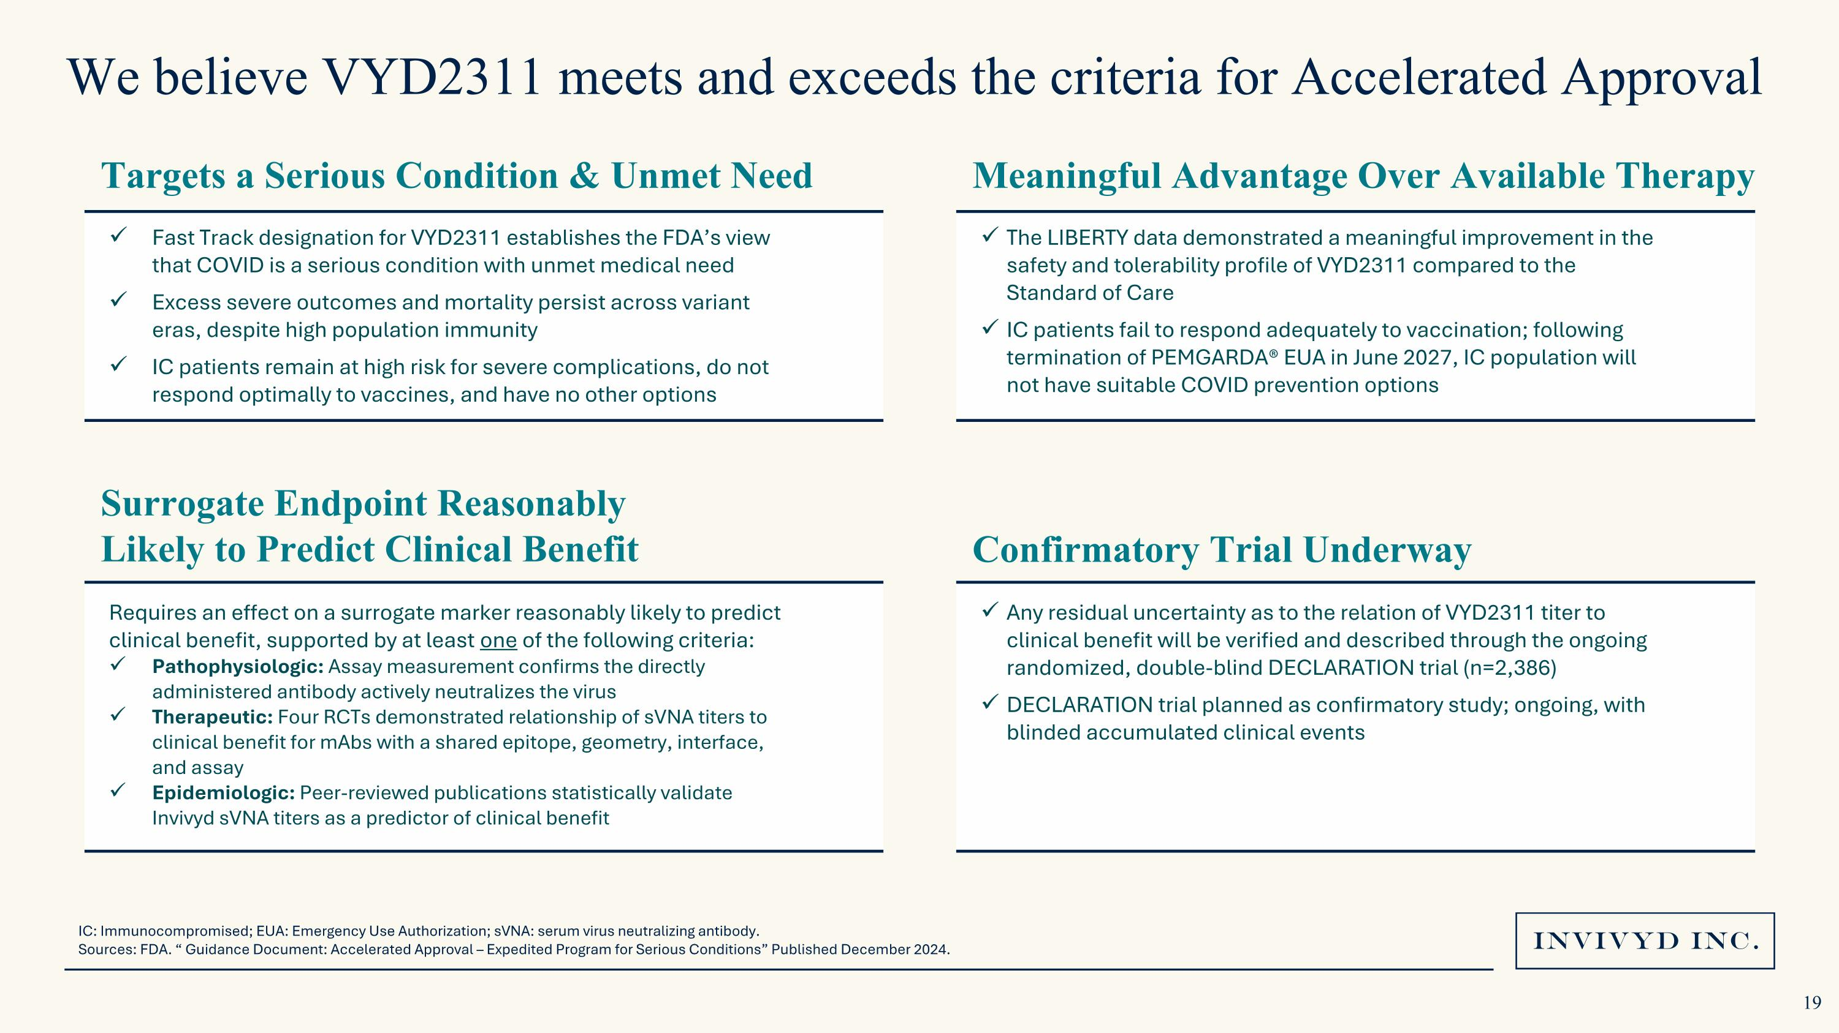
We believe VYD2311 meets and exceeds the criteria for Accelerated Approval IC: Immunocompromised; EUA: Emergency Use Authorization; sVNA: serum virus neutralizing antibody. Sources: FDA. “ Guidance Document: Accelerated Approval – Expedited Program for Serious Conditions” Published December 2024. Fast Track designation for VYD2311 establishes the FDA’s view that COVID is a serious condition with unmet medical need Excess severe outcomes and mortality persist across variant eras, despite high population immunity IC patients remain at high risk for severe complications, do not respond optimally to vaccines, and have no other options Targets a Serious Condition & Unmet Need Surrogate Endpoint Reasonably Likely to Predict Clinical Benefit Requires an effect on a surrogate marker reasonably likely to predict clinical benefit, supported by at least one of the following criteria: Pathophysiologic: Assay measurement confirms the directly administered antibody actively neutralizes the virus Therapeutic: Four RCTs demonstrated relationship of sVNA titers to clinical benefit for mAbs with a shared epitope, geometry, interface, and assay Epidemiologic: Peer-reviewed publications statistically validate Invivyd sVNA titers as a predictor of clinical benefit The LIBERTY data demonstrated a meaningful improvement in the safety and tolerability profile of VYD2311 compared to the Standard of Care IC patients fail to respond adequately to vaccination; following termination of PEMGARDA® EUA in June 2027, IC population will not have suitable COVID prevention options Meaningful Advantage Over Available Therapy Confirmatory Trial Underway Any residual uncertainty as to the relation of VYD2311 titer to clinical benefit will be verified and described through the ongoing randomized, double-blind DECLARATION trial (n=2,386) DECLARATION trial planned as confirmatory study; ongoing, with blinded accumulated clinical events 19

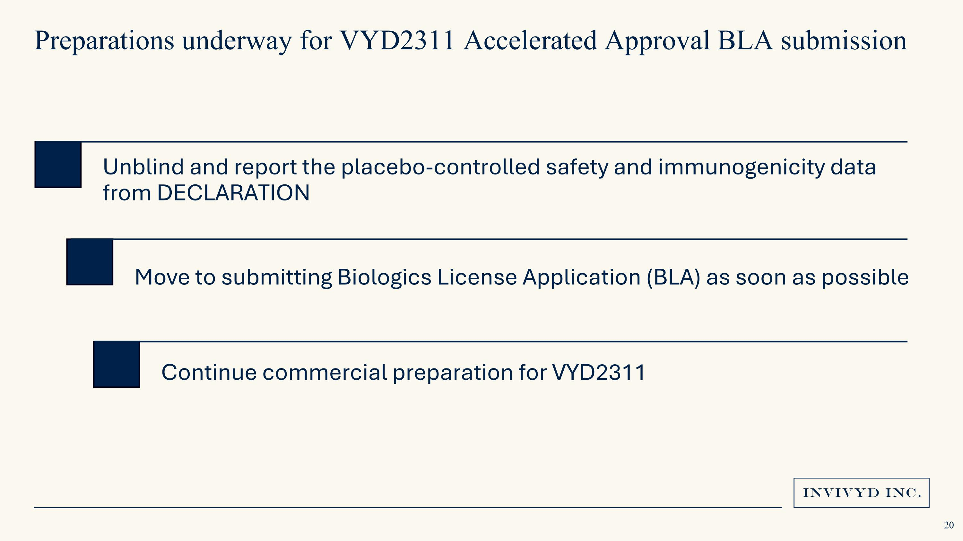
Preparations underway for VYD2311 Accelerated Approval BLA submission Unblind and report the placebo-controlled safety and immunogenicity data from DECLARATION Move to submitting Biologics License Application (BLA) as soon as possible Continue commercial preparation for VYD2311 20

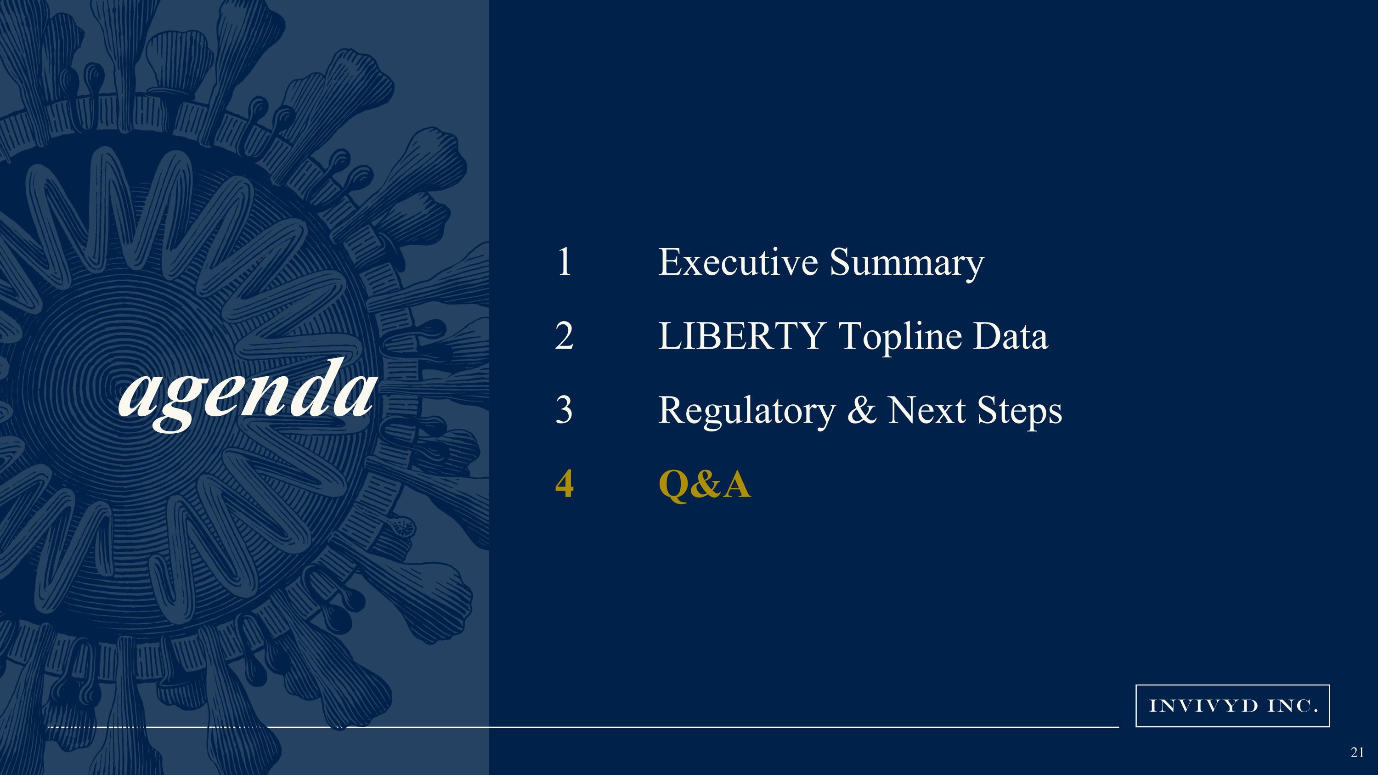
agenda Executive Summary LIBERTY Topline Data Regulatory & Next Steps Q&A


Q&A



