UNITED STATES
SECURITIES AND EXCHANGE COMMISSION
WASHINGTON, D.C. 20549

FORM 8-K

CURRENT REPORT
Pursuant to Section 13 or 15(d)
of the Securities Exchange Act of 1934
Date of report (Date of earliest event reported): November 9, 2023

Invivyd, Inc.
(Exact Name of Registrant as Specified in its Charter)

Delaware |  | 001-40703 |  | 85-1403134
(State or Other Jurisdiction  of Incorporation) |  | (Commission  File Number) |  | (IRS Employer  Identification No.)

1601 Trapelo Road, Suite 178  Waltham, MA |  | 02451
(Address of Principal Executive Offices) |  | (Zip Code)
Registrant’s telephone number, including area code: (781) 819-0080
Not applicable
(Former Name or Former Address, if Changed Since Last Report)

Check the appropriate box below if the Form 8-K filing is intended to simultaneously satisfy the filing obligation of the registrant under any of the following provisions:

☐ | Written communications pursuant to Rule 425 under the Securities Act (17 CFR 230.425)

☐ | Soliciting material pursuant to Rule 14a-12 under the Exchange Act (17 CFR 240.14a-12)

☐ | Pre-commencement communications pursuant to Rule 14d-2(b) under the Exchange Act (17 CFR 240.14d-2(b))

☐ | Pre-commencement communications pursuant to Rule 13e-4(c) under the Exchange Act (17 CFR 240.13e-4(c))
Securities registered pursuant to Section 12(b) of the Act:

Title of each class |  | Trading  Symbol(s) |  | Name of each exchange  on which registered
Common stock, par value $0.0001 per share |  | IVVD |  | The Nasdaq Stock Market LLC
Indicate by check mark whether the registrant is an emerging growth company as defined in Rule 405 of the Securities Act of 1933 (§230.405 of this chapter) or Rule 12b-2 of the Securities Exchange Act of 1934 (§240.12b-2 of this chapter).
Emerging growth company ☒
If an emerging growth company, indicate by check mark if the registrant has elected not to use the extended transition period for complying with any new or revised financial accounting standards provided pursuant to Section 13(a) of the Exchange Act. ☐

Item 2.02. | Results of Operations and Financial Condition.
On November 9, 2023, Invivyd, Inc. (the “Company”) issued a press release announcing its financial results for the quarter ended September 30, 2023, and recent business highlights. A copy of the press release is furnished as Exhibit 99.1 to this Current Report on Form 8-K and is incorporated by reference into this Item 2.02.
The information furnished pursuant to this Item 2.02, including Exhibit 99.1, shall not be deemed to be “filed” for purposes of Section 18 of the Securities Exchange Act of 1934, as amended (the “Exchange Act”), or otherwise subject to the liabilities of that Section, nor shall it be deemed to be incorporated by reference into any of the Company’s filings with the Securities and Exchange Commission under the Exchange Act or the Securities Act of 1933, as amended, whether made before or after the date hereof, regardless of any general incorporation language in such a filing, except as expressly set forth by specific reference in such a filing.

Item 8.01. | Other Events.
On November 9, 2023, the Company posted an updated corporate presentation on its website at www.invivyd.com. A copy of the presentation is filed as Exhibit 99.2 to this Current Report on Form 8-K and is incorporated by reference into this Item 8.01.

Item 9.01. | Financial Statements and Exhibits.
(d) Exhibits

Exhibit  No. |  | Description
99.1 |  | Press Release, dated November 9, 2023
99.2 |  | Corporate Presentation, dated November 9, 2023
104 |  | Cover Page Interactive Data File (embedded within the Inline XBRL document)

SIGNATURES
Pursuant to the requirements of the Securities Exchange Act of 1934, as amended, the registrant has duly caused this report to be signed on its behalf by the undersigned hereunto duly authorized.

 |  |  |  | INVIVYD, INC.
Date: November 9, 2023 |  |  |  | By: |  | /s/ Jill Andersen
 |  |  |  |  |  | Jill Andersen
 |  |  |  |  |  | Chief Legal Officer and Corporate Secretary
Exhibit 99.1
Invivyd Reports Third Quarter 2023 Financial Results and Recent Business Highlights

 |  |  | Enrollment completed in CANOPY Phase 3 pivotal clinical trial investigating VYD222 for the prevention of symptomatic COVID-19

 |  |  | Company expects to have initial CANOPY primary endpoint data by late 2023 or early Q1 2024

 |  |  | Company aims to submit an application for Emergency Use Authorization (EUA) in the U.S. as soon as practicable

 |  |  | Company continues to advance INVYMABTM, its proprietary platform approach designed for rapid, serial generation of new antibodies to address viral threats

 |  |  | Cash, cash equivalents and marketable securities of $264.9 million expected to support operating runway remains into the fourth quarter of 2024, excluding potential contribution of commercial product revenue

 |  |  | Conference call scheduled for Thursday, November 9th at 4:30 p.m. ET
Waltham, MA  November 9, 2023  Invivyd, Inc. (Nasdaq: IVVD), a clinical-stage biopharmaceutical company on a mission to protect the vulnerable from serious viral infectious diseases, today announced financial results for the quarter ended September 30, 2023, and recent business highlights.
I am immensely proud of our team and their remarkable performance throughout the third quarter. In September, less than six months after initiating a Phase 1 clinical trial, we announced we had dosed the first participant in CANOPY, our Phase 3 pivotal clinical trial investigating VYD222 for the prevention of symptomatic COVID-19. Today we are pleased to announce that we have completed enrollment in the CANOPY trial and continue to expect to have initial primary endpoint data in late 2023 or early Q1 2024, said Dave Hering, Chief Executive Officer of Invivyd. Given the urgent unmet medical need, we continue to aim to submit an application for EUA to the U.S. Food and Drug Administration (FDA) as soon as practicable.
Mr. Hering added, In preparation for a potential EUA, we have been engaged in commercial planning for an anticipated market entry of VYD222 in 2024. With an estimated total addressable market of more than 9 million immunocompromised individuals in the U.S., our teams have been developing and refining our strategy, which will initially focus on serving the highest risk immunocompromised people. Furthermore, we continue to have constructive dialogue with the FDA regarding potential pathways that would enable us to fully leverage our INVYMAB platform approach to rapidly and perpetually deliver monoclonal antibody candidates designed to keep pace with viral evolution.
Recent VYD222 Program Updates:

 |  |  | Enrollment completed in CANOPY Phase 3 pivotal clinical trial of VYD222: Invivyd enrolled approximately 750 participants across two cohorts, including approximately 300 individuals who are significantly immunocompromised in Cohort A and approximately 450 individuals at risk of exposure to SARS-CoV-2 in Cohort B. The company plans to include Day 28 serum neutralizing titers as calculated from the pharmacokinetic concentrations from the immunocompromised cohort, along with safety data from both cohorts, as part of the clinical data package for a potential EUA submission in the U.S.

 |  |  | VYD222 shows in vitro neutralizing activity against recent SARS-CoV-2 variants tested: Recent in vitro pseudovirus testing of VYD222 continues to show neutralizing activity against Omicron variants including XBB.1.5.10/EG.5. Importantly, VYD222 shows in vitro neutralizing activity against SARS-CoV-2 variants that harbor the F456L mutation in the spike glycoprotein, which is currently estimated to be present in approximately 80% of CDC-tracked variants.

 |  |  | Commercial preparations underway for VYD222: The company is actively preparing for the commercial launch of VYD222 in the U.S., if authorized. The company has conducted market research to further refine its understanding of the different immunocompromised populations and mapped the market access landscape, among other go-to-market planning activities. In addition, Invivyd has initiated the manufacturing of VYD222 commercial supply.
Recent Corporate Updates:

 |  |  | William Duke appointed Chief Financial Officer: On September 5, 2023, Invivyd announced the appointment of William (Bill) Duke as Chief Financial Officer. Mr. Duke has more than 25 years of finance, accounting, and operations experience, including over a decade of senior leadership experience in the biotechnology industry.

 |  |  | Company continues to advance INVYMAB, its propriety platform approach: In the third quarter, Invivyd filed a trademark application with the U.S. Patent and Trademark office for INVYMAB, the companys platform approach which combines state-of-the-art viral surveillance and predictive modeling with advanced antibody engineering. Leveraging its INVYMAB platform approach, the company continues to advance its preclinical work optimizing and characterizing potential future anti-SARS-CoV-2 monoclonal antibody candidates.

 |  |  | Presented VYD222 Phase 1 clinical trial data at IDWeek 2023 (Abstract #1363): On October 13, 2023, the company delivered a poster presentation at IDWeek which updated previously released safety data showing that, as of September 6, 2023, a single administration of VYD222 or placebo was generally well-tolerated at all three dose levels tested (1500 mg, 2500 mg and 4500 mg) with no serious adverse events reported (N=30).
Third Quarter 2023 Financial Results:

 |  |  | Cash position: Cash, cash equivalents and marketable securities were $264.9 million as of September 30, 2023.

 |  |  | Cash runway: Based on current operating plans, Invivyd continues to expect its existing total cash, cash equivalents and marketable securities will enable the company to fund its operating expenses into the fourth quarter of 2024, excluding potential contribution of commercial product revenue if a mAb candidate is authorized or approved.

 |  |  | Research & development (R&D) expenses (including in-process research & development): R&D expenses were $30.2 million for the quarter ended September 30, 2023, compared to $34.1 million for the comparable period of 2022. The decrease is primarily attributable to higher clinical trial costs in 2022 due to ongoing adintrevimab clinical trials, with no comparable costs during the same period in 2023 due to the wind-down of adintrevimab clinical trials, partially offset by clinical trial costs associated with dosing of our CANOPY clinical trial in September 2023.

 |  |  | Selling, general & administrative (SG&A) expenses: SG&A expenses remained relatively consistent at $12.9 million for the quarter ended September 30, 2023, compared to $13.2 million for the comparable period of 2022.

 |  |  | Net loss and net loss per share: Net loss was $39.4 million for the quarter ended September 30, 2023, compared to $45.1 million for the comparable period in 2022. Basic and diluted net loss per share was $0.36 for the quarter ended September 30, 2023, compared to $0.42 for the comparable period in 2022.
Conference Call
In connection with this announcement, Invivyd will host a conference call and webcast today at 4:30 p.m. ET. A live audio webcast will be available at https://investors.invivyd.com/. Listeners can register for the webcast via this link. Analysts wishing to participate in the question and answer session should use this link. A replay of the webcast will be available in the investor section of the companys website approximately two hours after the end of the call. Those who plan on participating are advised to join 15 minutes prior to the start time.
About CANOPY
The CANOPY pivotal clinical trial is an ongoing Phase 3 clinical trial designed to evaluate protection against symptomatic COVID-19 after receiving VYD222. The safety, tolerability, pharmacokinetic profile, and immunogenicity of VYD222 will also be evaluated. In November 2023, Invivyd announced the completion of enrollment in the CANOPY clinical trial, with approximately 750 participants enrolled in two cohorts (A and B) across multiple trial sites in the U.S. Cohort A enrolled approximately 300 participants who are significantly immunocompromised. For this cohort, the company will use serum neutralizing titers against relevant SARS-CoV-2 variants at Day 28 as the primary efficacy endpoint, which will be calculated based on the pharmacokinetic concentration of VYD222 from the immunocompromised participants and the IC50 value for VYD222 against relevant SARS-CoV-2 variants. The primary efficacy analysis will use an immunobridging approach comparing data obtained in the CANOPY clinical trial to certain historical data from the companys previous Phase 2/3 clinical trial of adintrevimab for the prevention of symptomatic COVID-19, in which serum neutralizing titers correlated with observed clinical efficacy. All Cohort A participants received VYD222 administered via intravenous (IV) infusion.
Cohort B enrolled approximately 450 participants at risk of exposure to SARS-CoV-2. The primary endpoint is safety and tolerability. Cohort B participants were randomized 2:1 to receive VYD222 or placebo administered via IV infusion.
Invivyd is evaluating the 4500 mg dose of VYD222 in the CANOPY clinical trial. The company expects to have initial primary endpoint data by late 2023 or early Q1 2024.
About VYD222
VYD222 is a broadly neutralizing, half-life extended monoclonal antibody (mAb) candidate in development for the prevention of symptomatic COVID-19 in vulnerable populations, such as immunocompromised people. Globally, there are millions of immunocompromised people, with more than 9 million in the U.S. alone who may not adequately respond to COVID-19 vaccination, increasing their risk for severe outcomes from COVID-19. Currently, there are no monoclonal antibodies authorized or approved in the U.S. for the prevention of symptomatic COVID-19. VYD222 was designed for broad activity and has demonstrated in vitro neutralizing activity against various pre-Omicron and Omicron variants, such as XBB.1.5, XBB.1.16, and XBB.1.5.10, an Omicron variant that has the same spike glycoprotein sequence as EG.5. VYD222 was engineered from adintrevimab, Invivyds investigational mAb that has a robust safety data package and demonstrated clinically meaningful results in global Phase 2/3 clinical trials for both the prevention and treatment of COVID-19.

About Invivyd
Invivyd, Inc. (Nasdaq: IVVD) is a biopharmaceutical company on a mission to rapidly and perpetually deliver antibody-based therapies that protect vulnerable people from the devastating consequences of circulating viral threats, beginning with SARS-CoV-2. The companys proprietary INVYMAB platform approach combines state-of-the-art viral surveillance and predictive modeling with advanced antibody engineering. Leveraging its INVYMAB platform approach, the company is generating a robust pipeline of product candidates which could be used in prevention or treatment of serious viral diseases, starting with COVID-19 and expanding into influenza and other high-need indications. Visit https://invivyd.com/ to learn more.
Cautionary Note Regarding Forward Looking Statements
This press release contains forward-looking statements within the meaning of the Private Securities Litigation Reform Act of 1995. Words such as anticipates, believes, could, expects, intends, potential, projects, and future or similar expressions (as well as other words or expressions referencing future events, conditions or circumstances) are intended to identify forward-looking statements. Forward-looking statements include statements concerning, among other things, the progress and timing of the companys ongoing research and clinical development activities, including with respect to VYD222; the timing of anticipated initial primary endpoint data from the CANOPY Phase 3 pivotal clinical trial; the companys plans to submit an application for EUA in the U.S. as soon as practicable; the companys expectations regarding the size of target patient populations and the potential market opportunity for its product candidates; the anticipated commercial launch of VYD222, if authorized, in the U.S.; the potential of the companys INVYMAB platform approach to rapidly, serially generate new antibodies to address viral threats; the companys dialogue with the FDA regarding potential pathways that would enable the company to fully leverage its INVYMAB platform approach; the companys expectations regarding the anticipated timeline of its cash runway; the companys ability to rapidly and perpetually deliver antibody-based therapies that protect vulnerable people from the devastating consequences of circulating viral threats, beginning with SARS-CoV-2; the companys plans to generate a robust pipeline of product candidates which, if authorized or approved, could be used in prevention or treatment of serious viral diseases, starting with COVID-19 and expanding into influenza and other high-need indications; and other statements that are not historical fact. The company may not actually achieve the plans, intentions or expectations disclosed in the companys forward-looking statements and you should not place undue reliance on the companys forward-looking statements. These forward-looking statements involve risks and uncertainties that could cause the companys actual results to differ materially from the results described in or implied by the forward-looking statements, including, without limitation: the timing and progress of the companys discovery, preclinical and clinical development activities, including the companys ability to generate the data needed from the CANOPY clinical trial to support a potential EUA submission for VYD222; whether the company is able to successfully submit an EUA in the future, and the outcome of any such EUA submission; unexpected safety or efficacy data observed during preclinical studies or clinical trials; the predictability of clinical success of VYD222 or other product candidates based on neutralizing activity in preclinical studies; potential variability in neutralizing activity of product candidates tested in different assays, such as pseudovirus assays and authentic assays; the risk that results of preclinical studies or clinical trials may not be predictive of future results in connection with current or future clinical trials; the ability of the company to generate and utilize tools to discover and develop a pipeline of antibodies to treat current and potential future SARS-CoV-2 variants; variability of results in models used to predict activity against SARS-CoV-2 variants of concern; changes in expected or existing competition; changes in the regulatory environment; the uncertainties and timing of the regulatory approval process; whether VYD222 or any other product candidate is able to demonstrate and sustain neutralizing activity against predominant SARS-CoV-2 variants, particularly in the face of viral evolution; whether the companys research and development efforts will identify and result in safe and effective therapeutic options for infectious diseases other than COVID-19; and whether the company has adequate funding to meet future operating expenses and capital expenditure requirements. Other factors that may cause the companys actual results to differ materially from those expressed or implied in the forward-looking statements in this press release are described under the heading Risk Factors in the companys Annual Report on Form 10-K for the year ended December 31, 2022 filed with the Securities and Exchange Commission (SEC), and in the companys other filings with the SEC, and in its future reports to be filed with the SEC and available at www.sec.gov. Forward-looking statements contained in this press release are made as of this date, and Invivyd undertakes no duty to update such information whether as a result of new information, future events or otherwise, except as required under applicable law.

This press release contains hyperlinks to information that is not deemed to be incorporated by reference in this press release.
Contacts:
Scott Young
(781) 208-1747
syoung@invivyd.com
Gabriella Linville-Engler
(781) 208-0160
gengler@invivyd.com

INVIVYD, INC.
CONDENSED CONSOLIDATED BALANCE SHEETS
(UNAUDITED)
(In thousands, except share and per share amounts)

 |  | September 30,  2023 |  |  |  | December 31,  2022
Assets
Current assets:
Cash and cash equivalents |  | $ | 181,822 |  |  | $ | 92,076
Marketable securities |  |  | 83,063 |  |  |  | 279,915
Prepaid expenses and other current assets |  |  | 5,218 |  |  |  | 4,926
Total current assets |  |  | 270,103 |  |  |  | 376,917
Property and equipment, net |  |  | 2,002 |  |  |  | 2,282
Operating lease right-of-use assets |  |  | 2,625 |  |  |  | 3,777
Other non-current assets |  |  | 187 |  |  |  | 191
Total assets |  | $ | 274,917 |  |  | $ | 383,167
Liabilities, Preferred Stock and Stockholders Equity
Current liabilities:
Accounts payable |  | $ | 9,168 |  |  | $ | 1,517
Accrued expenses |  |  | 15,958 |  |  |  | 21,911
Operating lease liabilities, current |  |  | 1,638 |  |  |  | 1,559
Other current liabilities |  |  | 27 |  |  |  | 44
Total current liabilities |  |  | 26,791 |  |  |  | 25,031
Operating lease liabilities, non-current |  |  | 927 |  |  |  | 2,165
Other non-current liability |  |  | 700 |  |  |  | 
Early-exercise liability |  |  |  |  |  |  | 1
Total liabilities |  |  | 28,418 |  |  |  | 27,197
Commitments and contingencies
Stockholders equity (deficit):
Preferred stock (undesignated), $0.0001 par value; 10,000,000 shares  authorized and no shares issued and outstanding at September 30, 2023  and December 31, 2022 |  |  |  |  |  |  | 
Common stock, $0.0001 par value; 1,000,000,000 shares authorized,  109,846,329 shares issued and outstanding at September 30, 2023;  109,044,046 shares issued and outstanding at December 31, 2022 |  |  | 11 |  |  |  | 11
Additional paid-in capital |  |  | 904,905 |  |  |  | 889,657
Accumulated other comprehensive loss |  |  | (2 | ) |  |  | (272 | )
Accumulated deficit |  |  | (658,415 | ) |  |  | (533,426 | )
Total stockholders equity |  |  | 246,499 |  |  |  | 355,970
Total liabilities, preferred stock and stockholders equity |  | $ | 274,917 |  |  | $ | 383,167

INVIVYD, INC.
CONDENSED CONSOLIDATED STATEMENTS OF OPERATIONS AND COMPREHENSIVE LOSS
(UNAUDITED)
(In thousands, except share and per share amounts)

 |  | Three Months  Ended  September 30,  2023 |  |  |  | Three Months  Ended  September 30,  2022 |  |  |  | Nine Months  Ended  September 30,  2023 |  |  |  | Nine Months  Ended  September 30,  2022
Operating expenses:
Research and development(1) |  | $ | 25,574 |  |  | $ | 30,131 |  |  | $ | 96,393 |  |  | $ | 159,295
Acquired in-process research and development(2) |  |  | 4,600 |  |  |  | 4,000 |  |  |  | 5,575 |  |  |  | 4,000
Selling, general and administrative |  |  | 12,886 |  |  |  | 13,200 |  |  |  | 34,038 |  |  |  | 36,524
Total operating expenses |  |  | 43,060 |  |  |  | 47,331 |  |  |  | 136,006 |  |  |  | 199,819
Loss from operations |  |  | (43,060 | ) |  |  | (47,331 | ) |  |  | (136,006 | ) |  |  | (199,819 | )
Other income:
Other income |  |  | 3,620 |  |  |  | 2,244 |  |  |  | 11,017 |  |  |  | 3,076
Total other income |  |  | 3,620 |  |  |  | 2,244 |  |  |  | 11,017 |  |  |  | 3,076
Net loss |  |  | (39,440 | ) |  |  | (45,087 | ) |  |  | (124,989 | ) |  |  | (196,743 | )
Other comprehensive income (loss)
Unrealized gain on available-for-sale securities, net of tax |  |  | 20 |  |  |  | 46 |  |  |  | 270 |  |  |  | 54
Comprehensive loss |  | $ | (39,420 | ) |  | $ | (45,041 | ) |  | $ | (124,719 | ) |  | $ | (196,689 | )
Net loss per share attributable to common stockholders, basic and diluted |  | $ | (0.36 | ) |  | $ | (0.42 | ) |  | $ | (1.14 | ) |  | $ | (1.82 | )
Weighted-average common shares outstanding, basic and diluted |  |  | 109,754,812 |  |  |  | 108,420,674 |  |  |  | 109,333,684 |  |  |  | 108,154,397

(1) | Includes related-party amounts of $1,448 and $6,666 for the three and nine months ended September 30, 2023, respectively, and $1,742 and $6,027 for the three and nine months ended September 30, 2022, respectively.
(2) | Includes related-party amounts of $4,600 and $4,975 for the three and nine months ended September 30, 2023, respectively, and $4,000 for both the three and nine months ended September 30, 2022.
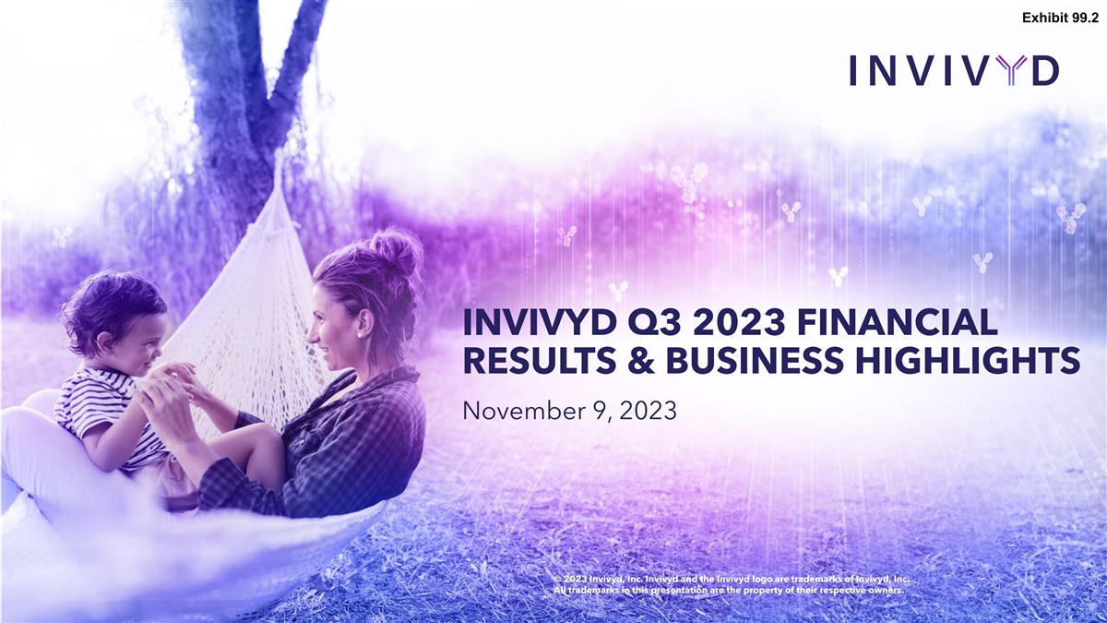
Exhibit 99.2 INVIVYD Q3 2023 FINANCIAL RESULTS & BUSINESS HIGHLIGHTS November 9, 2023 © 2023 Invivyd, Inc. Invivyd and the Invivyd logo are trademarks of Invivyd, Inc. All trademarks in this presentation are the property of their respective owners.

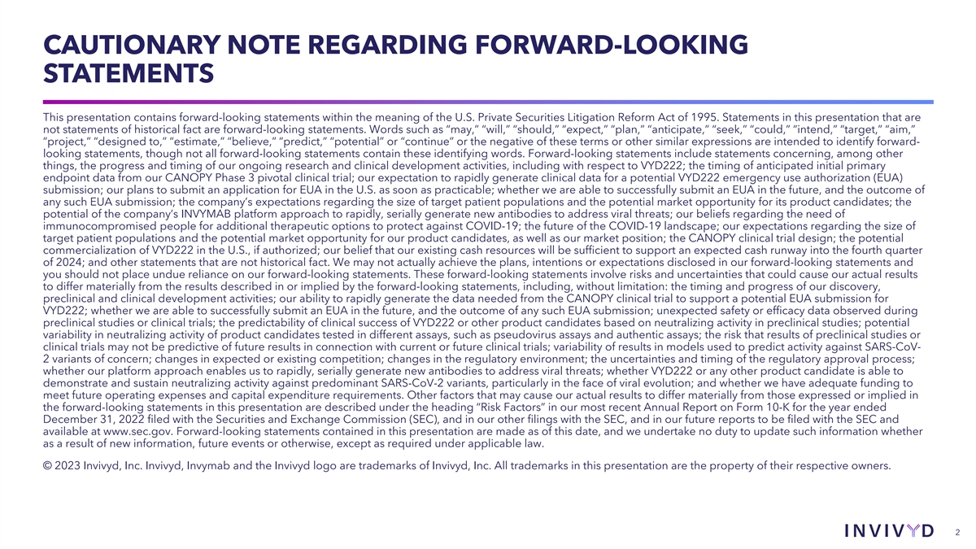
CAUTIONARY NOTE REGARDING FORWARD-LOOKING STATEMENTS This presentation contains forward-looking statements within the meaning of the U.S. Private Securities Litigation Reform Act of 1995. Statements in this presentation that are not statements of historical fact are forward-looking statements. Words such as “may,” “will,” “should,” “expect,” “plan,” “anticipate,” “seek,” “could,” “intend,” “target,” “aim,” “project,” “designed to,” “estimate,” “believe,” “predict,” “potential” or “continue” or the negative of these terms or other similar expressions are intended to identify forward- looking statements, though not all forward-looking statements contain these identifying words. Forward-looking statements include statements concerning, among other things, the progress and timing of our ongoing research and clinical development activities, including with respect to VYD222; the timing of anticipated initial primary endpoint data from our CANOPY Phase 3 pivotal clinical trial; our expectation to rapidly generate clinical data for a potential VYD222 emergency use authorization (EUA) submission; our plans to submit an application for EUA in the U.S. as soon as practicable; whether we are able to successfully submit an EUA in the future, and the outcome of any such EUA submission; the company’s expectations regarding the size of target patient populations and the potential market opportunity for its product candidates; the potential of the company’s INVYMAB platform approach to rapidly, serially generate new antibodies to address viral threats; our beliefs regarding the need of immunocompromised people for additional therapeutic options to protect against COVID-19; the future of the COVID-19 landscape; our expectations regarding the size of target patient populations and the potential market opportunity for our product candidates, as well as our market position; the CANOPY clinical trial design; the potential commercialization of VYD222 in the U.S., if authorized; our belief that our existing cash resources will be sufficient to support an expected cash runway into the fourth quarter of 2024; and other statements that are not historical fact. We may not actually achieve the plans, intentions or expectations disclosed in our forward-looking statements and you should not place undue reliance on our forward-looking statements. These forward-looking statements involve risks and uncertainties that could cause our actual results to differ materially from the results described in or implied by the forward-looking statements, including, without limitation: the timing and progress of our discovery, preclinical and clinical development activities; our ability to rapidly generate the data needed from the CANOPY clinical trial to support a potential EUA submission for VYD222; whether we are able to successfully submit an EUA in the future, and the outcome of any such EUA submission; unexpected safety or efficacy data observed during preclinical studies or clinical trials; the predictability of clinical success of VYD222 or other product candidates based on neutralizing activity in preclinical studies; potential variability in neutralizing activity of product candidates tested in different assays, such as pseudovirus assays and authentic assays; the risk that results of preclinical studies or clinical trials may not be predictive of future results in connection with current or future clinical trials; variability of results in models used to predict activity against SARS-CoV- 2 variants of concern; changes in expected or existing competition; changes in the regulatory environment; the uncertainties and timing of the regulatory approval process; whether our platform approach enables us to rapidly, serially generate new antibodies to address viral threats; whether VYD222 or any other product candidate is able to demonstrate and sustain neutralizing activity against predominant SARS-CoV-2 variants, particularly in the face of viral evolution; and whether we have adequate funding to meet future operating expenses and capital expenditure requirements. Other factors that may cause our actual results to differ materially from those expressed or implied in the forward-looking statements in this presentation are described under the heading “Risk Factors” in our most recent Annual Report on Form 10-K for the year ended December 31, 2022 filed with the Securities and Exchange Commission (SEC), and in our other filings with the SEC, and in our future reports to be filed with the SEC and available at www.sec.gov. Forward-looking statements contained in this presentation are made as of this date, and we undertake no duty to update such information whether as a result of new information, future events or otherwise, except as required under applicable law. © 2023 Invivyd, Inc. Invivyd, Invymab and the Invivyd logo are trademarks of Invivyd, Inc. All trademarks in this presentation are the property of their respective owners. 2

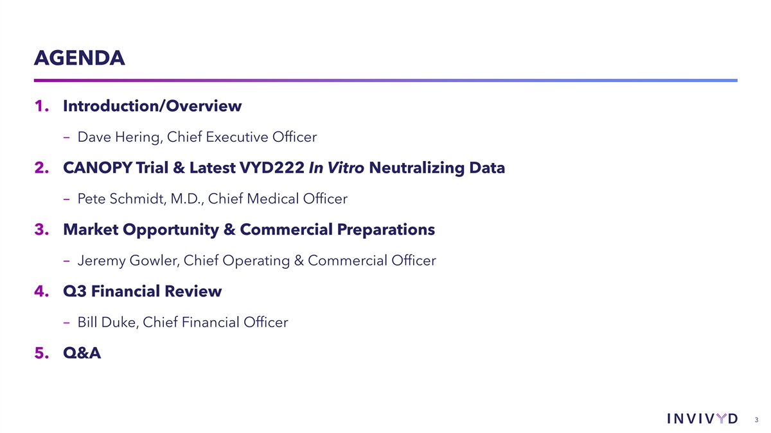
AGENDA 1. Introduction/Overview − Dave Hering, Chief Executive Officer 2. CANOPY Trial & Latest VYD222 In Vitro Neutralizing Data − Pete Schmidt, M.D., Chief Medical Officer 3. Market Opportunity & Commercial Preparations − Jeremy Gowler, Chief Operating & Commercial Officer 4. Q3 Financial Review − Bill Duke, Chief Financial Officer 5. Q&A 3

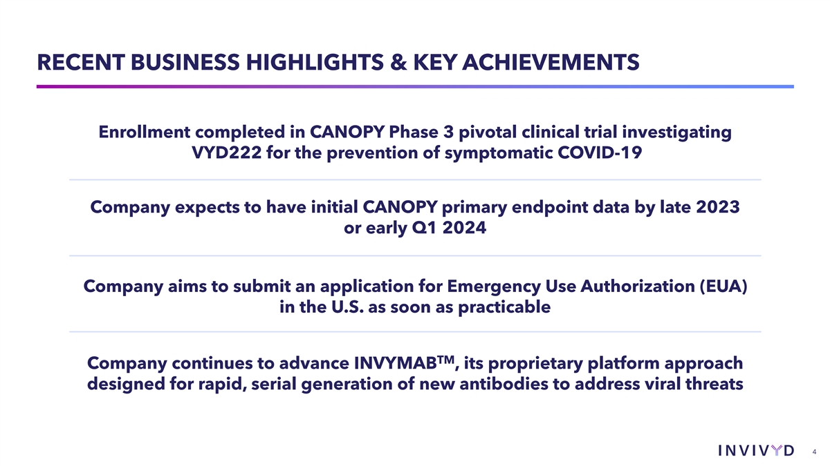
RECENT BUSINESS HIGHLIGHTS & KEY ACHIEVEMENTS Enrollment completed in CANOPY Phase 3 pivotal clinical trial investigating VYD222 for the prevention of symptomatic COVID-19 Company expects to have initial CANOPY primary endpoint data by late 2023 or early Q1 2024 Company aims to submit an application for Emergency Use Authorization (EUA) in the U.S. as soon as practicable TM Company continues to advance INVYMAB , its proprietary platform approach designed for rapid, serial generation of new antibodies to address viral threats 4

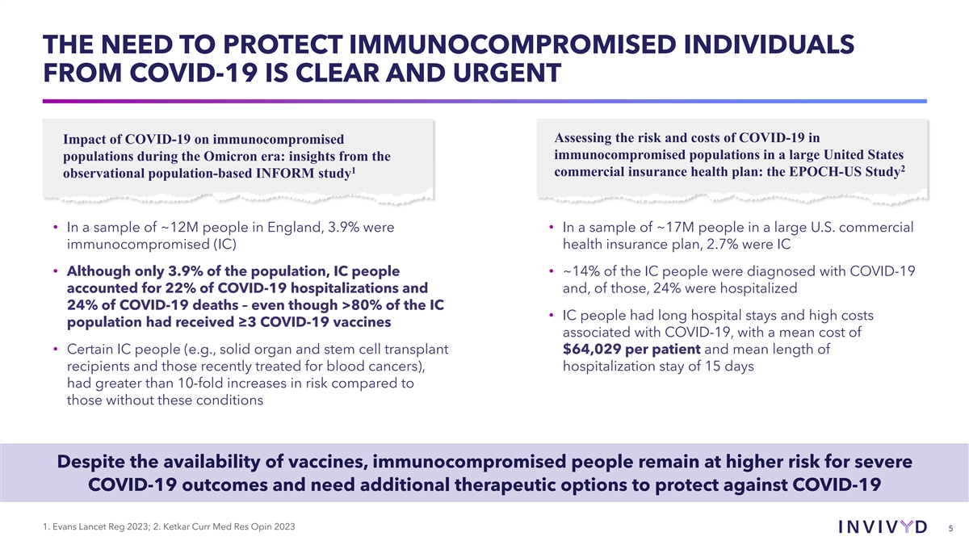
THE NEED TO PROTECT IMMUNOCOMPROMISED INDIVIDUALS FROM COVID-19 IS CLEAR AND URGENT Assessing the risk and costs of COVID-19 in Impact of COVID-19 on immunocompromised immunocompromised populations in a large United States populations during the Omicron era: insights from the 2 1 commercial insurance health plan: the EPOCH-US Study observational population-based INFORM study • In a sample of ~12M people in England, 3.9% were • In a sample of ~17M people in a large U.S. commercial immunocompromised (IC) health insurance plan, 2.7% were IC • Although only 3.9% of the population, IC people • ~14% of the IC people were diagnosed with COVID-19 accounted for 22% of COVID-19 hospitalizations and and, of those, 24% were hospitalized 24% of COVID-19 deaths – even though >80% of the IC • IC people had long hospital stays and high costs population had received ≥3 COVID-19 vaccines associated with COVID-19, with a mean cost of • Certain IC people (e.g., solid organ and stem cell transplant $64,029 per patient and mean length of recipients and those recently treated for blood cancers), hospitalization stay of 15 days had greater than 10-fold increases in risk compared to those without these conditions Despite the availability of vaccines, immunocompromised people remain at higher risk for severe COVID-19 outcomes and need additional therapeutic options to protect against COVID-19 1. Evans Lancet Reg 2023; 2. Ketkar Curr Med Res Opin 2023 5

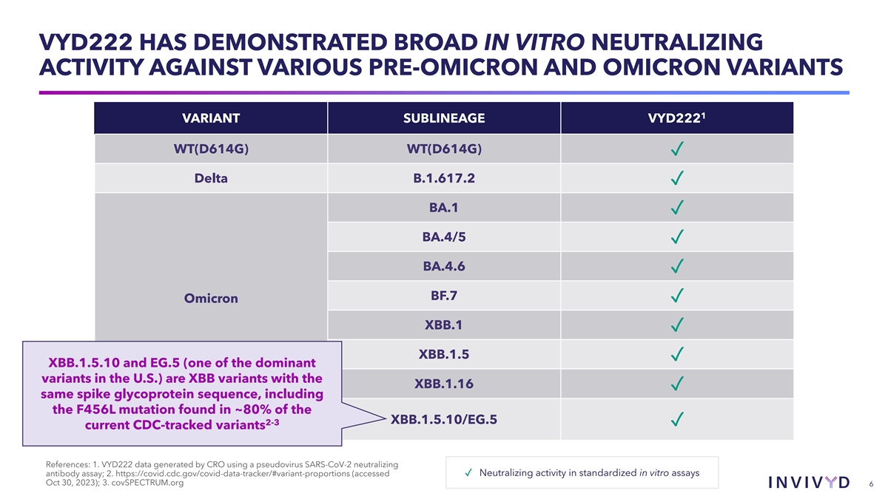
VYD222 HAS DEMONSTRATED BROAD IN VITRO NEUTRALIZING ACTIVITY AGAINST VARIOUS PRE-OMICRON AND OMICRON VARIANTS 1 VARIANT SUBLINEAGE VYD222 WT(D614G) WT(D614G) ✓ Delta B.1.617.2 ✓ BA.1 ✓ BA.4/5 ✓ BA.4.6 ✓ BF.7 ✓ Omicron XBB.1 ✓ XBB.1.5 ✓ XBB.1.5.10 and EG.5 (one of the dominant variants in the U.S.) are XBB variants with the XBB.1.16 ✓ same spike glycoprotein sequence, including the F456L mutation found in ~80% of the XBB.1.5.10/EG.5 2-3 ✓ current CDC-tracked variants References: 1. VYD222 data generated by CRO using a pseudovirus SARS-CoV-2 neutralizing ✓ Neutralizing activity in standardized in vitro assays antibody assay; 2. https://covid.cdc.gov/covid-data-tracker/#variant-proportions (accessed Oct 30, 2023); 3. covSPECTRUM.org 6

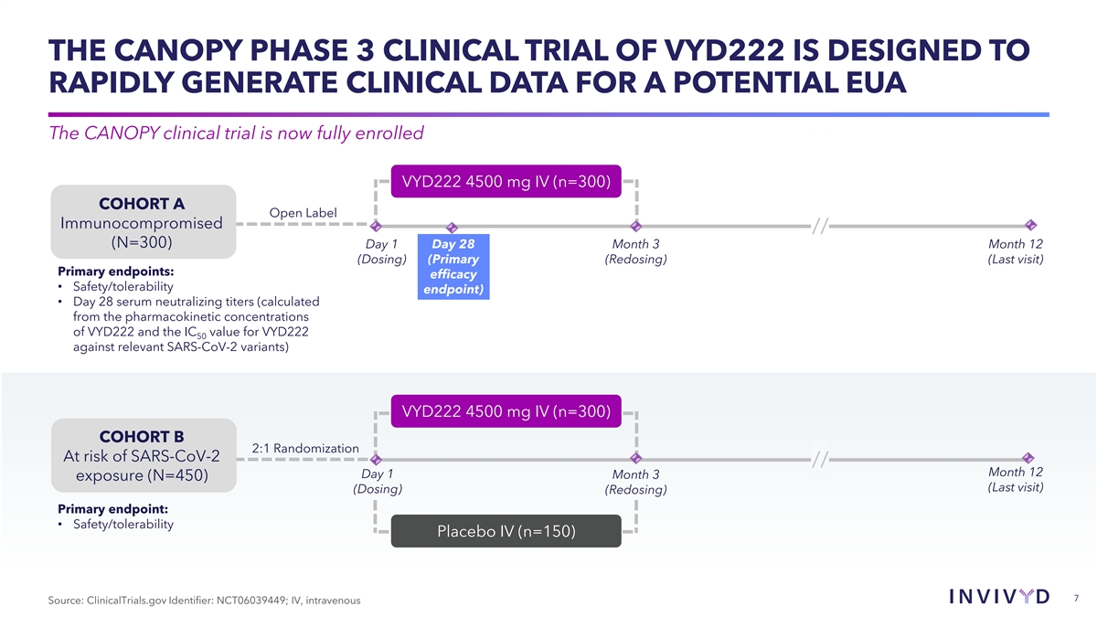
THE CANOPY PHASE 3 CLINICAL TRIAL OF VYD222 IS DESIGNED TO RAPIDLY GENERATE CLINICAL DATA FOR A POTENTIAL EUA The CANOPY clinical trial is now fully enrolled VYD222 4500 mg IV (n=300) COHORT A Open Label Immunocompromised // (N=300) Day 1 Day 28 Month 3 Month 12 (Dosing) (Primary (Redosing) (Last visit) Primary endpoints: efficacy • Safety/tolerability endpoint) • Day 28 serum neutralizing titers (calculated from the pharmacokinetic concentrations of VYD222 and the IC value for VYD222 50 against relevant SARS-CoV-2 variants) VYD222 4500 mg IV (n=300) COHORT B 2:1 Randomization At risk of SARS-CoV-2 // Month 12 Day 1 Month 3 exposure (N=450) (Last visit) (Dosing) (Redosing) Primary endpoint: • Safety/tolerability Placebo IV (n=150) 7 Source: ClinicalTrials.gov Identifier: NCT06039449; IV, intravenous

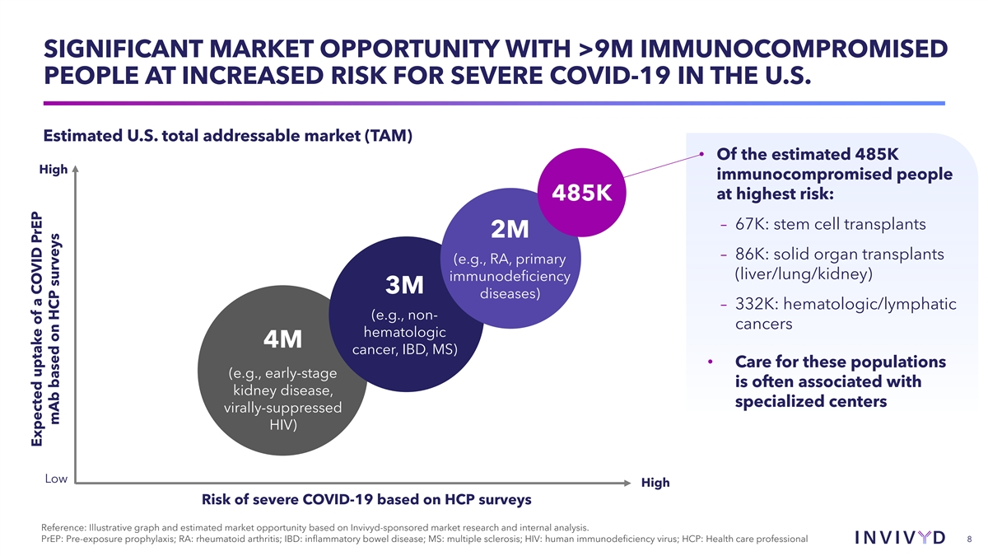
SIGNIFICANT MARKET OPPORTUNITY WITH >9M IMMUNOCOMPROMISED PEOPLE AT INCREASED RISK FOR SEVERE COVID-19 IN THE U.S. Estimated U.S. total addressable market (TAM) • Of the estimated 485K High immunocompromised people at highest risk: 485K – 67K: stem cell transplants 2M – 86K: solid organ transplants (e.g., RA, primary (liver/lung/kidney) immunodeficiency 3M diseases) – 332K: hematologic/lymphatic (e.g., non- cancers hematologic 4M cancer, IBD, MS) • Care for these populations (e.g., early-stage is often associated with kidney disease, specialized centers virally-suppressed HIV) Low High Risk of severe COVID-19 based on HCP surveys Reference: Illustrative graph and estimated market opportunity based on Invivyd-sponsored market research and internal analysis. PrEP: Pre-exposure prophylaxis; RA: rheumatoid arthritis; IBD: inflammatory bowel disease; MS: multiple sclerosis; HIV: human immunodeficiency virus; HCP: Health care professional 8 Expected uptake of a COVID PrEP mAb based on HCP surveys

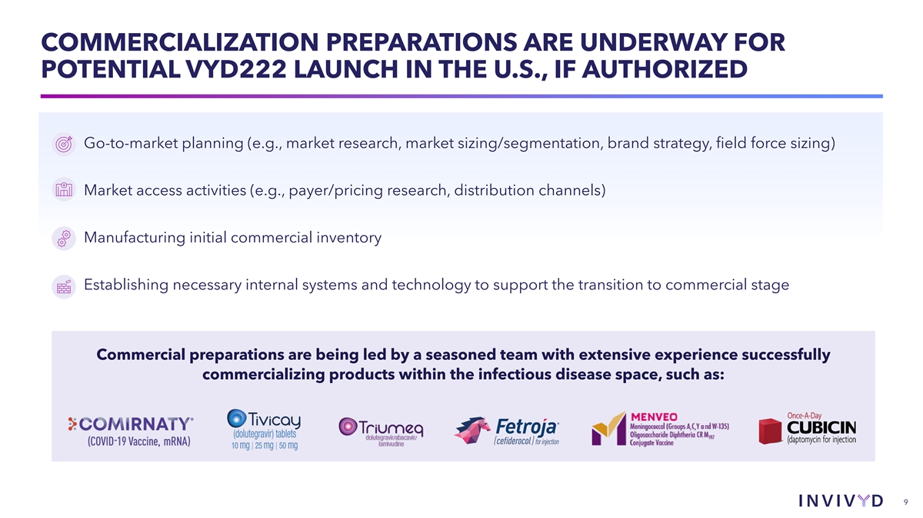
COMMERCIALIZATION PREPARATIONS ARE UNDERWAY FOR POTENTIAL VYD222 LAUNCH IN THE U.S., IF AUTHORIZED Go-to-market planning (e.g., market research, market sizing/segmentation, brand strategy, field force sizing) Market access activities (e.g., payer/pricing research, distribution channels) Manufacturing initial commercial inventory Establishing necessary internal systems and technology to support the transition to commercial stage Commercial preparations are being led by a seasoned team with extensive experience successfully commercializing products within the infectious disease space, such as: 9

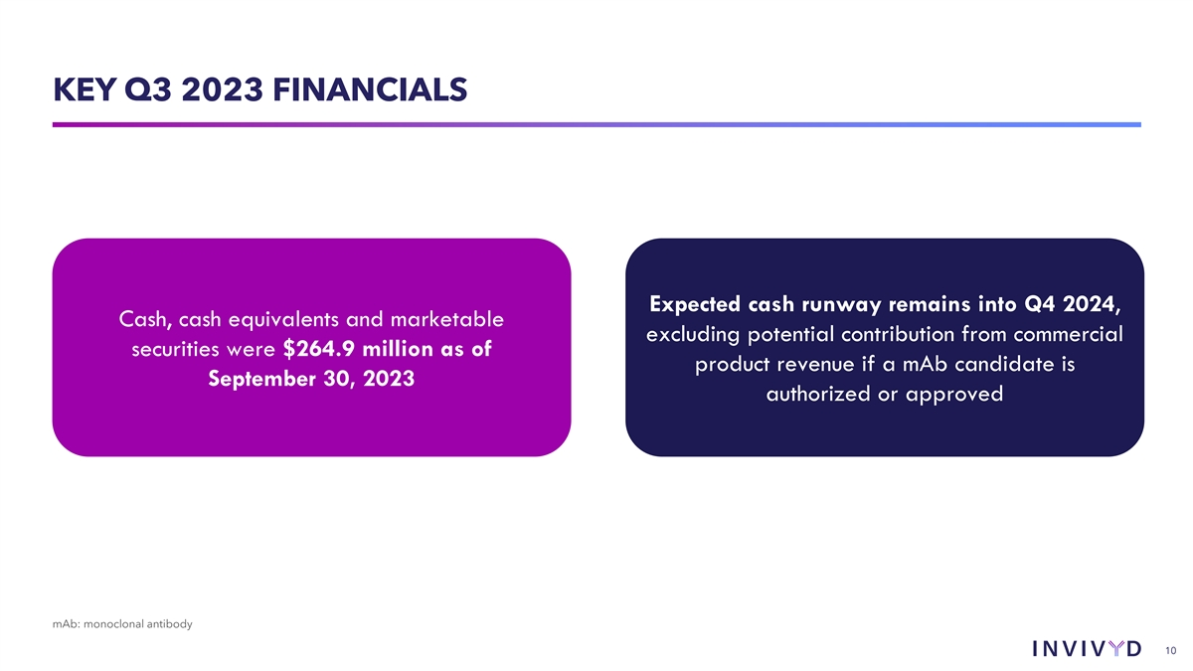
KEY Q3 2023 FINANCIALS Expected cash runway remains into Q4 2024, Cash, cash equivalents and marketable excluding potential contribution from commercial securities were $264.9 million as of product revenue if a mAb candidate is September 30, 2023 authorized or approved mAb: monoclonal antibody 10

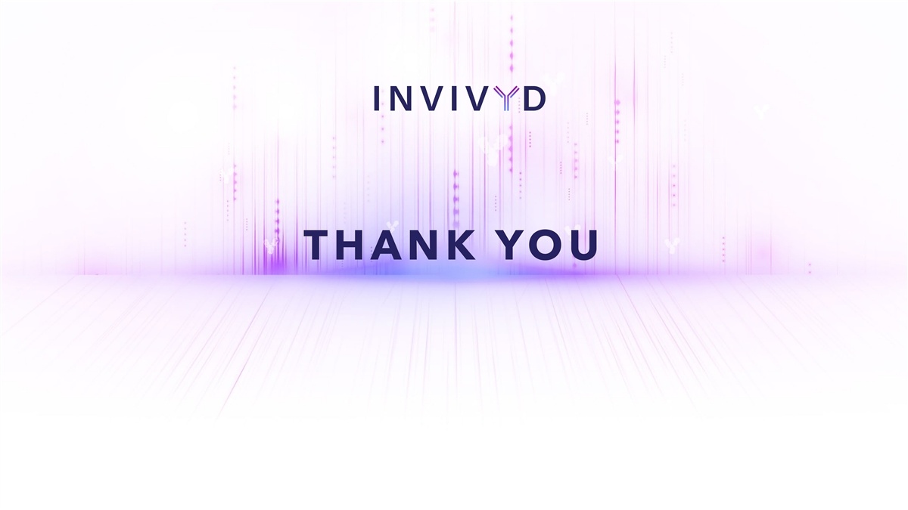
THANK YOU

