UNITED STATES
SECURITIES AND EXCHANGE COMMISSION
WASHINGTON, D.C. 20549

FORM 8-K

CURRENT REPORT
Pursuant to Section 13 or 15(d)
of the Securities Exchange Act of 1934
Date of report (Date of earliest event reported): April 26, 2023

Invivyd, Inc.
(Exact Name of Registrant as Specified in its Charter)

Delaware |  | 001-40703 |  | 85-1403134
(State or Other Jurisdiction  of Incorporation) |  | (Commission  File Number) |  | (IRS Employer  Identification No.)

1601 Trapelo Road, Suite 178  Waltham, MA |  | 02451
(Address of Principal Executive Offices) |  | (Zip Code)
Registrant’s telephone number, including area code: (781) 819-0080
Not applicable
(Former Name or Former Address, if Changed Since Last Report)

Check the appropriate box below if the Form 8-K filing is intended to simultaneously satisfy the filing obligation of the registrant under any of the following provisions:

☐ | Written communications pursuant to Rule 425 under the Securities Act (17 CFR 230.425)

☐ | Soliciting material pursuant to Rule 14a-12 under the Exchange Act (17 CFR 240.14a-12)

☐ | Pre-commencement communications pursuant to Rule 14d-2(b) under the Exchange Act (17 CFR 240.14d-2(b))

☐ | Pre-commencement communications pursuant to Rule 13e-4(c) under the Exchange Act (17 CFR 240.13e-4(c))
Securities registered pursuant to Section 12(b) of the Act:

Title of each class |  | Trading  Symbol(s) |  | Name of each exchange  on which registered
Common stock, par value $0.0001 per share |  | IVVD |  | The Nasdaq Stock Market LLC
Indicate by check mark whether the registrant is an emerging growth company as defined in Rule 405 of the Securities Act of 1933 (§230.405 of this chapter) or Rule 12b-2 of the Securities Exchange Act of 1934 (§240.12b-2 of this chapter).
Emerging growth company ☒
If an emerging growth company, indicate by check mark if the registrant has elected not to use the extended transition period for complying with any new or revised financial accounting standards provided pursuant to Section 13(a) of the Exchange Act. ☐

Item 5.02. | Departure of Directors or Certain Officers; Election of Directors; Appointment of Certain Officers; Compensatory Arrangements of Certain Officers.
On April 26, 2023, the Board of Directors of Invivyd, Inc. (the “Company”) approved a cash-based incentive program designed to incentivize and retain employees of the Company, pursuant to which substantially all of the Company’s executive and non-executive employees would be awarded a cash payment equal to a percentage of each employee’s respective annual bonus target in the event that the Company doses the first patient in a pivotal clinical trial of VYD222 by September 30, 2023 (the “Incentive Program”). VYD222 is a monoclonal antibody candidate for prevention of COVID-19 that is currently being evaluated by the Company in a Phase 1 clinical trial. Commencement of any pivotal clinical trial of VYD222 is subject to input from applicable regulatory authorities on the Company’s pivotal clinical trial design and to other regulatory and operational requirements. Pursuant to the Incentive Program, (i) David Hering, Chief Executive Officer of the Company, is eligible to receive a cash payment equal to $180,000, and (ii) Jill Andersen, Chief Legal Officer and Corporate Secretary of the Company, is eligible to receive a cash payment equal to $92,000. If the Company does not dose the first patient in a pivotal clinical trial of VYD222 by September 30, 2023, no payments pursuant to the Incentive Program will be made to employees of the Company.
Cautionary Note Regarding Forward-Looking Statements. This Form 8-K contains forward-looking statements within the meaning of the Private Securities Litigation Reform Act of 1995. Words such as “would be,” “in the event that,” or similar expressions are intended to identify forward-looking statements, which include statements concerning the Incentive Program and the Company’s ongoing research and clinical development plans for VYD222. The Company may not actually achieve the plans, intentions or expectations disclosed in its forward-looking statements and you should not place undue reliance on its forward-looking statements. These forward-looking statements involve risks and uncertainties that could cause the Company’s actual results to differ materially from the results described in or implied by the forward-looking statements, including, without limitation: the timing, progress and results of the Company’s Phase 1 clinical trial of VYD222; the Company’s ability to gain alignment with applicable regulatory authorities on the Company’s clinical trial design and the development pathway for VYD222 and the timing thereof; whether VYD222 is able to demonstrate and sustain neutralizing activity against predominant SARS-CoV-2 variant(s); and whether the Company will dose the first patient in a pivotal clinical trial of VYD222 by September 30, 2023, or at all. Other factors that may cause the Company’s actual results to differ materially from those expressed or implied in the forward-looking statements in this Form 8-K are described under the heading “Risk Factors” in the Company’s Annual Report on Form 10-K for the year ended December 31, 2022 filed with the Securities and Exchange Commission (the “SEC”), and in its other filings with the SEC, and in the Company’s future reports to be filed with the SEC and available at www.sec.gov. Such risks may be amplified by the impacts of the COVID-19 pandemic. Forward-looking statements contained in this Form 8-K are made as of this date, and the Company undertakes no duty to update such information whether as a result of new information, future events or otherwise, except as required under applicable law.

Item 8.01. | Other Events.
On May 2, 2023, the Company posted an updated corporate presentation on its website at www.invivyd.com. A copy of the presentation is filed herewith as Exhibit 99.1 and is incorporated by reference in this Item 8.01.

Item 9.01. | Financial Statements and Exhibits.
(d) Exhibits

Exhibit  No. |  | Description
99.1 |  | Corporate Presentation, dated May 2, 2023
104 |  | Cover Page Interactive Data File (embedded within the Inline XBRL document)

SIGNATURES
Pursuant to the requirements of the Securities Exchange Act of 1934, as amended, the registrant has duly caused this report to be signed on its behalf by the undersigned hereunto duly authorized.

 |  |  |  | INVIVYD, INC.
Date: May 2, 2023 |  |  |  | By: |  | /s/ Jill Andersen
 |  |  |  |  |  | Jill Andersen
 |  |  |  |  |  | Chief Legal Officer and Corporate Secretary
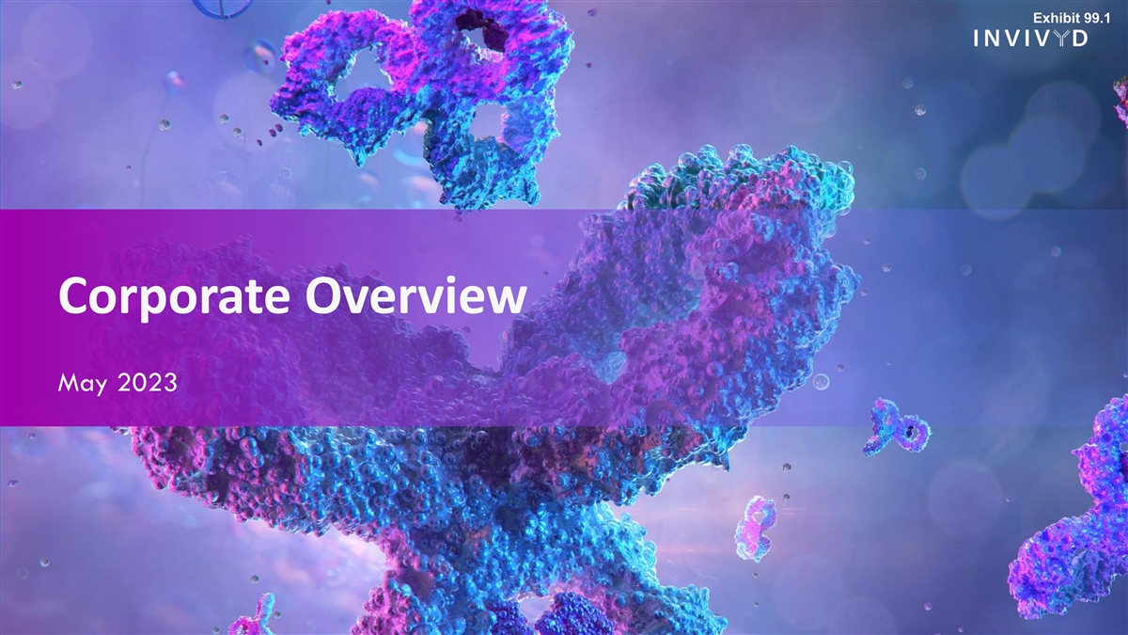
Exhibit 99.1 Corporate Overview May 2023

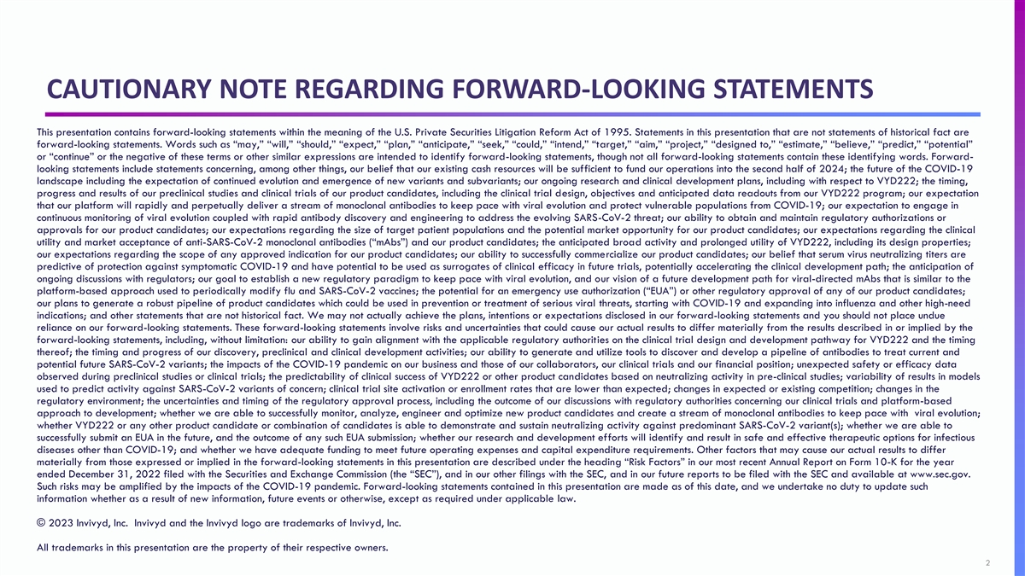
CAUTIONARY NOTE REGARDING FORWARD-LOOKING STATEMENTS This presentation contains forward-looking statements within the meaning of the U.S. Private Securities Litigation Reform Act of 1995. Statements in this presentation that are not statements of historical fact are forward-looking statements. Words such as “may,” “will,” “should,” “expect,” “plan,” “anticipate,” “seek,” “could,” “intend,” “target,” “aim,” “project,” “designed to,” “estimate,” “believe,” “predict,” “potential” or “continue” or the negative of these terms or other similar expressions are intended to identify forward-looking statements, though not all forward-looking statements contain these identifying words. Forward- looking statements include statements concerning, among other things, our belief that our existing cash resources will be sufficient to fund our operations into the second half of 2024; the future of the COVID-19 landscape including the expectation of continued evolution and emergence of new variants and subvariants; our ongoing research and clinical development plans, including with respect to VYD222; the timing, progress and results of our preclinical studies and clinical trials of our product candidates, including the clinical trial design, objectives and anticipated data readouts from our VYD222 program; our expectation that our platform will rapidly and perpetually deliver a stream of monoclonal antibodies to keep pace with viral evolution and protect vulnerable populations from COVID-19; our expectation to engage in continuous monitoring of viral evolution coupled with rapid antibody discovery and engineering to address the evolving SARS-CoV-2 threat; our ability to obtain and maintain regulatory authorizations or approvals for our product candidates; our expectations regarding the size of target patient populations and the potential market opportunity for our product candidates; our expectations regarding the clinical utility and market acceptance of anti-SARS-CoV-2 monoclonal antibodies (“mAbs”) and our product candidates; the anticipated broad activity and prolonged utility of VYD222, including its design properties; our expectations regarding the scope of any approved indication for our product candidates; our ability to successfully commercialize our product candidates; our belief that serum virus neutralizing titers are predictive of protection against symptomatic COVID-19 and have potential to be used as surrogates of clinical efficacy in future trials, potentially accelerating the clinical development path; the anticipation of ongoing discussions with regulators; our goal to establish a new regulatory paradigm to keep pace with viral evolution, and our vision of a future development path for viral-directed mAbs that is similar to the platform-based approach used to periodically modify flu and SARS-CoV-2 vaccines; the potential for an emergency use authorization (“EUA”) or other regulatory approval of any of our product candidates; our plans to generate a robust pipeline of product candidates which could be used in prevention or treatment of serious viral threats, starting with COVID-19 and expanding into influenza and other high-need indications; and other statements that are not historical fact. We may not actually achieve the plans, intentions or expectations disclosed in our forward-looking statements and you should not place undue reliance on our forward-looking statements. These forward-looking statements involve risks and uncertainties that could cause our actual results to differ materially from the results described in or implied by the forward-looking statements, including, without limitation: our ability to gain alignment with the applicable regulatory authorities on the clinical trial design and development pathway for VYD222 and the timing thereof; the timing and progress of our discovery, preclinical and clinical development activities; our ability to generate and utilize tools to discover and develop a pipeline of antibodies to treat current and potential future SARS-CoV-2 variants; the impacts of the COVID-19 pandemic on our business and those of our collaborators, our clinical trials and our financial position; unexpected safety or efficacy data observed during preclinical studies or clinical trials; the predictability of clinical success of VYD222 or other product candidates based on neutralizing activity in pre-clinical studies; variability of results in models used to predict activity against SARS-CoV-2 variants of concern; clinical trial site activation or enrollment rates that are lower than expected; changes in expected or existing competition; changes in the regulatory environment; the uncertainties and timing of the regulatory approval process, including the outcome of our discussions with regulatory authorities concerning our clinical trials and platform-based approach to development; whether we are able to successfully monitor, analyze, engineer and optimize new product candidates and create a stream of monoclonal antibodies to keep pace with viral evolution; whether VYD222 or any other product candidate or combination of candidates is able to demonstrate and sustain neutralizing activity against predominant SARS-CoV-2 variant(s); whether we are able to successfully submit an EUA in the future, and the outcome of any such EUA submission; whether our research and development efforts will identify and result in safe and effective therapeutic options for infectious diseases other than COVID-19; and whether we have adequate funding to meet future operating expenses and capital expenditure requirements. Other factors that may cause our actual results to differ materially from those expressed or implied in the forward-looking statements in this presentation are described under the heading “Risk Factors” in our most recent Annual Report on Form 10-K for the year ended December 31, 2022 filed with the Securities and Exchange Commission (the “SEC”), and in our other filings with the SEC, and in our future reports to be filed with the SEC and available at www.sec.gov. Such risks may be amplified by the impacts of the COVID-19 pandemic. Forward-looking statements contained in this presentation are made as of this date, and we undertake no duty to update such information whether as a result of new information, future events or otherwise, except as required under applicable law. © 2023 Invivyd, Inc. Invivyd and the Invivyd logo are trademarks of Invivyd, Inc. All trademarks in this presentation are the property of their respective owners. 2 2

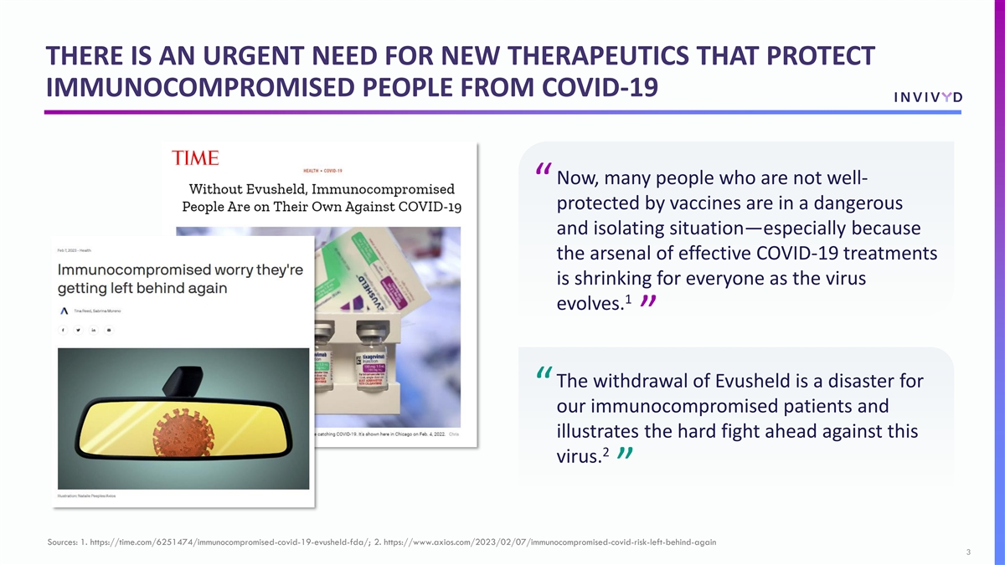
THERE IS AN URGENT NEED FOR NEW THERAPEUTICS THAT PROTECT IMMUNOCOMPROMISED PEOPLE FROM COVID-19 Now, many people who are not well- “ protected by vaccines are in a dangerous and isolating situation—especially because the arsenal of effective COVID-19 treatments is shrinking for everyone as the virus 1 evolves. ” The withdrawal of Evusheld is a disaster for “ our immunocompromised patients and illustrates the hard fight ahead against this 2 virus. ” Sources: 1. https://time.com/6251474/immunocompromised-covid-19-evusheld-fda/; 2. https://www.axios.com/2023/02/07/immunocompromised-covid-risk-left-behind-again 3

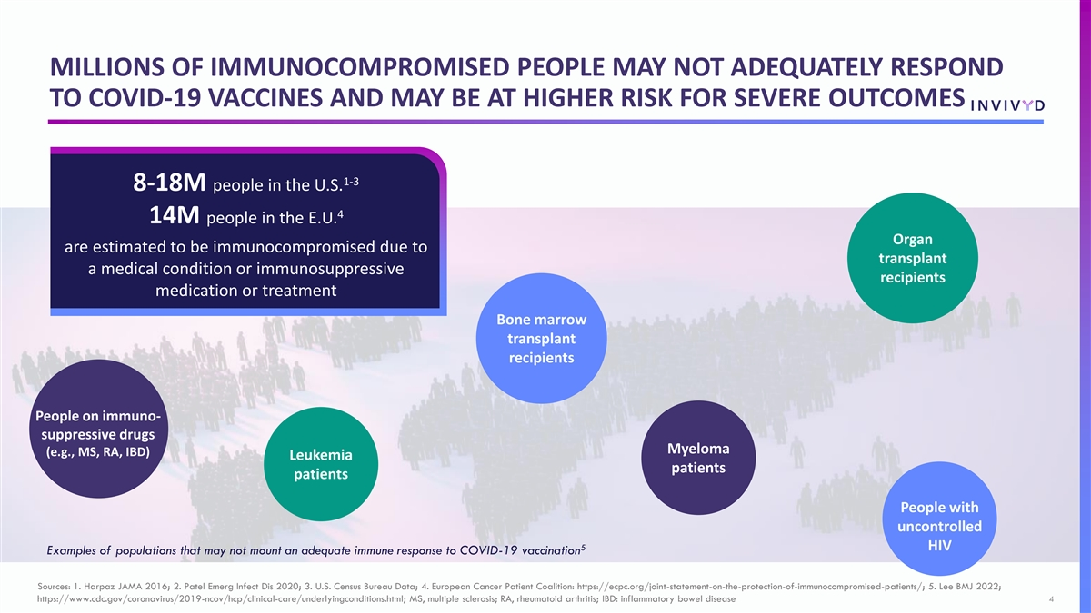
MILLIONS OF IMMUNOCOMPROMISED PEOPLE MAY NOT ADEQUATELY RESPOND TO COVID-19 VACCINES AND MAY BE AT HIGHER RISK FOR SEVERE OUTCOMES 1-3 8-18M people in the U.S. 4 14M people in the E.U. Organ are estimated to be immunocompromised due to transplant a medical condition or immunosuppressive recipients medication or treatment Bone marrow transplant recipients People on immuno- suppressive drugs Myeloma (e.g., MS, RA, IBD) Leukemia patients patients People with uncontrolled 5 HIV Examples of populations that may not mount an adequate immune response to COVID-19 vaccination Sources: 1. Harpaz JAMA 2016; 2. Patel Emerg Infect Dis 2020; 3. U.S. Census Bureau Data; 4. European Cancer Patient Coalition: https://ecpc.org/joint-statement-on-the-protection-of-immunocompromised-patients/; 5. Lee BMJ 2022; https://www.cdc.gov/coronavirus/2019-ncov/hcp/clinical-care/underlyingconditions.html; MS, multiple sclerosis; RA, rheumatoid arthritis; IBD: inflammatory bowel disease 4

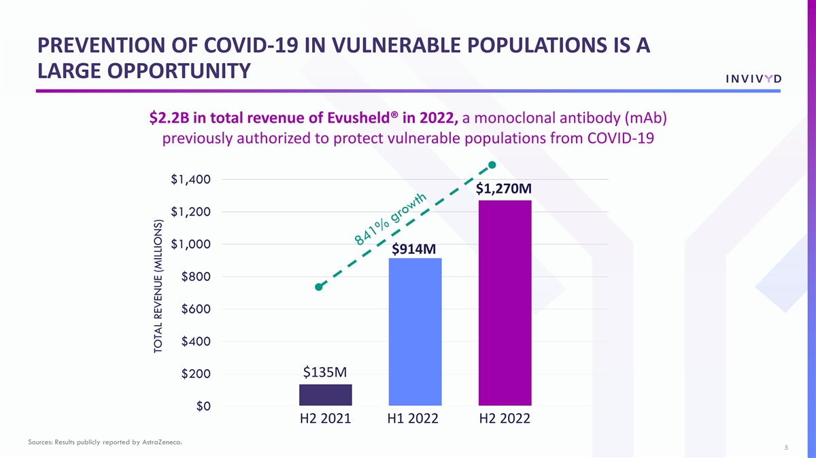
PREVENTION OF COVID-19 IN VULNERABLE POPULATIONS IS A LARGE OPPORTUNITY $2.2B in total revenue of Evusheld® in 2022, a monoclonal antibody (mAb) previously authorized to protect vulnerable populations from COVID-19 $1,400 $1,270M $1,200 $1,000 $914M $800 $600 $400 $135M $200 $0 H2 2021 H1 2022 H2 2022 Sources: Results publicly reported by AstraZeneca. 5 TOTAL REVENUE (MILLIONS)

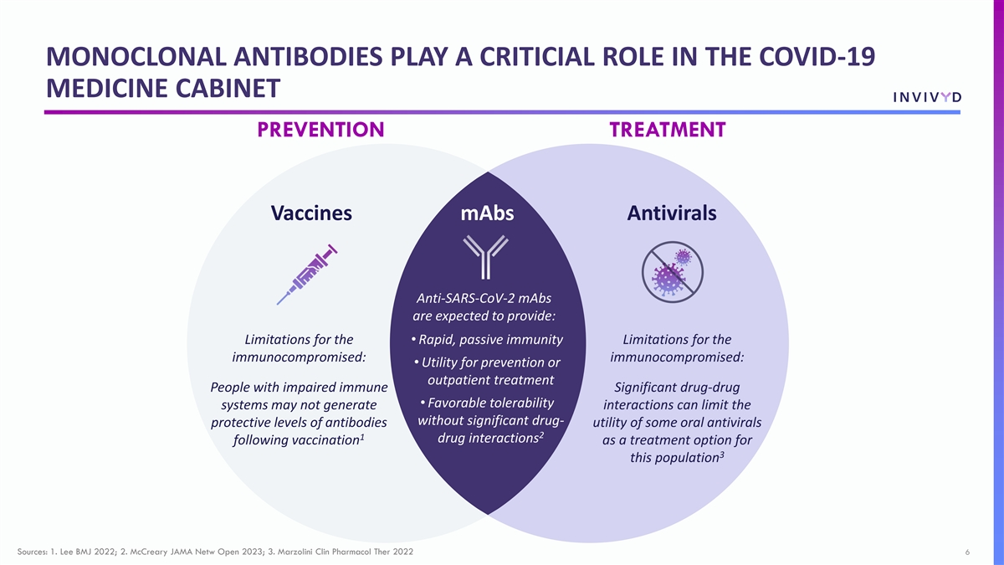
MONOCLONAL ANTIBODIES PLAY A CRITICIAL ROLE IN THE COVID-19 MEDICINE CABINET PREVENTION TREATMENT Vaccines mAbs Antivirals Anti-SARS-CoV-2 mAbs are expected to provide: Limitations for the • Rapid, passive immunity Limitations for the immunocompromised: immunocompromised: • Utility for prevention or outpatient treatment People with impaired immune Significant drug-drug • Favorable tolerability systems may not generate interactions can limit the without significant drug- protective levels of antibodies utility of some oral antivirals 2 1 drug interactions following vaccination as a treatment option for 3 this population Sources: 1. Lee BMJ 2022; 2. McCreary JAMA Netw Open 2023; 3. Marzolini Clin Pharmacol Ther 2022 6

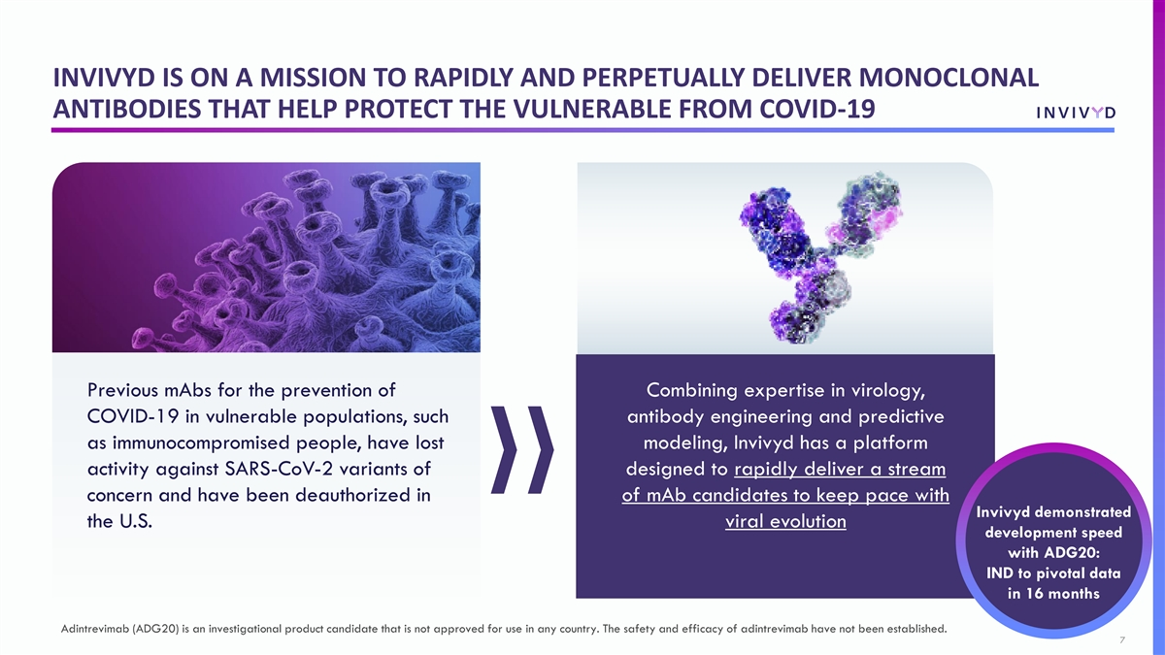
INVIVYD IS ON A MISSION TO RAPIDLY AND PERPETUALLY DELIVER MONOCLONAL ANTIBODIES THAT HELP PROTECT THE VULNERABLE FROM COVID-19 Previous mAbs for the prevention of Combining expertise in virology, COVID-19 in vulnerable populations, such antibody engineering and predictive as immunocompromised people, have lost modeling, Invivyd has a platform activity against SARS-CoV-2 variants of designed to rapidly deliver a stream concern and have been deauthorized in of mAb candidates to keep pace with Invivyd demonstrated the U.S. viral evolution development speed with ADG20: IND to pivotal data in 16 months Adintrevimab (ADG20) is an investigational product candidate that is not approved for use in any country. The safety and efficacy of adintrevimab have not been established. 7

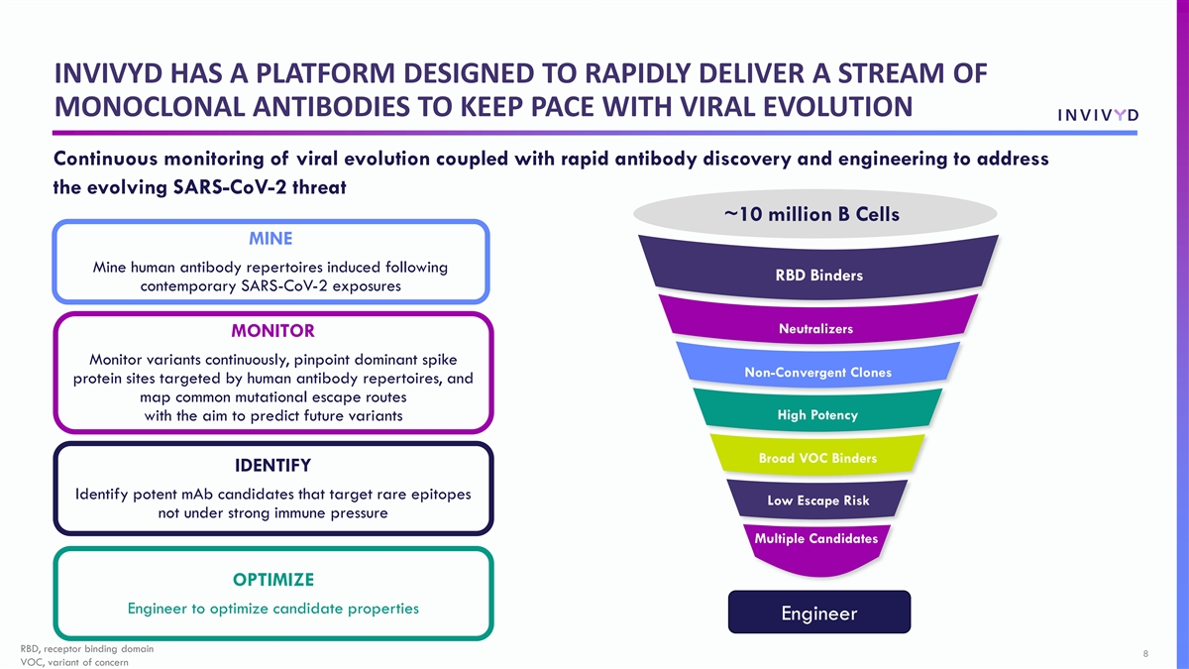
INVIVYD HAS A PLATFORM DESIGNED TO RAPIDLY DELIVER A STREAM OF MONOCLONAL ANTIBODIES TO KEEP PACE WITH VIRAL EVOLUTION Continuous monitoring of viral evolution coupled with rapid antibody discovery and engineering to address the evolving SARS-CoV-2 threat ~10 million B Cells MINE Mine human antibody repertoires induced following RBD Binders contemporary SARS-CoV-2 exposures Neutralizers MONITOR Monitor variants continuously, pinpoint dominant spike Non-Convergent Clones protein sites targeted by human antibody repertoires, and map common mutational escape routes High Potency with the aim to predict future variants Broad VOC Binders IDENTIFY Identify potent mAb candidates that target rare epitopes Low Escape Risk not under strong immune pressure Multiple Candidates OPTIMIZE Engineer to optimize candidate properties Engineer RBD, receptor binding domain 8 VOC, variant of concern

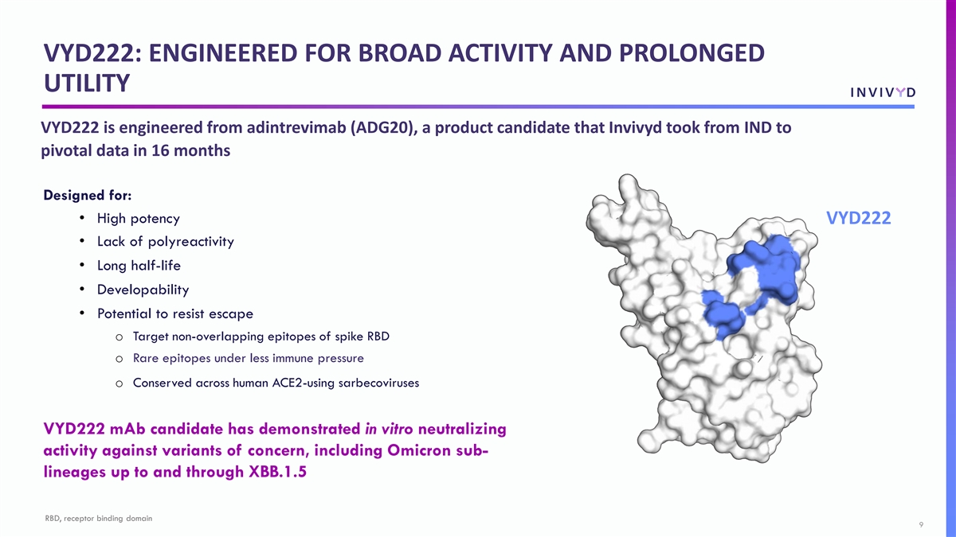
VYD222: ENGINEERED FOR BROAD ACTIVITY AND PROLONGED UTILITY VYD222 is engineered from adintrevimab (ADG20), a product candidate that Invivyd took from IND to pivotal data in 16 months Designed for: • High potency VYD222 • Lack of polyreactivity • Long half-life • Developability • Potential to resist escape o Target non-overlapping epitopes of spike RBD o Rare epitopes under less immune pressure o Conserved across human ACE2-using sarbecoviruses VYD222 mAb candidate has demonstrated in vitro neutralizing activity against variants of concern, including Omicron sub- lineages up to and through XBB.1.5 RBD, receptor binding domain 9

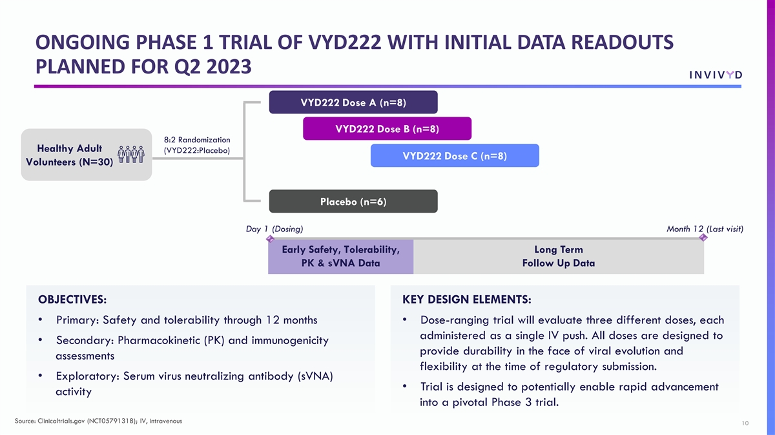
ONGOING PHASE 1 TRIAL OF VYD222 WITH INITIAL DATA READOUTS PLANNED FOR Q2 2023 VYD222 Dose A (n=8) VYD222 Dose B (n=8) 8:2 Randomization Healthy Adult (VYD222:Placebo) VYD222 Dose C (n=8) Volunteers (N=30) Placebo (n=6) Day 1 (Dosing) Month 12 (Last visit) Early Safety, Tolerability, Long Term PK & sVNA Data Follow Up Data OBJECTIVES: KEY DESIGN ELEMENTS: • Primary: Safety and tolerability through 12 months• Dose-ranging trial will evaluate three different doses, each administered as a single IV push. All doses are designed to • Secondary: Pharmacokinetic (PK) and immunogenicity provide durability in the face of viral evolution and assessments flexibility at the time of regulatory submission. • Exploratory: Serum virus neutralizing antibody (sVNA) • Trial is designed to potentially enable rapid advancement activity into a pivotal Phase 3 trial. Source: Clinicaltrials.gov (NCT05791318); IV, intravenous 10

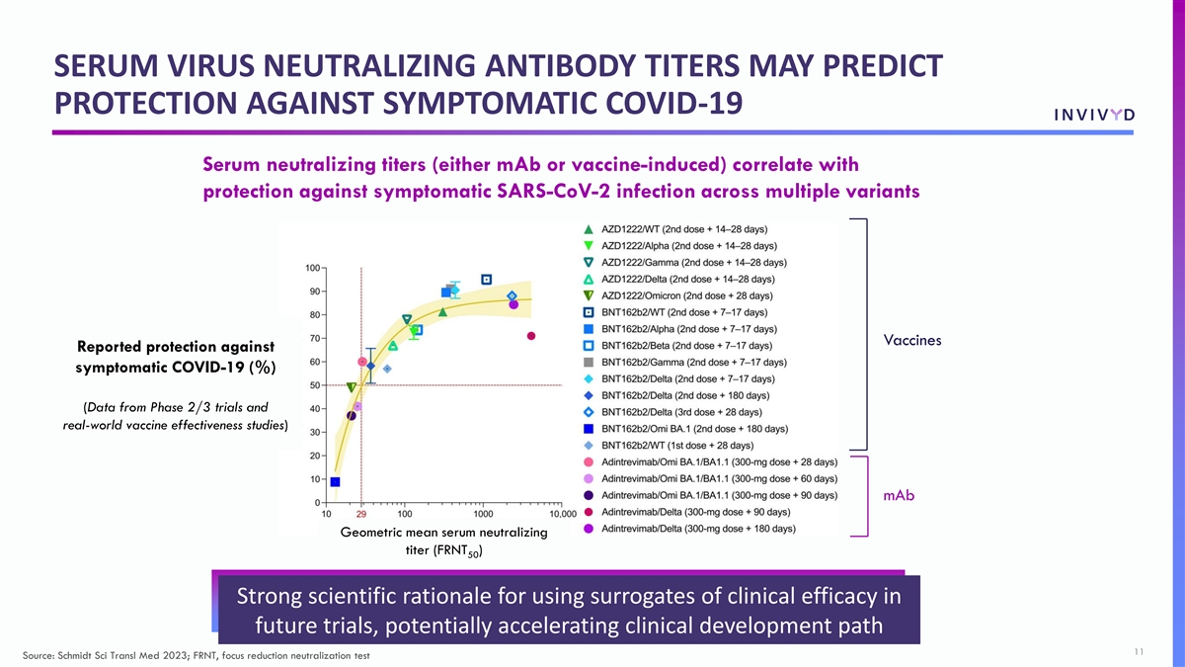
SERUM VIRUS NEUTRALIZING ANTIBODY TITERS MAY PREDICT PROTECTION AGAINST SYMPTOMATIC COVID-19 Serum neutralizing titers (either mAb or vaccine-induced) correlate with protection against symptomatic SARS-CoV-2 infection across multiple variants Vaccines Reported protection against symptomatic COVID-19 (%) (Data from Phase 2/3 trials and real-world vaccine effectiveness studies) mAb Geometric mean serum neutralizing titer (FRNT ) 50 Strong scientific rationale for using surrogates of clinical efficacy in future trials, potentially accelerating clinical development path 11 Source: Schmidt Sci Transl Med 2023; FRNT, focus reduction neutralization test

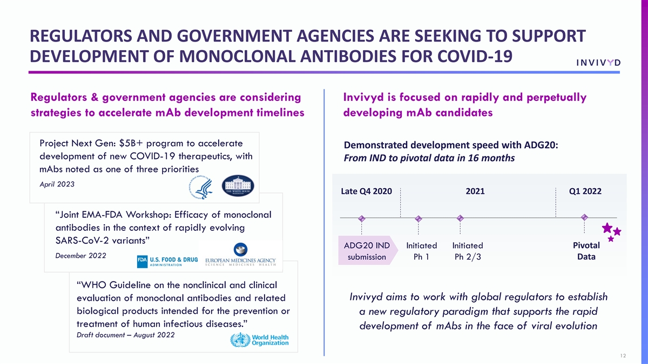
REGULATORS AND GOVERNMENT AGENCIES ARE SEEKING TO SUPPORT DEVELOPMENT OF MONOCLONAL ANTIBODIES FOR COVID-19 Regulators & government agencies are considering Invivyd is focused on rapidly and perpetually strategies to accelerate mAb development timelines developing mAb candidates Project Next Gen: $5B+ program to accelerate Demonstrated development speed with ADG20: development of new COVID-19 therapeutics, with From IND to pivotal data in 16 months mAbs noted as one of three priorities April 2023 Late Q4 2020 2021 Q1 2022 “Joint EMA-FDA Workshop: Efficacy of monoclonal antibodies in the context of rapidly evolving SARS-CoV-2 variants” Pivotal ADG20 IND Initiated Initiated December 2022 submission Ph 1 Ph 2/3 Data “WHO Guideline on the nonclinical and clinical Invivyd aims to work with global regulators to establish evaluation of monoclonal antibodies and related biological products intended for the prevention or a new regulatory paradigm that supports the rapid treatment of human infectious diseases.” development of mAbs in the face of viral evolution Draft document – August 2022 12

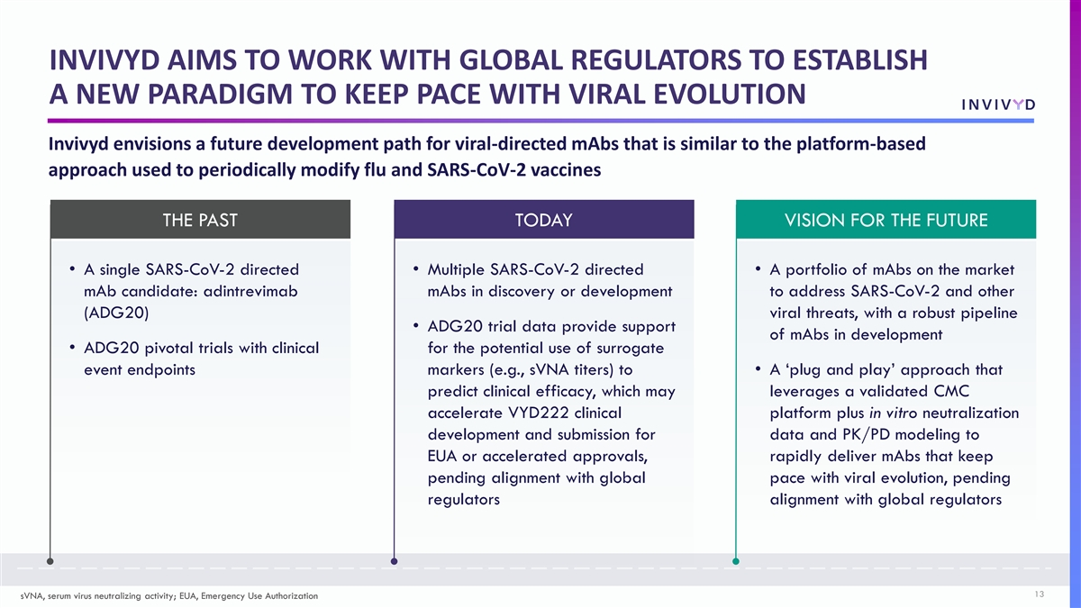
INVIVYD AIMS TO WORK WITH GLOBAL REGULATORS TO ESTABLISH A NEW PARADIGM TO KEEP PACE WITH VIRAL EVOLUTION Invivyd envisions a future development path for viral-directed mAbs that is similar to the platform-based approach used to periodically modify flu and SARS-CoV-2 vaccines THE PAST TODAY VISION FOR THE FUTURE • A single SARS-CoV-2 directed• Multiple SARS-CoV-2 directed • A portfolio of mAbs on the market mAb candidate: adintrevimab mAbs in discovery or development to address SARS-CoV-2 and other (ADG20) viral threats, with a robust pipeline • ADG20 trial data provide support of mAbs in development • ADG20 pivotal trials with clinical for the potential use of surrogate event endpoints markers (e.g., sVNA titers) to • A ‘plug and play’ approach that predict clinical efficacy, which may leverages a validated CMC accelerate VYD222 clinical platform plus in vitro neutralization development and submission for data and PK/PD modeling to EUA or accelerated approvals, rapidly deliver mAbs that keep pending alignment with global pace with viral evolution, pending regulators alignment with global regulators 13 sVNA, serum virus neutralizing activity; EUA, Emergency Use Authorization

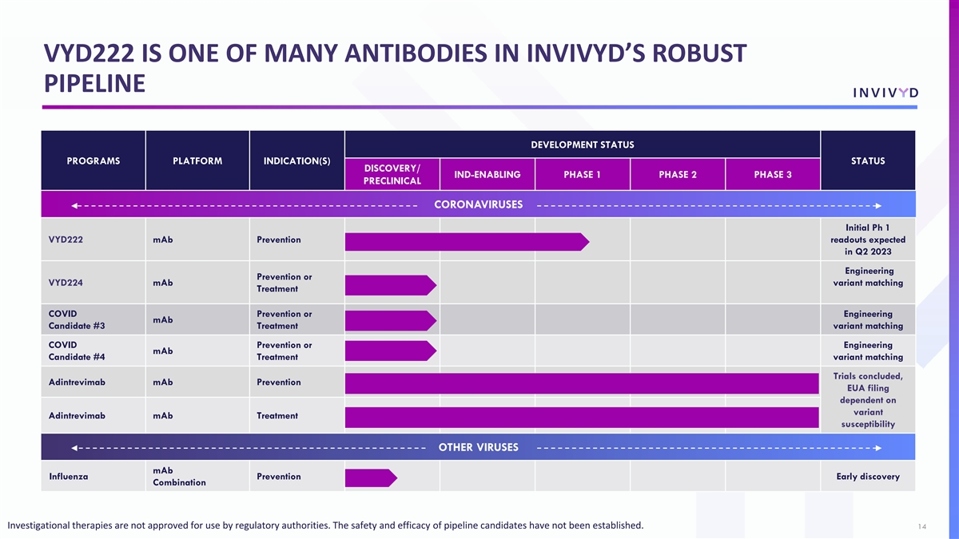
VYD222 IS ONE OF MANY ANTIBODIES IN INVIVYD’S ROBUST PIPELINE DEVELOPMENT STATUS PROGRAMS PLATFORM INDICATION(S) STATUS DISCOVERY/ IND-ENABLING PHASE 1 PHASE 2 PHASE 3 PRECLINICAL CORONAVIRUSES Initial Ph 1 VYD222 mAb Prevention readouts expected in Q2 2023 Engineering Prevention or VYD224 mAb variant matching Treatment COVID Prevention or Engineering mAb Candidate #3 Treatment variant matching COVID Prevention or Engineering mAb Candidate #4 Treatment variant matching Trials concluded, Adintrevimab mAb Prevention EUA filing dependent on variant Adintrevimab mAb Treatment susceptibility OTHER VIRUSES Investigational therapies are not approved for use by regulatory authorities. The safety and efficacy of pipeline candidates have not been established. mAb Influenza Prevention Early discovery Combination Investigational therapies are not approved for use by regulatory authorities. The safety and efficacy of pipeline candidates have not been established. 14

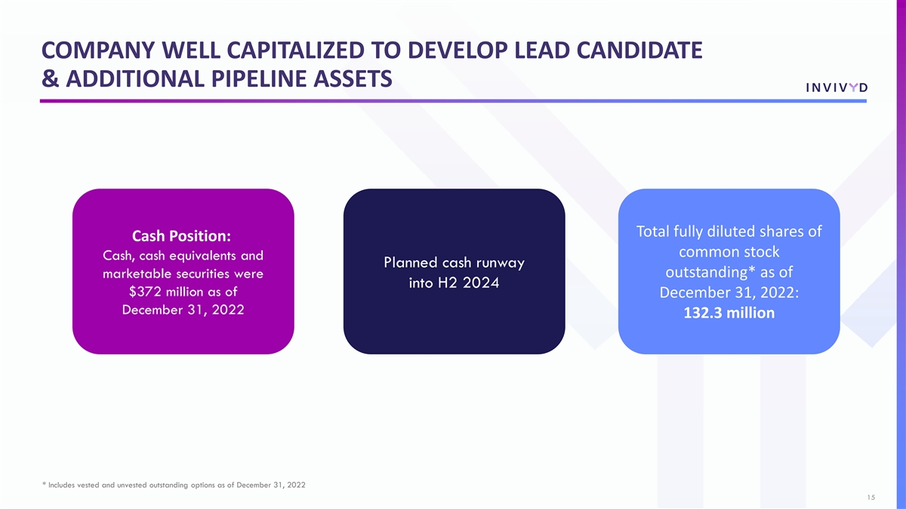
COMPANY WELL CAPITALIZED TO DEVELOP LEAD CANDIDATE & ADDITIONAL PIPELINE ASSETS Total fully diluted shares of Cash Position: common stock Cash, cash equivalents and Planned cash runway outstanding* as of marketable securities were into H2 2024 $372 million as of December 31, 2022: December 31, 2022 132.3 million * Includes vested and unvested outstanding options as of December 31, 2022 15

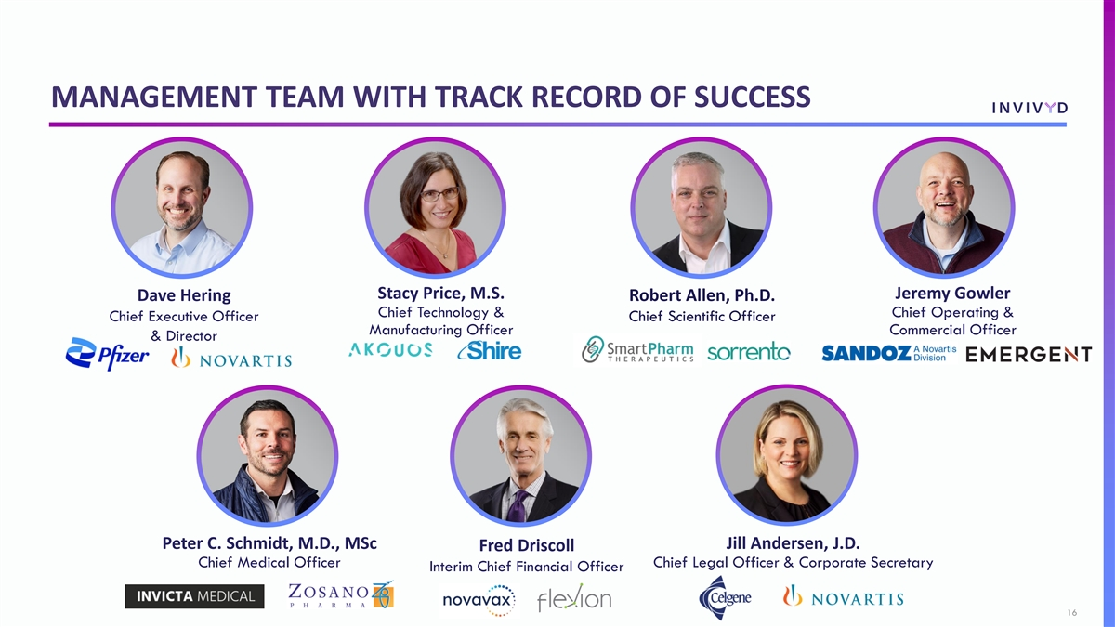
MANAGEMENT TEAM WITH TRACK RECORD OF SUCCESS Stacy Price, M.S. Jeremy Gowler Dave Hering Robert Allen, Ph.D. Chief Technology & Chief Operating & Chief Executive Officer Chief Scientific Officer Manufacturing Officer Commercial Officer & Director Peter C. Schmidt, M.D., MSc Jill Andersen, J.D. Fred Driscoll Chief Medical Officer Chief Legal Officer & Corporate Secretary Interim Chief Financial Officer 16

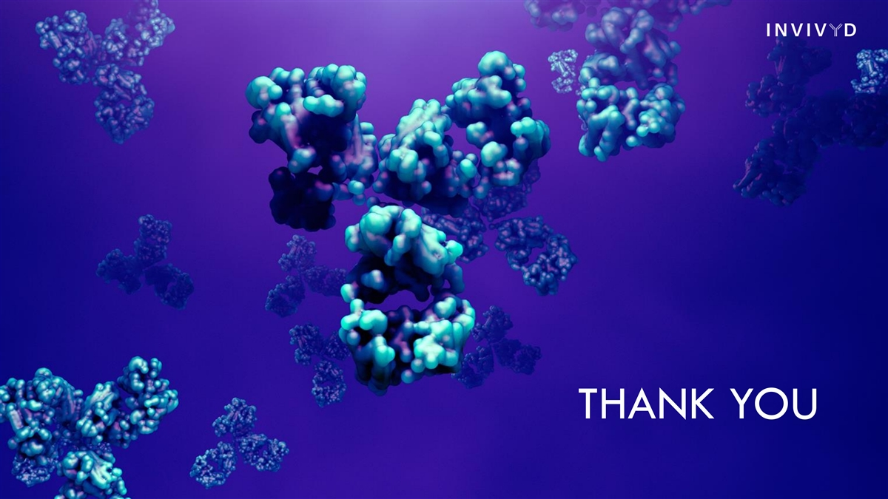
THANK YOU

